Lesson 5: Splitting Triangle Sides with Dilation, Part 1
- Let’s draw segments connecting midpoints of the sides of triangles.

5.1: Notice and Wonder: Midpoints
Here’s a triangle $ABC$ with midpoints $L,M$, and $N$.
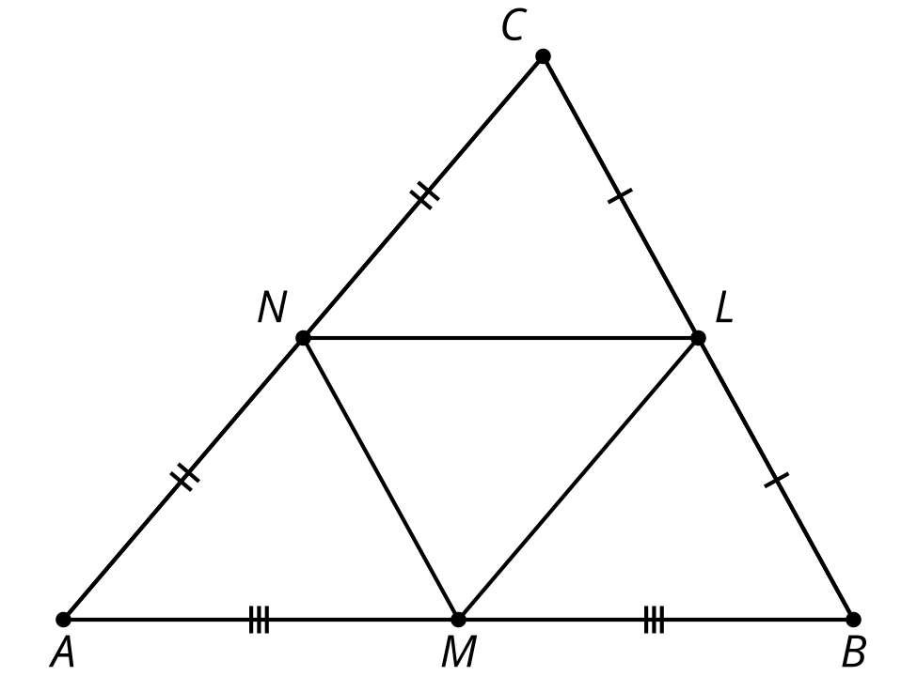
What do you notice? What do you wonder?

5.2: Dilation or Violation?
Here’s a triangle $ABC$. Points $M$ and $N$ are the midpoints of 2 sides.
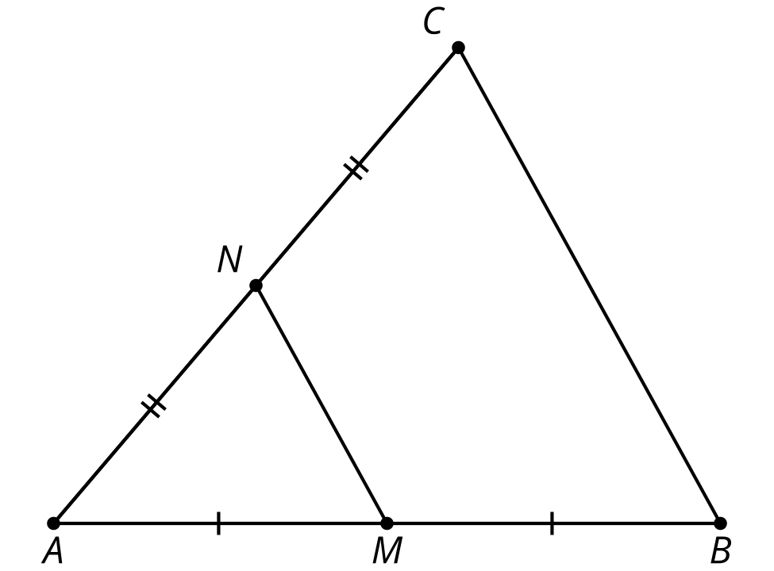
- Convince yourself triangle $ABC$ is a dilation of triangle $AMN$. What is the center of the dilation? What is the scale factor?
- Convince your partner that triangle $ABC$ is a dilation of triangle $AMN$, with the center and scale factor you found.
- With your partner, check the definition of dilation on your reference chart and make sure both of you could convince a skeptic that $ABC$ definitely fits the definition of dilation.
- Convince your partner that segment $BC$ is twice as long as segment $MN$.
- Prove that $BC=2MN$. Convince a skeptic.

5.3: A Little Bit Farther Now
Here’s a triangle $ABC$. $M$ is $\frac{2}{3}$ of the way from $A$ to $B$. $N$ is $\frac{2}{3}$ of the way from $A$ to $C$.
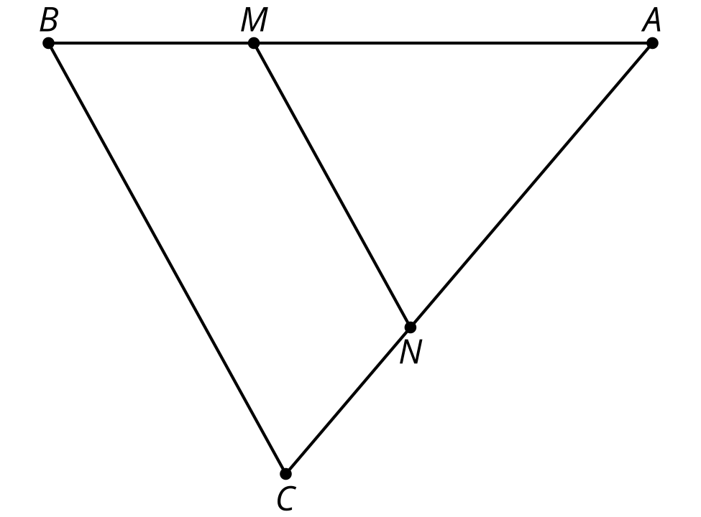
What can you say about segment $MN$, compared to segment $BC$? Provide a reason for each of your conjectures.

Are you ready for more?
- Dilate triangle $DEF$ using a scale factor of -1 and center $F$.
- How does $DF$ compare to $D^{′}F^{′}$?
- Are $E$, $F$, and $E^{′}$ collinear? Explain or show your reasoning.
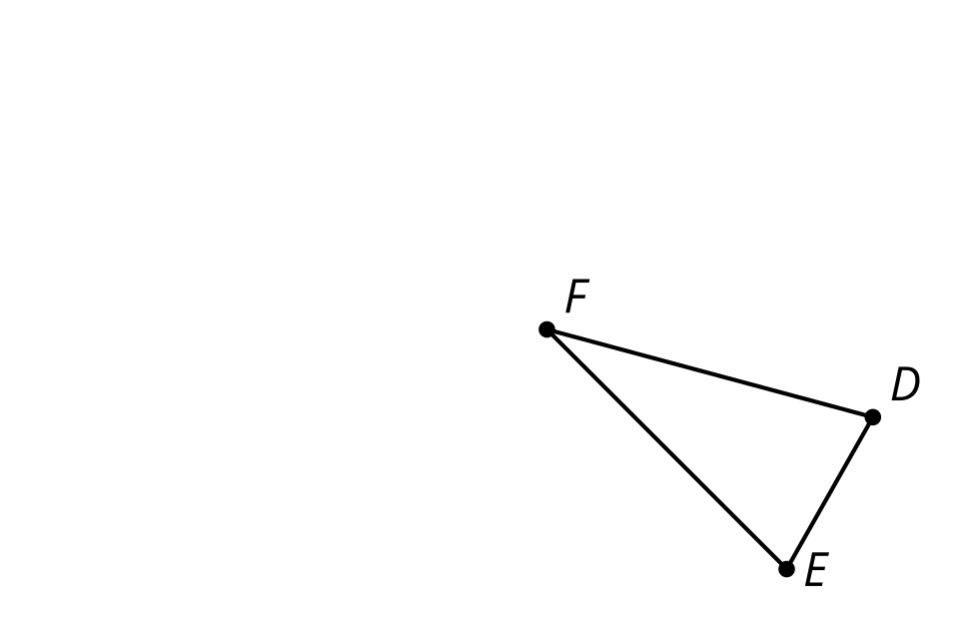

Lesson 5 Summary
Let's examine a segment whose endpoints are the midpoints of 2 sides of the triangle. If $D$ is the midpoint of segment $BC$ and $E$ is the midpoint of segment $BA$, then what can we say about $ED$ and triangle $ABC$?
Segment $ED$ is parallel to the third side of the triangle and half the length of the third side of the triangle. For example, if $AC=10$, then $ED=5$. This happens because the entire triangle $EBD$ is a dilation of triangle $ABC$ with a scale factor of $\frac{1}{2}$.

$\overset{¯}{BD}≅\overset{¯}{DC},\overset{¯}{BE}≅\overset{¯}{EA}$
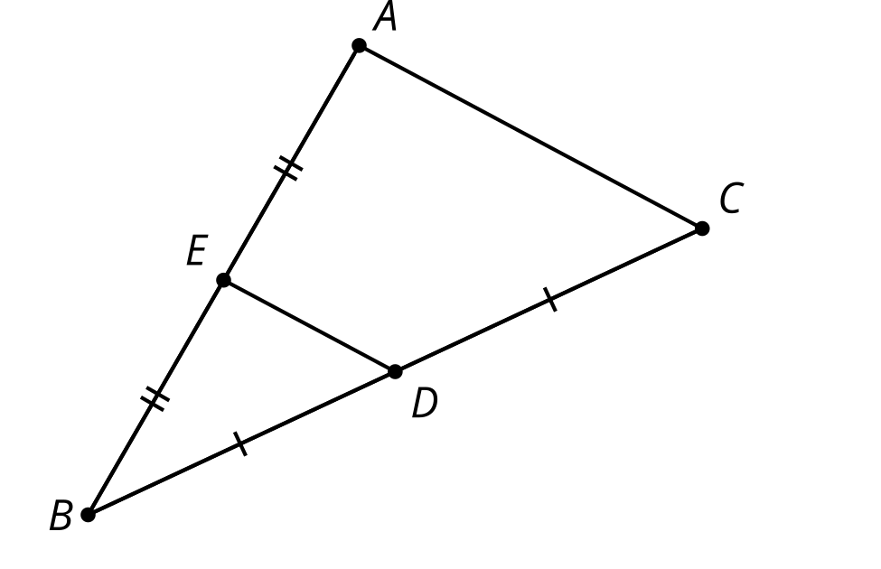
In triangle $ABC$, segment $FG$ divides segments $AB$ and $CB$ proportionally. In other words, $\frac{BG}{GA}$=$\frac{BF}{FC}$. Again, there is a dilation that takes triangle $ABC$ to triangle $GBF$, so $FG$ is parallel to $AC$ and we can calculate its length using the same scale factor.

$\overset{↔}{FG}∥\overset{↔}{AC}$
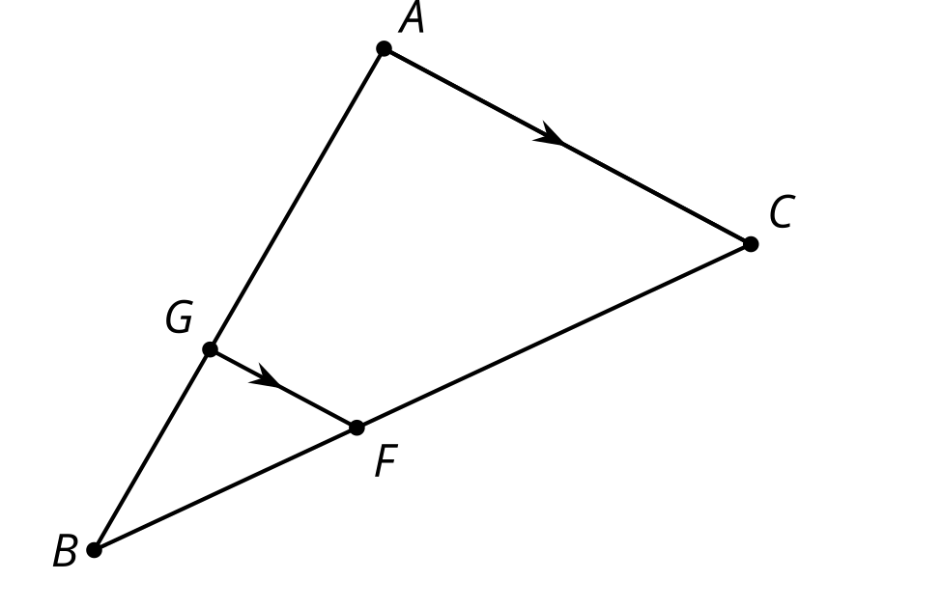
© CC BY 2019 by Illustrative Mathematics®

