Lesson 13: More Standard Deviation
- Let’s continue to interpret standard deviation.

13.1: Math Talk: Outlier Math
Evaluate mentally.
$0.5⋅30$
$1.5⋅30$
$100−1.5⋅30$
$100−1.5⋅18$

13.2: Info Gap: African and Asian Elephants
Your teacher will give you either a problem card or a data card. Do not show or read your card to your partner.
If your teacher gives you the data card:
- Silently read the information on your card.
- Ask your partner “What specific information do you need?” and wait for your partner to ask for information. Only give information that is on your card. (Do not figure out anything for your partner!)
- Before telling your partner the information, ask “Why do you need to know (that piece of information)?”
- Read the problem card, and solve the problem independently.
- Share the data card, and discuss your reasoning.
If your teacher gives you the problem card:
- Silently read your card and think about what information you need to answer the question.
- Ask your partner for the specific information that you need.
- Explain to your partner how you are using the information to solve the problem.
- When you have enough information, share the problem card with your partner, and solve the problem independently.
- Read the data card, and discuss your reasoning.

13.3: Interpreting Measures of Center and Variability
For each situation, you are given two graphs of data, a measure of center for each, and a measure of variability for each.
- Interpret the measure of center in terms of the situation.
- Interpret the measure of variability in terms of the situation.
- Compare the two data sets.
- The heights of the 40 trees in each of two forests are collected.

- mean: 44.8 feet, standard deviation: 4.72 feet
- 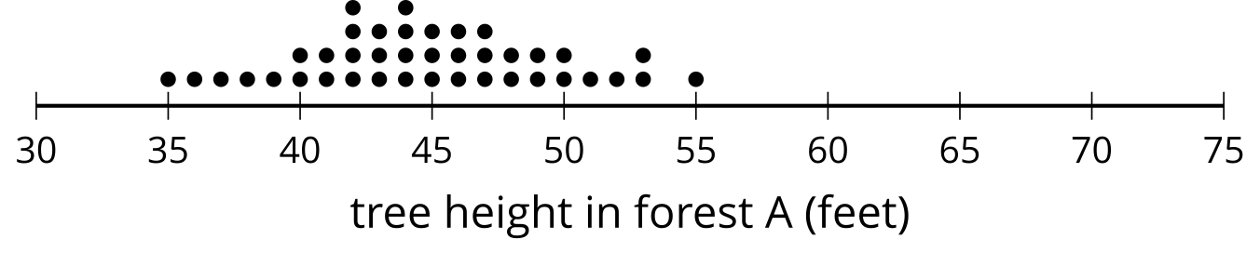

- mean: 56.03 feet, standard deviation: 7.87 feet
- 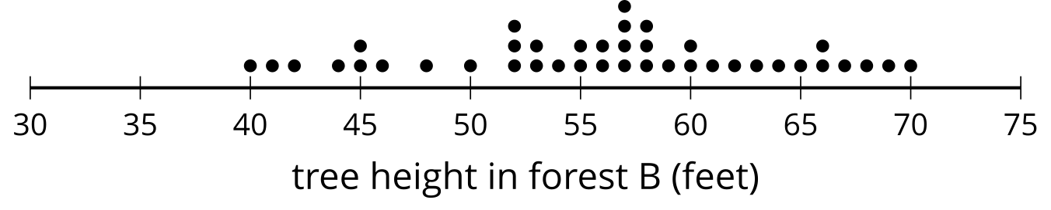
- The number of minutes it takes Lin and Noah to finish their tests in German class is collected for the year.

- mean: 29.48 minutes, standard deviation: 5.44 minutes
- 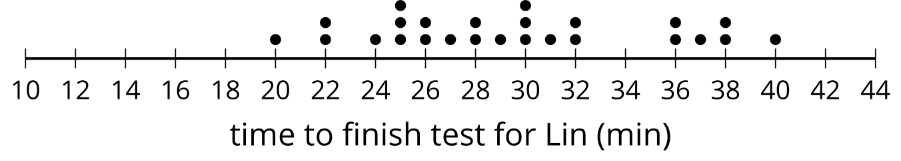

- mean: 28.44 minutes, standard deviation: 7.40 minutes
- 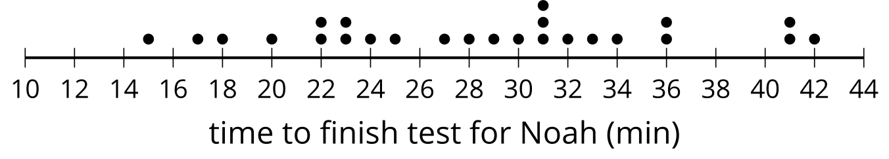
- The number of raisins in a cereal with a name brand and the generic version of the same cereal are collected for several boxes.

- mean: 289.1 raisins, standard deviation: 19.8 raisins
- 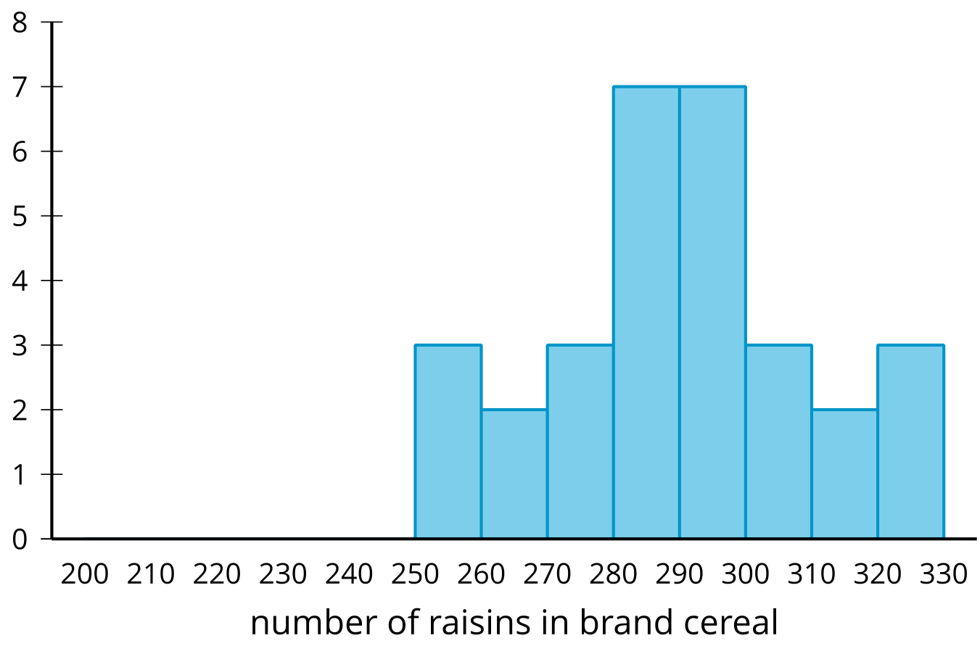

- mean: 249.17 raisins, standard deviation: 26.35 raisins
- 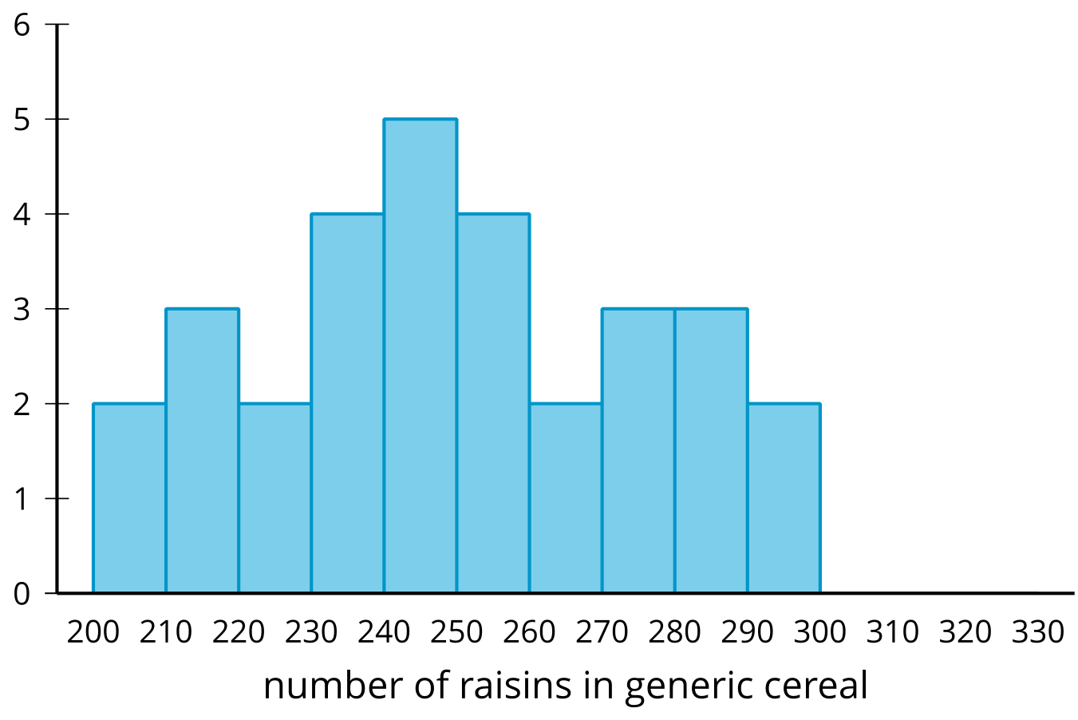

Are you ready for more?
One use of standard deviation is it gives a natural scale as to how far above or below the mean a data point is. This is incredibly useful for comparing points from two different distributions.
For example, they say you cannot compare apples and oranges, but here is a way. The average weight of a granny smith weighs 128 grams with a standard deviation of about 10 grams. The average weight of a navel orange is 140 grams with a standard deviation of about 14 grams. If we have a 148 gram granny smith apple and a 161 gram navel orange, we might wonder which is larger for its species even though they are both about 20 grams above their respective mean. We could say that the apple, which is 2 standard deviations above its mean, is larger for its species than the orange, which is only 1.5 standard deviations above its mean.
- How many standard deviations above the mean height of a tree in forest A is its tallest tree?
- How many standard deviations above the mean height of a tree in forest B is its tallest tree?
- Which tree is taller in its forest?

Lesson 13 Summary
The more variation a distribution has, the greater the standard deviation. A more compact distribution will have a lesser standard deviation.
The first dot plot shows the number of points that a player on a basketball team made during each of 15 games. The second dot plot shows the number of points scored by another player during the same 15 games.
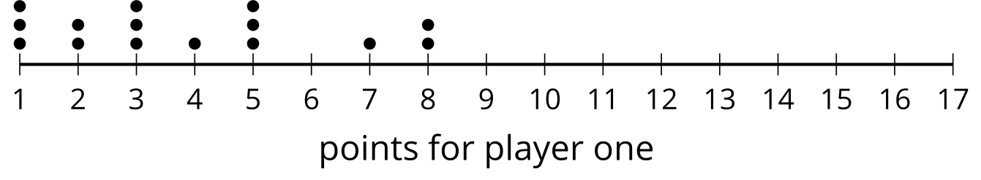
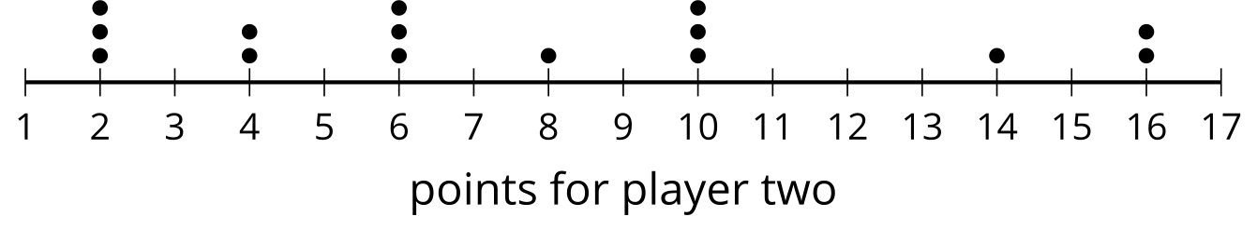
The data in the first plot has a mean of approximately 3.87 points and standard deviation of about 2.33 points. The data in the second plot has a mean of approximately 7.73 points and a standard deviation of approximately 4.67 points. The second distribution has greater variability than first distribution because the data is more spread out. This is shown in the standard deviation for the second distribution being greater than the standard deviation for the first distribution.
Standard deviation is calculated using the mean, so it makes sense to use it as a measure of variability when the mean is appropriate to use for the measure of center. In cases where the median is a more appropriate measure of center, the interquartile range is still a better measure of variability than standard deviation.
© CC BY 2019 by Illustrative Mathematics®

