Lesson 20: Rational Equations (Part 1)
- Let’s write and solve some rational equations.

20.1: Notice and Wonder: Denominators and Solutions
What do you notice? What do you wonder?
A: $\frac{2x+5}{x}=\frac{7x−5}{x}$, $x=2$
B: $2x+5=7x−5$, $x=2$
C: $\frac{2x^{2}+3}{x+2}=\frac{4x+1}{x+2}$, $x=1$
D: $2x^{2}+3=4x+1$, $x=1$

20.2: Rationalizing the Price of T-shirts
The school art club at a large high school is in charge of designing school T-shirts and getting them printed this year. A local business charges $35 to set up their T-shirt printing machine with the design and $4.25 in materials per T-shirt to print.
- Create an equation to represent the average cost $C\left(x\right)$, in dollars, per T-shirt if $x$ T-shirts are printed by this business.
- What is the average cost per shirt to print 25 shirts? 100 shirts?
- What is the cheapest the average cost per T-shirt will get? Explain or show your reasoning.
- How many shirts should be printed to have an average cost of $5 or less per shirt? Explain how you know.

20.3: Batting Averages
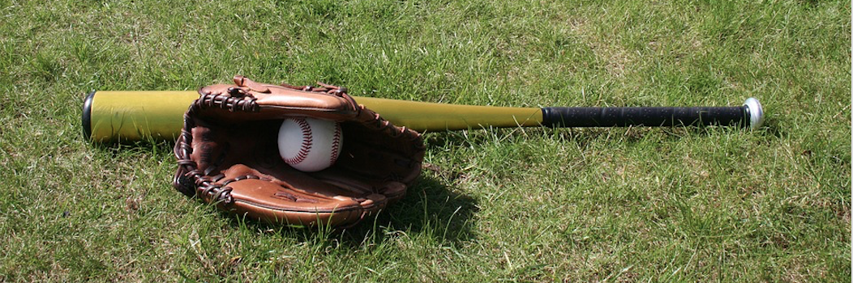
Tyler is on a school baseball team and he has had 24 base hits out of 110 at bats this year.
- What is his current batting average?
- He wants to raise his batting average to .300. How many of the next consecutive at bats need to be base hits to raise his batting average to .300? Write and solve an equation to describe this situation using $x$ for the number of consecutive base hits. Be prepared to explain how you wrote your equation and each of your solving steps.
- Unfortunately, Tyler gets no base hits in his next three at bats. Revise your equation and then calculate how many of his next consecutive at bats need to be base hits to raise his batting average to .300. Be prepared to explain how you revised your equation and each of your solving steps.

Are you ready for more?
Elena had 24 base hits in 110 at bats. She has done a lot of practice and now thinks that for all of her future at bats in this season, she will have a batting average of 0.350. If she does, then how many more at bats will Elena need so that with this average, she reaches a 0.300 batting average overall for the whole season?

Lesson 20 Summary
Consider a student on a school softball team who wants to raise her batting average to .200. So far this year, she has 20 base hits out of 120 at bats, making her current batting average .167 since $\frac{20}{120}=0.167$.
To increase her batting average, she needs to have more base hits. But each base hit means the number of at bats also increases by 1. Since batting average is the number of base hits divided by the number of at bats, we can use the rational expression $\frac{20+x}{120+x}$ to model how her batting average changes based on the number of consecutive base hits $x$ she gets. Her batting average is the value of this expression to 3 decimal places. The value of $x$ that makes this expression equal to .200 will tell us how many consecutive base hits she needs to get the batting average she wants.
$\begin{matrix}.200 & =\frac{20+x}{120+x} \\ .200⋅\left(120+x\right) & =\frac{20+x}{120+x}⋅\left(120+x\right) \\ 0.2\left(120+x\right) & =20+x \\ 24+0.2x & =20+x \\ 4 & =0.8x \\ 5 & =x\end{matrix}$
Even though we started out with a rational expression on the right side of the equation, multiplying each side by $\left(120+x\right)$ resulted in an equation similar to ones we have solved before. Checking $x=5$ in our original expression, $\frac{20+5}{120+5}=\frac{25}{125}=.2$, so she needs 5 consecutive base hits to have a batting average of .200.
© CC BY 2019 by Illustrative Mathematics®

