Lesson 4: Dilating Lines and Angles
- Let’s dilate lines and angles.

4.1: Angle Articulation
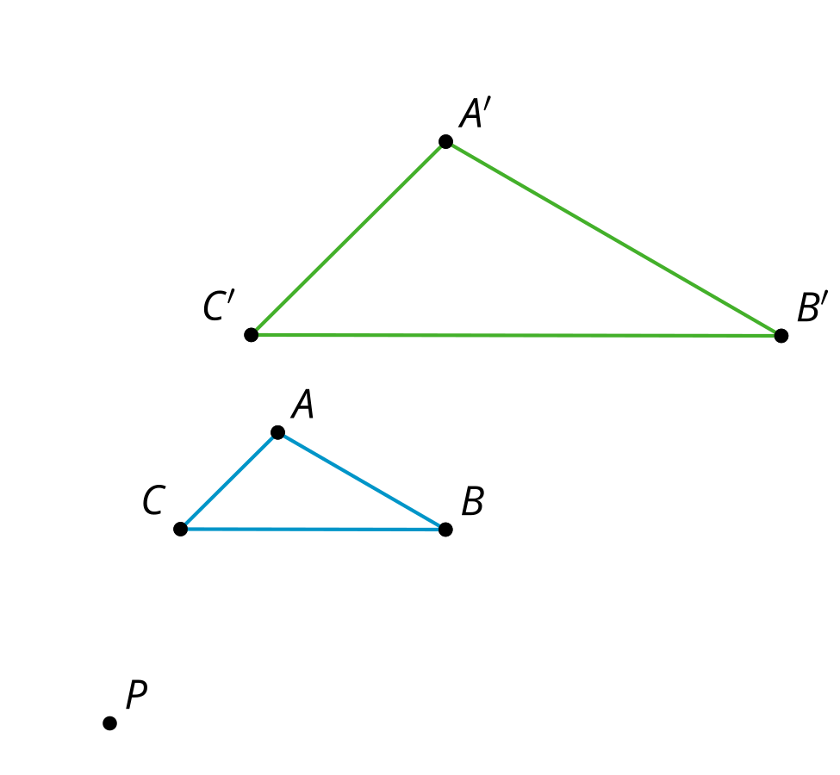
Triangle $A^{′}B^{′}C^{′}$ is a dilation of triangle $ABC$ using center $P$ and scale factor 2.
- What do you think is true about the angles in $A^{′}B^{′}C^{′}$ compared to the angles in $ABC$?
- Use the tools available to figure out if what you thought was true is definitely true for these triangles.
- Do you think it would be true for angles in any dilation?

4.2: Dilating Lines
- Dilate point $A$ using center $C$ and scale factor $\frac{3}{4}$.
- Dilate point $B$ using center $C$ and scale factor $\frac{1}{3}$.
- Dilate point $D$ using center $C$ and scale factor $\frac{3}{2}$.
- Dilate line $CE$ using center $C$ and scale factor 2.
- What happens when the center of dilation is on a line and then you dilate the line?
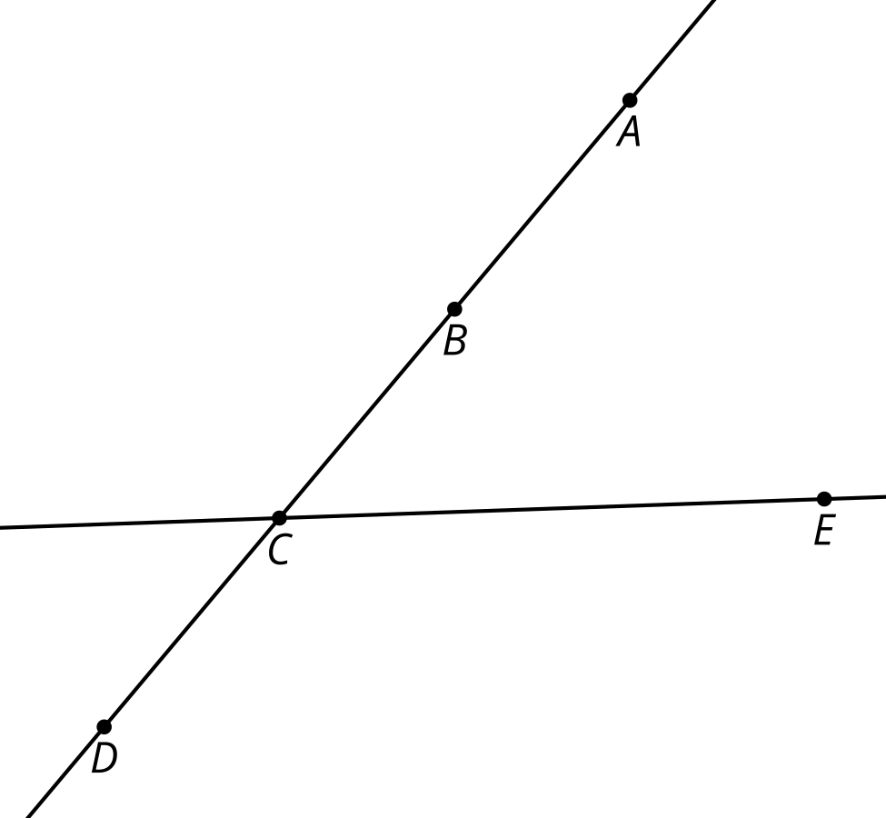

Are you ready for more?
- $X$ is the midpoint of $AB$.
- $B^{′}$ is the image of $B$ after being dilated by a scale factor of 0.5 using center $C$.
- $A^{′}$ is the image of $A$ after being dilated by a scale factor of 0.5 using center $C$.
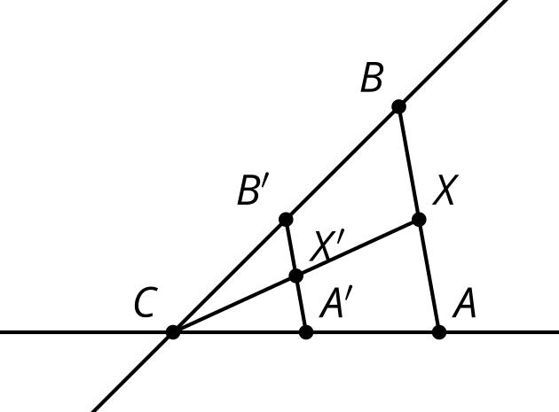
Call the intersection of $CX$ and $A^{′}B^{′}$ point $X^{′}$. Is point $X^{′}$ a dilation of point $X$? Explain or show your reasoning.

4.3: Proof in Parallel
Jada dilated triangle $ABC$ using center $P$ and scale factor 2.
- Jada claims that all the segments in $ABC$ are parallel to the corresponding segments in $A^{′}B^{′}C^{′}$. Write Jada's claim as a conjecture.
- Prove your conjecture.
- In Jada’s diagram the scale factor was greater than one. Would your proof have to change if the scale factor was less than one?

Lesson 4 Summary
When one figure is a dilation of the other, we know that corresponding side lengths of the original figure and dilated image are in the same proportion, and are all related by the same scale factor, $k$. What is the relationship of corresponding angles in the original figure and dilated image?
For example, if triangle $ABC$ is dilated using center $P$ with scale factor 2, we can verify experimentally that each angle in triangle $ABC$ is congruent to its corresponding angle in triangle $A^{′}B^{′}C^{′}$. $∠A≅∠A^{′},∠B≅∠B^{′},∠C≅∠C^{′}$.
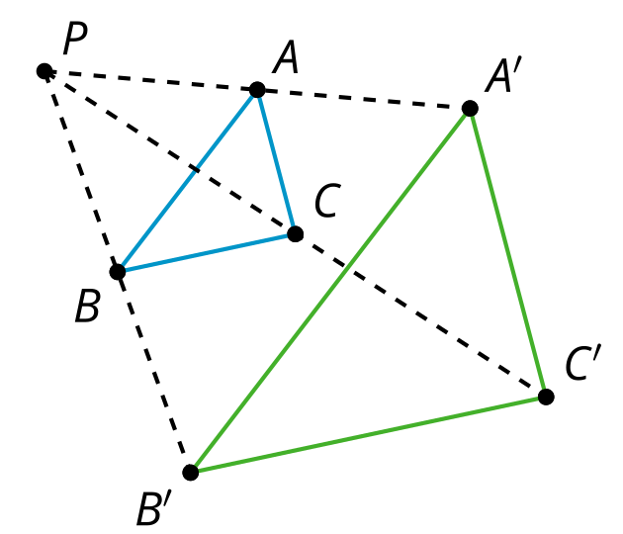
What is the image of a line not passing through the center of dilation? For example, what will be the image of line $BC$ when it is dilated with center $P$ and scale factor 2? We can use congruent corresponding angles to show that line $BC$ is taken to parallel line $B^{′}C^{′}$.
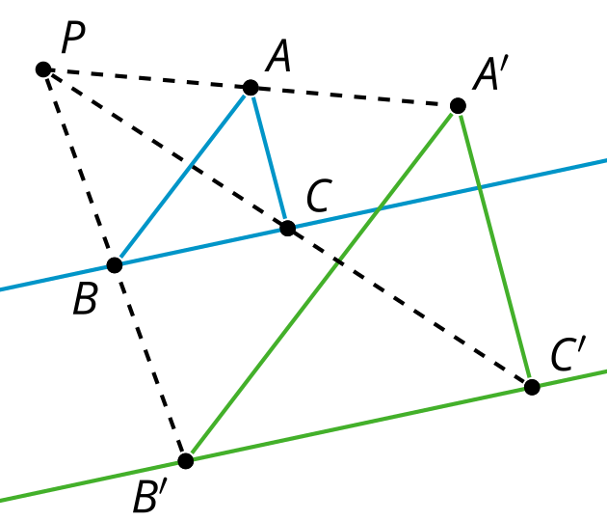
What is the image of a line passing through the center of dilation?
For example, what will be the image of line $GH$ when it is dilated with center $C$ and scale factor $\frac{1}{2}$? When line $GH$ is dilated with center $C$ and scale factor $\frac{1}{2}$, line $GH$ is unchanged, because dilations take points on a line through the center of a dilation to points on the same line, by definition.
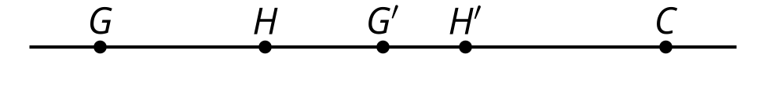
So, a dilation takes a line not passing through the center of the dilation to a parallel line, and leaves a line passing through the center unchanged.
© CC BY 2019 by Illustrative Mathematics®

