Lesson 13 Practice Problems
- Here is a graph of $p$, an insect population, $w$ weeks after it was first measured. The population grows exponentially.
  - What is the weekly factor of growth for the insect population?
  - What was the population when it was first measured?
  - Write an equation relating $p$ and $w$.
- 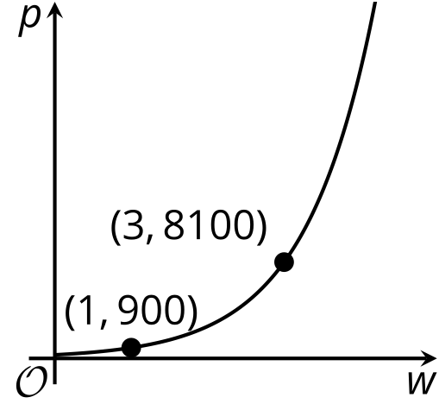
- Here is a graph of the function $f$ defined by $f\left(x\right)=a⋅b^{x}$.
- Select all possible values of $b$.
- 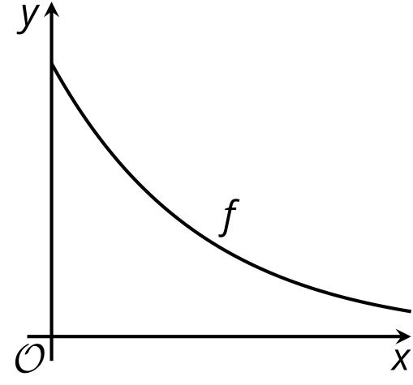
  - 0
  - $\frac{1}{10}$
  - $\frac{1}{2}$
  - $\frac{9}{10}$
  - 1
  - 1.3
  - $\frac{18}{5}$
- The function $f$ is given by $f\left(x\right)=50⋅{\left(\frac{1}{2}\right)}^{x}$, and the function $g$ is given by $g\left(x\right)=50⋅{\left(\frac{1}{3}\right)}^{x}$.
- Here are graphs of $f$ and $g$.
- Kiran says that since $3>2$, the graph of $g$ lies above the graph of $f$ so graph 1 is the graph of $g$ and graph 2 is the graph of $f$.
- Do you agree? Explain your reasoning.
- 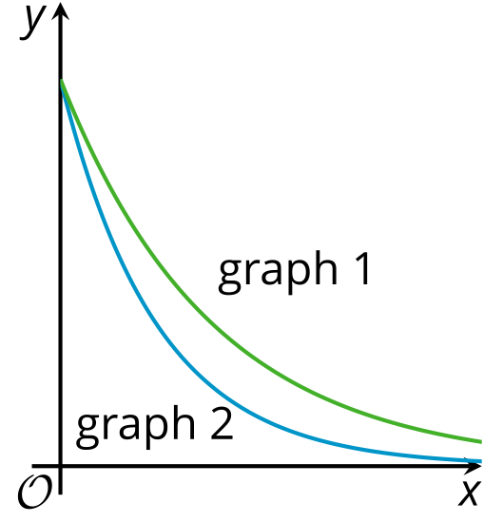
- The function $f$ is defined by $f\left(x\right)=50⋅3^{x}$. The function $g$ is defined by $g\left(x\right)=a⋅b^{x}$.
- Here are graphs of $f$ and $g$.
  - How does $a$ compare to 50? Explain how you know.
  - How does $b$ compare to 3? Explain how you know.
- 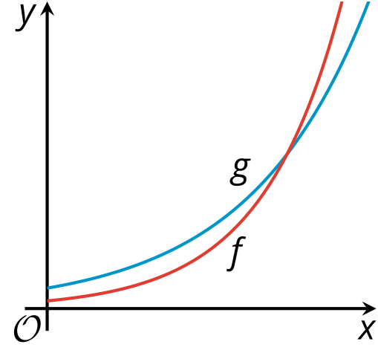
- Technology required. The equation $y=600,​000⋅{\left(1.055\right)}^{t}$ represents the population of a country $t$ decades after the year 2000.
- Use graphing technology to graph the equation. Then, set the graphing window so that you can simultaneously see points on the graph representing the population predicted by the model in 1980 and in the year 2020. What graphing window did you use?
- (From Unit 5, Lesson 7.)
- The dollar value of a car is a function, $f$, of the number of years, $t$, since the car was purchased. The function is defined by the equation $f\left(t\right)=12,​000⋅{\left(\frac{3}{4}\right)}^{t}$ .
  - How much was the car worth when it was purchased? Explain how you know.
  - What is $f\left(2\right)$? What does this tell you about the car?
  - Sketch a graph of the function $f$.
  - About when was the car worth $6,000? Explain how you know.
- (From Unit 5, Lesson 9.)
- A ball was dropped from a height of 150 cm. The rebound factor of the ball is 0.8. About how high, in centimeters, did the ball go after the third bounce?
  - 77
  - 96
  - 234
  - 293
- (From Unit 5, Lesson 11.)
- A triathlon athlete runs at an average rate of 8.2 miles per hour, swims at an average rate of 2.4 miles per hour, and bikes at an average rate of 16.1 miles per hour. At the end of one training session (during which she did not run), she has swum and biked more than 20 miles in total.
  - Is it possible that she swam and biked for the following amounts of time in that session? Show your reasoning.
    - Swam for 0.5 hour and biked 1.25 hours
    - Swam for $\frac{1}{3}$ hour and biked for 70 minutes
  - Write an inequality to represent the relationship between the time she swam and biked, in hours, and the total distance she traveled. Be sure to specify what each variable represents.
  - Use your inequality to graph a solution set that represents all the possible combinations of swimming and running times that meet the distance constraint (regardless of whether the times are realistic).
  - 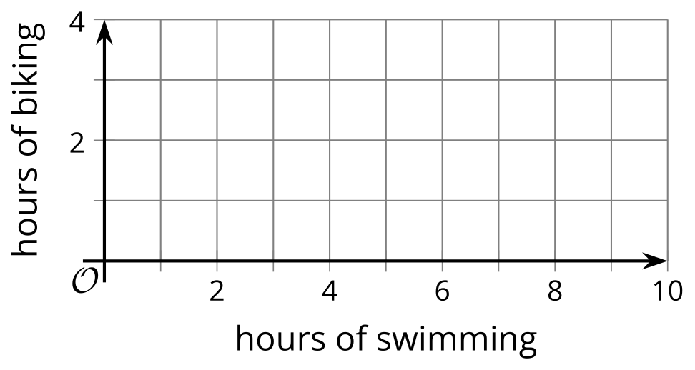
- (From Unit 2, Lesson 22.)
© CC BY 2019 by Illustrative Mathematics®

