Lesson 12: Standard Deviation
- Let’s learn about standard deviation, another measure of variability.

12.1: Notice and Wonder: Measuring Variability
What do you notice? What do you wonder?

mean: 10, MAD: 1.56, standard deviation: 2
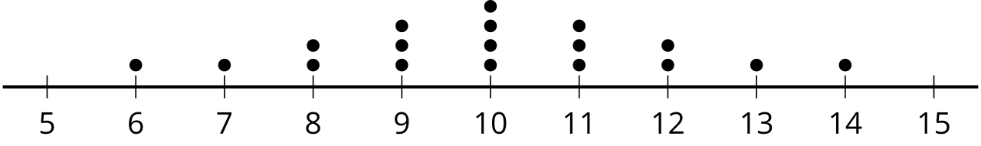

mean: 10, MAD: 2.22, standard deviation: 2.58
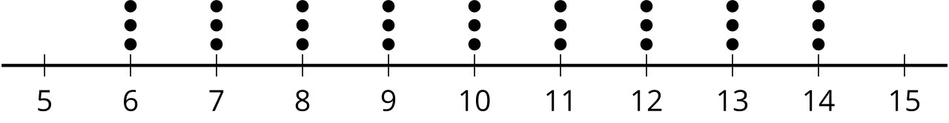
​​​​​​

mean: 10, MAD: 2.68, standard deviation: 2.92
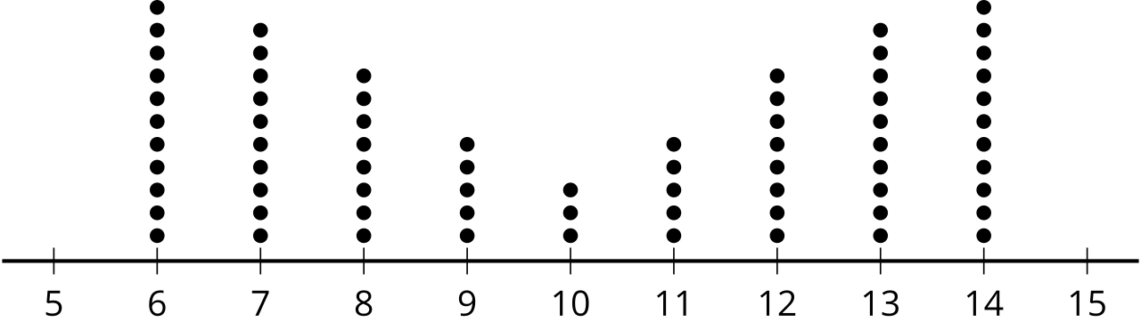

mean: 10, MAD: 1.12, standard deviation: 1.61
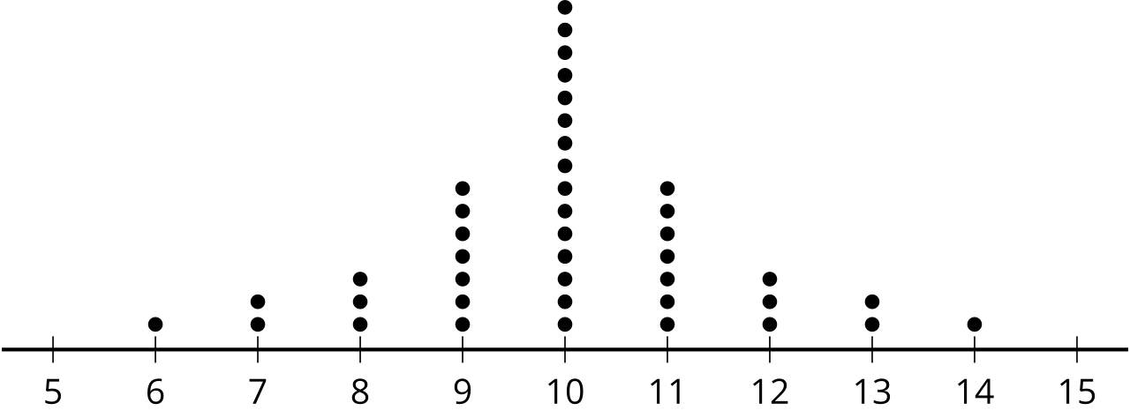

mean: 10, MAD: 2.06, standard deviation: 2.34
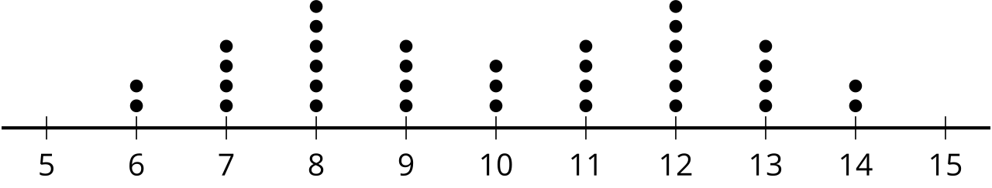

mean: 10, MAD: 0, standard deviation: 0
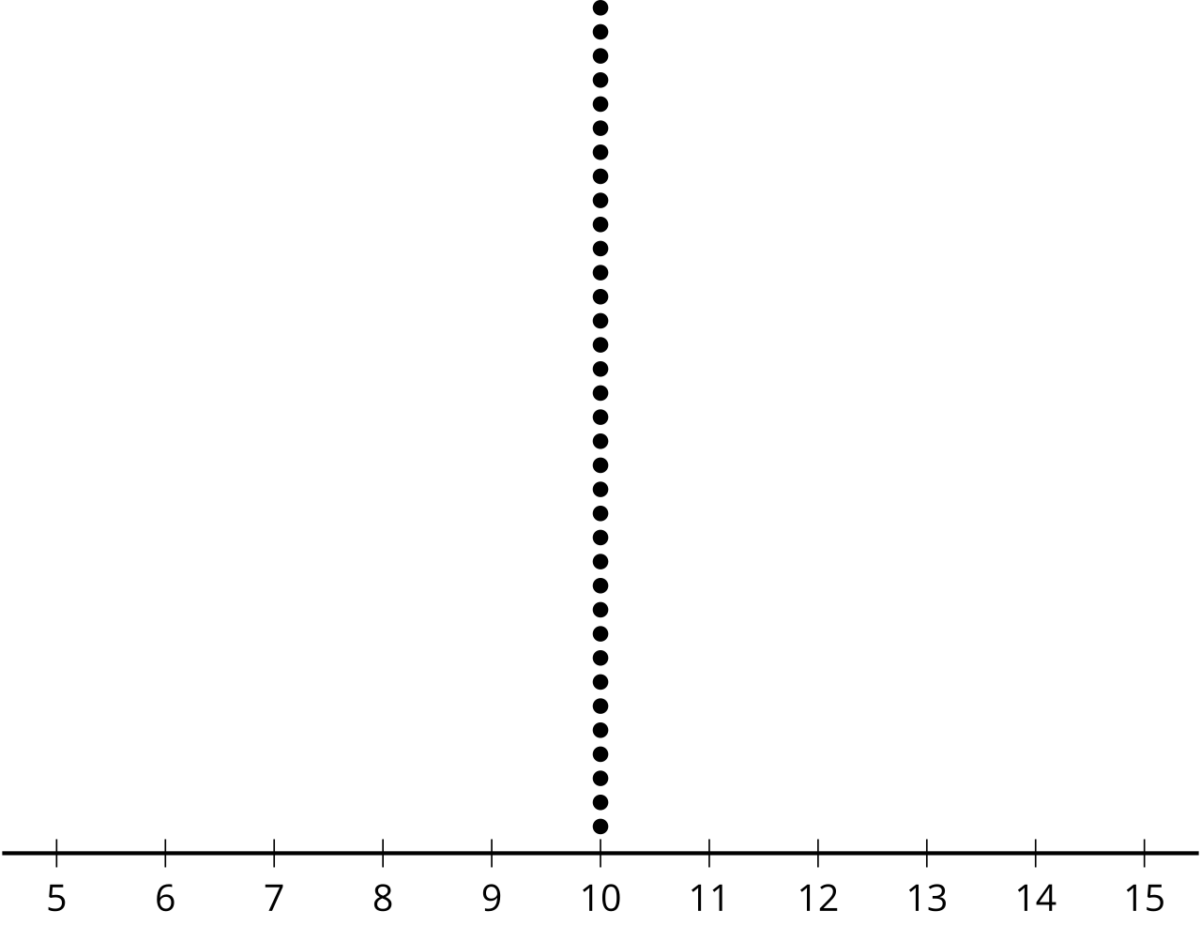

12.2: Investigating Standard Deviation
Use technology to find the mean and the standard deviation for the data in the dot plots.
- What do you notice about the mean and standard deviation you and your partner found for the three dot plots?
- Invent some data that fits the conditions. Be prepared to share your data set and reasoning for choice of values.
Partner 1
​Partner 2
Dot plots:
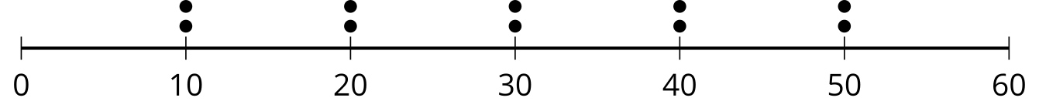
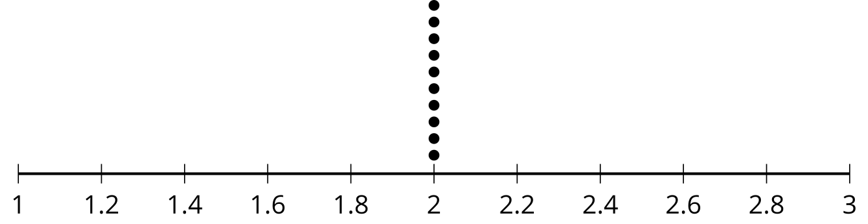
Dot plots:
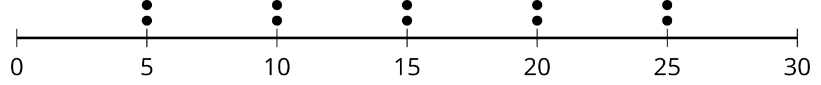
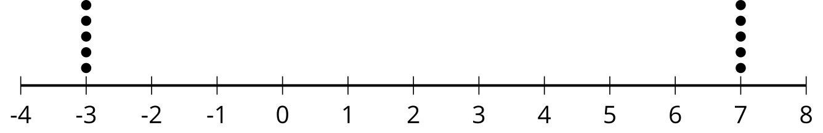
​​​​​​
Conditions:
- 10 numbers with a standard deviation equal to the standard deviation of your first dot plot with a mean of 6.
- 10 numbers with a standard deviation three times greater than the data in the first row.
- 10 different numbers with a standard deviation as close to 2 as you can get in 1 minute.
Conditions:
- 10 numbers with a standard deviation equal to the standard deviation of your first dot plot with a mean of 12.
- 10 numbers with a standard deviation four times greater than the data in the first row.
- 10 different numbers with a standard deviation as close to 2 as you can get in 1 minute.

12.3: Investigating Variability
Begin with the data:
1, 2, 3, 4, 5, 6, 7, 8, 9, 10, 11, 12, 13, 14, 15, 16, 17, 18, 19, 20
- Use technology to find the mean, standard deviation, median, and interquartile range.
- How do the standard deviation and mean change when you remove the greatest value from the data set? How do they change if you add a value to the data set that is twice the greatest value?
- What do you predict will happen to the standard deviation and mean when you remove the least value from the data set? Check to see if your prediction was correct.
- What happens to the standard deviation and mean when you add a value to the data set equal to the mean? Add a second value equal to the mean. What happens?
- Add, change, and remove values from the data set to answer the question: What appears to change more easily, the standard deviation or the interquartile range? Explain your reasoning.

Are you ready for more?
How is the standard deviation calculated? We have seen that the standard deviation behaves a lot like the mean absolute deviation and that is because the key idea behind both is the same.
- Using the original data set, calculate the deviation of each point from the mean by subtracting the mean from each data point.
- If we just tried to take a mean of those deviations what would we get?
- There are two common ways to turn negative values into more useful positive values: take the absolute value or square the value. To find the MAD we find the absolute value of each deviation, then find the mean of those numbers. To find the standard deviation we square each of the deviations, then find the mean of those numbers. Then finally take the square root of that mean. Compute the MAD and the standard deviation of the original data set.

Lesson 12 Summary
We can describe the variability of a distribution using the standard deviation. The standard deviation is a measure of variability that is calculated using a method that is similar to the one used to calculate the MAD, or mean absolute deviation.
A deeper understanding of the importance of standard deviation as a measure of variability will come with a deeper study of statistics. For now, know that standard deviation is mathematically important and will be used as the appropriate measure of variability when mean is an appropriate measure of center.
Like the MAD, the standard deviation is large when the data set is more spread out, and the standard deviation is small when the variability is small. The intuition you gained about MAD will also work for the standard deviation.
© CC BY 2019 by Illustrative Mathematics®

