Lesson 6: Connecting Similarity and Transformations
- Let’s identify similar figures.

6.1: Dilation Miscalculation
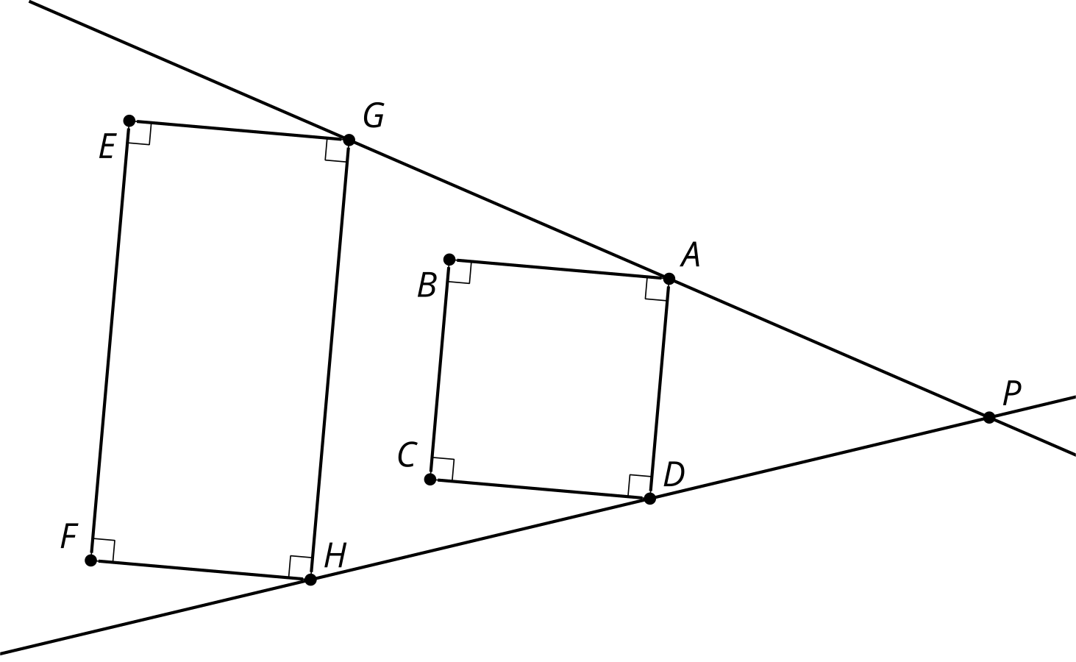
What’s wrong with this dilation? Why is $GHFE$ not a dilation of $ADCB$?

6.2: Card Sort: Not-So-Rigid Transformations
- Your teacher will give you a set of cards. Sort the cards into categories of your choosing. Be prepared to explain the meaning of your categories.
- Your teacher will assign you one card. Write the sequence of transformations (translation, rotation, reflection, dilation) to take one figure to the other.
- For all the cards that could include a dilation, what scale factor is used to go from Figure $F$ to Figure $G$? What scale factor is used to go from Figure $G$ to Figure $F$?

Are you ready for more?
Find a sequence of transformations that takes Figure $G$ to Figure $F$. How does this sequence compare to the sequence that took Figure $F$ to Figure $G$?

6.3: Alphabet Soup
Are the triangles similar?

$\overset{¯}{AB}∥\overset{¯}{QR},\overset{¯}{AB}⊥\overset{¯}{AE},\overset{¯}{QR}⊥\overset{¯}{QT}$
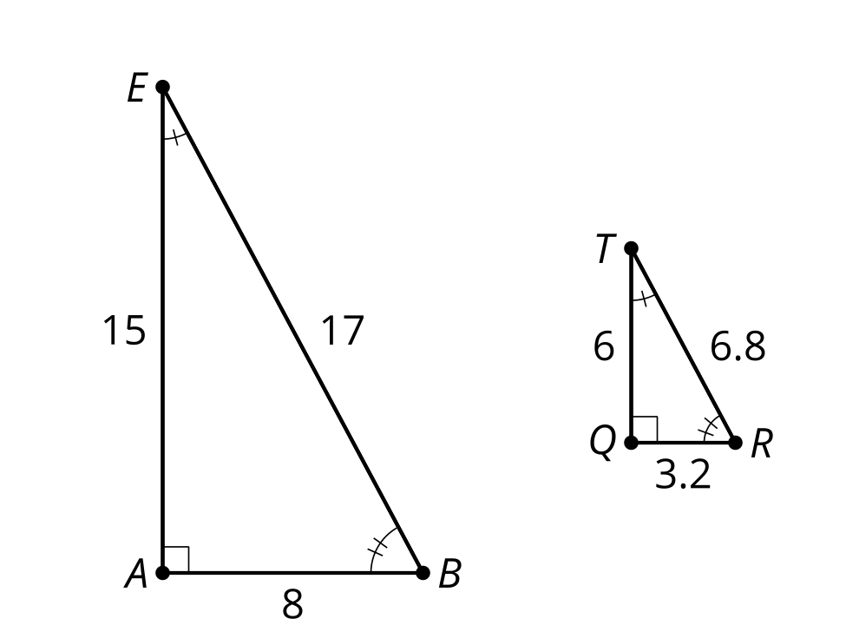
- Write a sequence of transformations (dilation, translation, rotation, reflection) to take one triangle to the other.
- Write a similarity statement about the 2 figures, and explain how you know they are similar.
- Compare your statement with your partner’s statement. Is there more than one correct way to write a similarity statement? Is there a wrong way to write a similarity statement?

Lesson 6 Summary
One figure is similar to another if there is a sequence of rigid motions and dilations that takes the first figure so that it fits exactly over the second. For example, triangle $DHF$ is similar to triangle $EHG$. What is a rotation and a dilation that will take $DHF$ onto $EHG$?
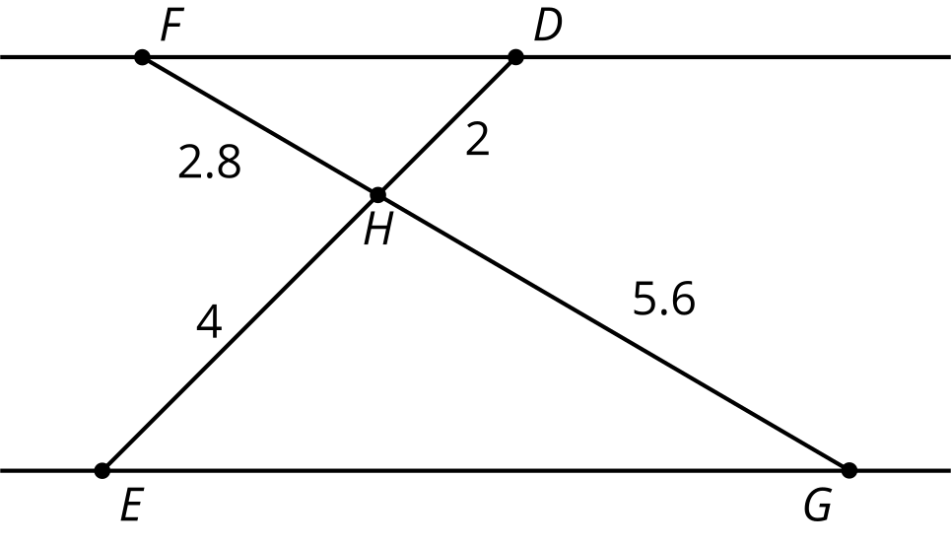
The triangles are similar because a ${180}^{∘}$ rotation of $DHF$ using center $H$ will take segment $HF$ onto segment $HG$, since ${180}^{∘}$ rotations take lines through the center of the rotation to themselves. It will also take $HD$ onto $HE$ for the same reason. Then $G$ will be on a ray from $H$ through $F^{′}$, and $E$ will be on a ray from $H$ through $D^{′}$. Since $\frac{H^{′}F^{′}}{HG}=\frac{H^{′}D^{′}}{HE}=\frac{1}{2}$, a dilation by a scale factor of 2 will take $D^{′}H^{′}F^{′}$ onto $EHG$, which means there is a sequence of rigid motions and dilations that takes $DHF$ onto $EHG$.
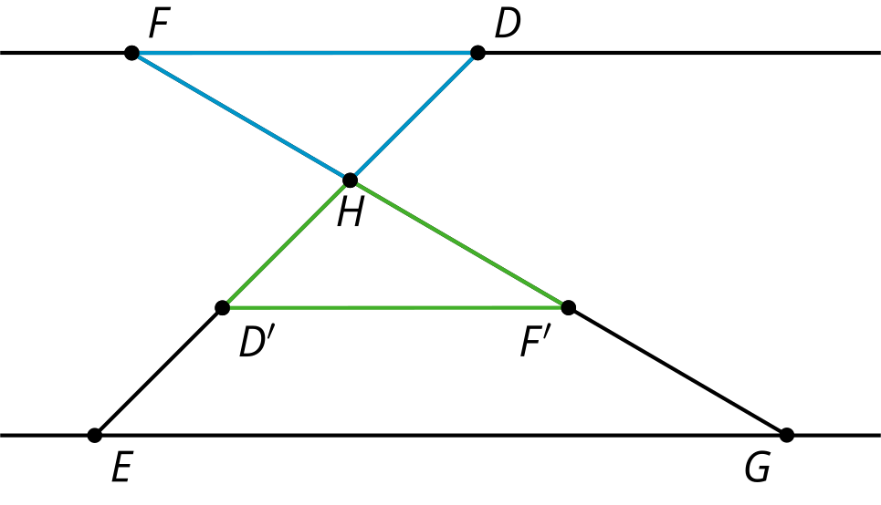
Since similar figures are the result of rigid motions and dilations, in similar figures, all pairs of corresponding angles are congruent, and the lengths of all pairs of corresponding sides are in the same proportion. Angle $D$ is congruent to angle $E$. Angle $F$ is congruent to angle $G$. Angle $DHF$ is congruent to angle $EHG$. And $\frac{HD}{HE}$=$\frac{HF}{HG}$=$\frac{DF}{EG}$.
We use $∼$ as a symbol for is similar to, so we read $△DHF∼△EHG$ as “triangle $DHF$ is similar to triangle $EHG$.”
© CC BY 2019 by Illustrative Mathematics®

