Lesson 2: Scale of the Solar System
- Let’s dilate figures.

2.1: Solar Eclipse

NOT TO SCALE
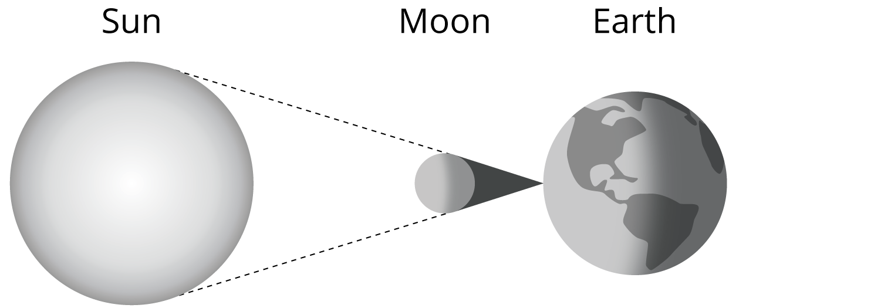
The diameter of the Sun is 1,391,000 km. The diameter of the Moon is 3,475 km. The distance from Earth to the Sun is 149,600,000 km.
How far would the Moon have to be from Earth for the Moon to appear the same size as the Sun?

2.2: Shrinking the Solar System
The class is going to make a scale drawing of the planets in the solar system and their distances from Earth. Your teacher will assign you a planet to draw and place on the scale drawing. A circle with a diameter of 2 cm represents Earth.
- What information do you need in order to draw your planet and place it accurately on the class’s scale drawing?
- Your teacher will give you some information. Record the information here. Calculate any additional information you need.
- Draw the scale drawing of your planet on a separate sheet of blank paper. Label it with measurements. When you’re finished, place it the correct distance from Earth on the class’s scale drawing.
- You probably weren’t able to place your planet the correct scaled distance from Earth. Why not?

Are you ready for more?
- What has the greater quotient: the radius of Earth compared to the Sun or the radius of the Sun compared to the radius of the star Betelgeuse?
- If a circle of radius 6 cm represents the star Betelgeuse, how large would the Sun be? How large would the earth be?
- Draw the scale drawing of the Sun and Earth, or explain why you can't.

2.3: Shrinking the Solar System, Take 2
Imagine that Earth is about the size of the period at the end of this sentence. That’s a diameter of 0.3 mm.
- How big is the scaled version of your planet now?
- How far from Earth is it?
- Can the scale drawing of the solar system fit in the classroom now?

Lesson 2 Summary
To make a scaled copy of this figure so that its new height is 3 cm instead of 8 cm, we could start calculating what the lengths of different parts of the figure would be. One way to calculate the measurements of the scaled copy is to multiply every length in the original figure by the scale factor $\frac{3}{8}$ to find the corresponding length in the scaled copy. For example, the radius of the head is 1.3 cm. $1.3⋅\frac{3}{8}≈0.5$ so the radius of the scaled head is about 0.5 cm.
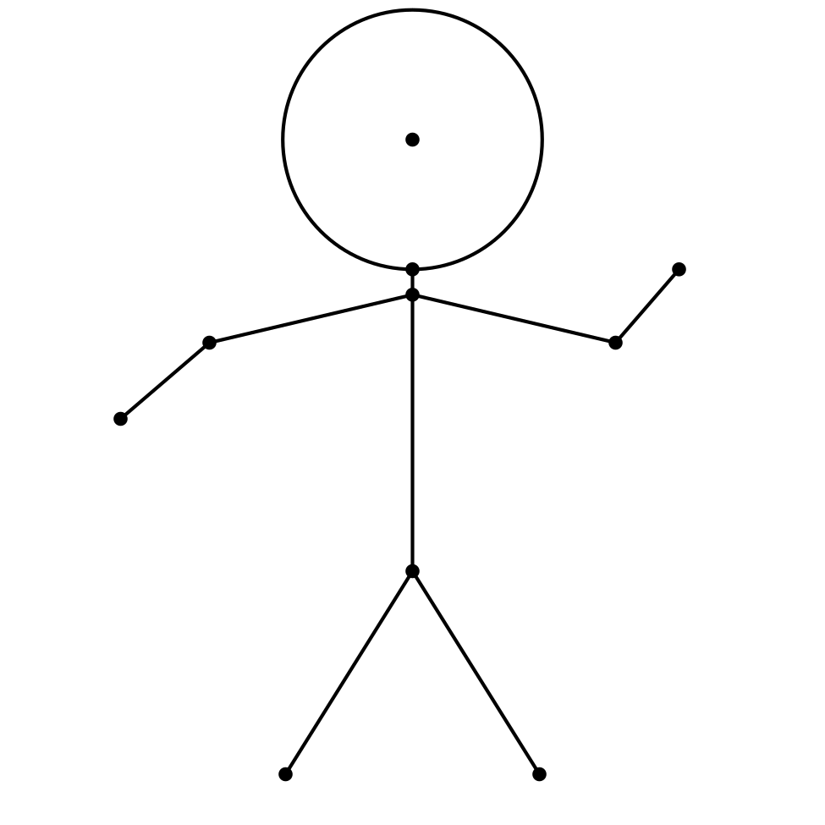
The length of segment $AB$ is 2.4 cm. How long is segment $A^{′}B^{′}$? Instead of multiplying by the scale factor we could use equivalent ratios. Since $\frac{A^{′}B^{′}}{AB}=\frac{3}{8}$ then $\frac{A^{′}B^{′}}{2.4}=\frac{3}{8}$. So $A^{′}B^{′}$ is 0.9 cm.
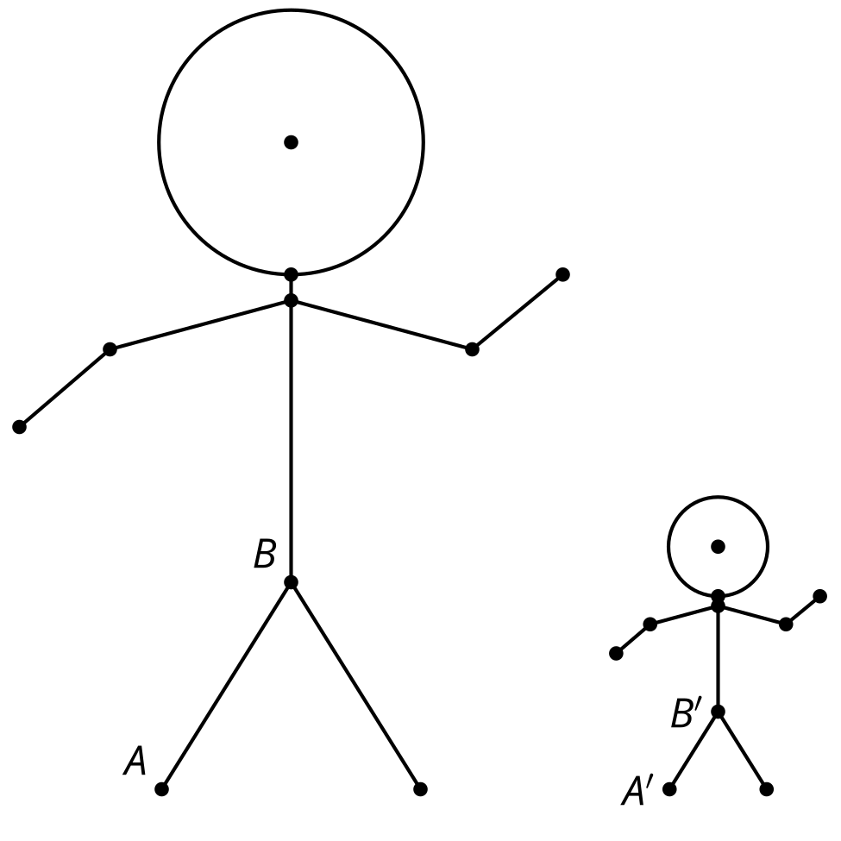
© CC BY 2019 by Illustrative Mathematics®

