Lesson 11 Practice Problems
- Here is an image showing the highest point of the path of a ball after one bounce.
- Someone is collecting data to model the bounce height of this ball after each bounce. Which measurement for the location of the top of the ball would be the best one to record?
- 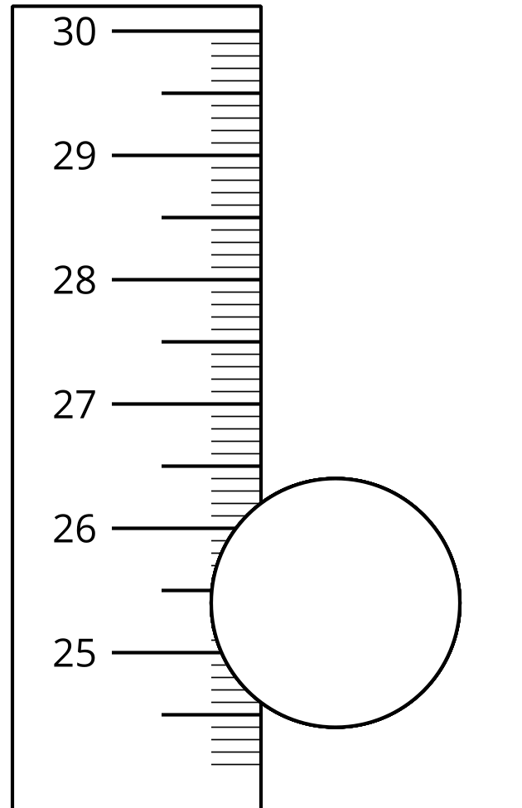
  - 26 cm
  - 26.4 cm
  - 26.43 cm
  - 26.431 cm
- Function $h$ describes the height of a ball, in inches, after $n$ bounces and is defined by the equation $h\left(n\right)=120⋅{\left(\frac{4}{5}\right)}^{n}$.
  - What is $h\left(3\right)$? What does it represent in this situation?
  - Could $h\left(n\right)$ be 150? Explain how you know.
  - Which ball loses its height more quickly, this ball or a tennis ball whose height in inches after $n$ bounces is modeled by the function $f$ where $f\left(n\right)=50⋅{\left(\frac{5}{9}\right)}^{n}$?
  - How many bounces would it take before the ball bounces less than 12 inches from the surface?
- After its second bounce, a ball reached a height of 80 cm. The rebound factor for the ball was 0.7. From approximately what height, in cm, was the ball dropped?
  - 34
  - 49
  - 115
  - 163
- Which equation is most appropriate for modeling this data?
- $x$ | - 1 | - 2 | - 3 | - 4 | - 5 | - 6
- $y$ | - 79 | - 101 | - 124 | - 158 | - 195 | - 244
  - $y=64⋅{\left(1.25\right)}^{x}$
  - $y=79⋅{\left(1.25\right)}^{x}$
  - $y=79+1.25x$
  - $y=64+22x$
- The table shows the number of employees and number of active customer accounts for some different marketing companies.
- number of employees | - 1 | - 2 | - 3 | - 4 | - 10
- number of customers | - 4 | - 8 | - 13 | - 17 | - 39
- Would a linear or exponential model for the relationship between number of employees and number of customers be more appropriate? Explain how you know.
- A bank account has a balance of 1,000 dollars. It grows by a factor of $1.04$ each year.
  - Explain why the balance, in dollars, is a function, $f$, of the number of years, $t$, since the account was opened.
  - Write an equation defining $f$.
- (From Unit 5, Lesson 8.)
- The table shows the number of people, $n$, who went to see a musical on the $d^{th}$ day of April.
  - What is the average rate of change for the number of people from day 1 to day 7?
  - Is the average rate of change a good measure for how the number of people changed throughout the week? Explain your reasoning.
- $d$ | - $n$
- 1 | - 1,534
- 2 | - 2,324
- 3 | - 2,418
- 4 | - 2,281
- 5 | - 2,350
- 6 | - 2,394
- 7 | - 1,720
- (From Unit 5, Lesson 10.)
- This graph shows the cost in dollars of mailing a letter from the United States to Canada in 2018 as a function of weight in ounces.
  - How much does it cost to send a letter that weighs 1.5 oz?
  - How much does it cost to send a letter that weighs 2 oz?
  - What is the range of this function?
- 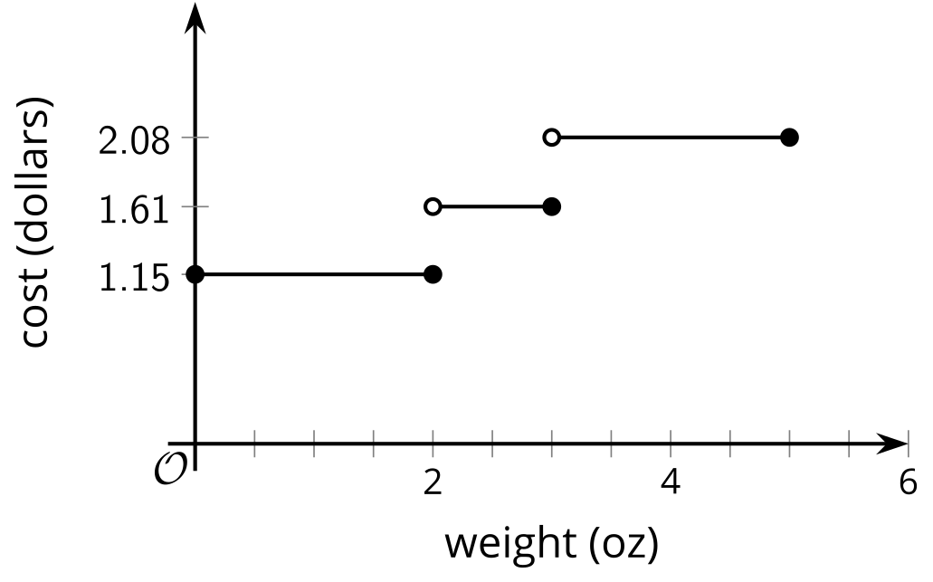
- (From Unit 4, Lesson 12.)
© CC BY 2019 by Illustrative Mathematics®

