Lesson 19: Real and Non-Real Solutions
Let's create and solve quadratic equations.

19.1: Notice and Wonder: Where Is It 0?
What do you notice? What do you wonder?
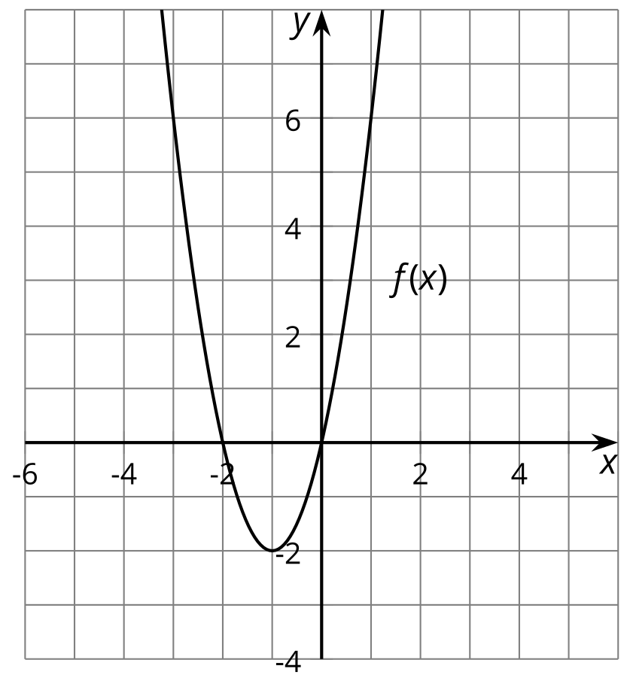
$f\left(x\right)=2x^{2}+4x$
$f\left(x\right)=0$ when $x=0,\text{-}2$.
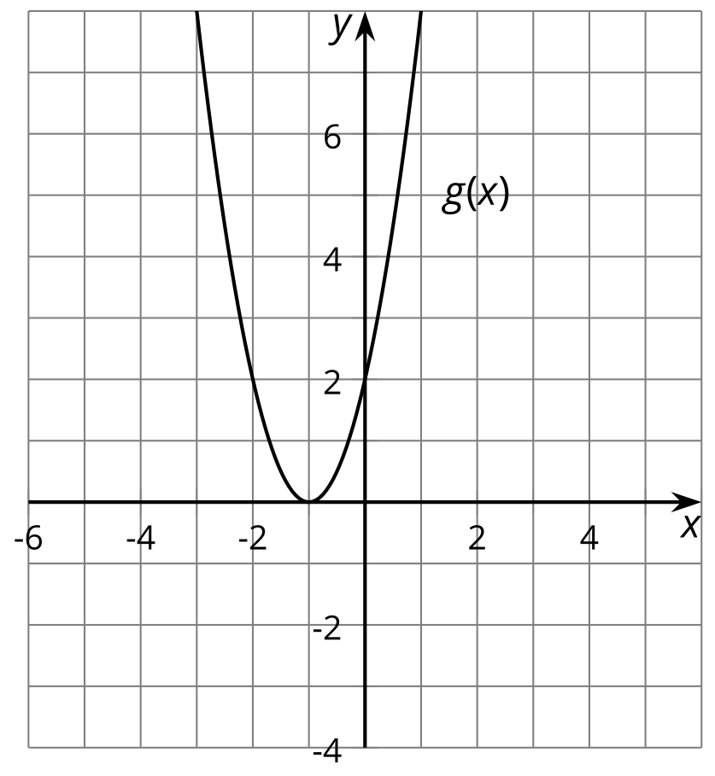
$g\left(x\right)=2x^{2}+4x+2$
$g\left(x\right)=0$ when $x=\text{-}1$.
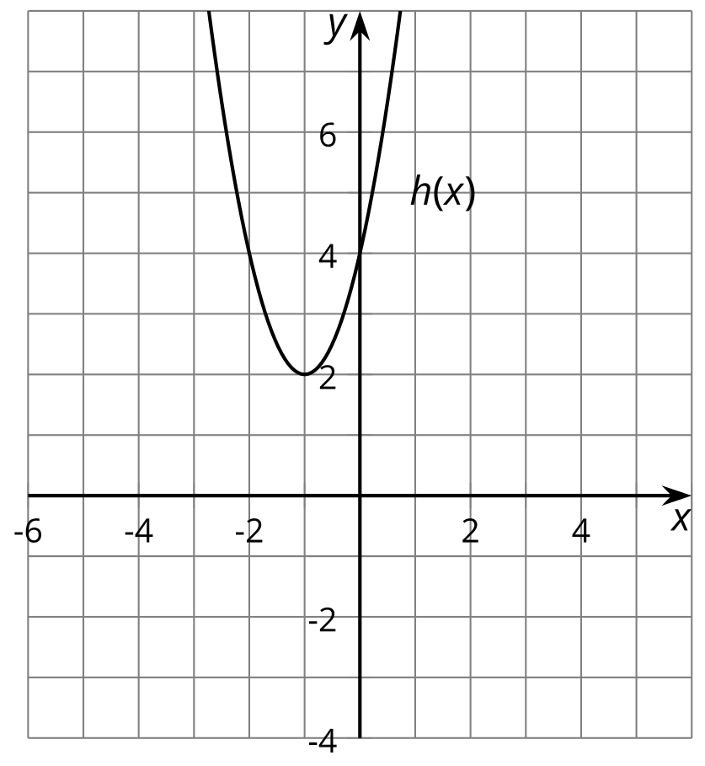
$h\left(x\right)=2x^{2}+4x+4$
$h\left(x\right)=0$ when $x=\text{-}1+i,\text{-}1−i$.

19.2: Real or Not?
Here are some equations:
Equation | Prediction
$x^{2}−6x+5=0$
$x^{2}−6x+13=0$
$\text{-}x^{2}+6x−9=0$
$\text{-}x^{2}−9=0$
- Which equations will have real solutions, and which ones will not? Write your prediction in the table.
Pause here for discussion.
- What advice would you give to someone who is trying to figure out whether a quadratic equation has real solutions?

19.3: Make Your Own
- Create three different quadratic equations. At least one should have solutions with an imaginary part, and at least one should have solutions with only real parts.
- Solve your equations. Write down your equations and their solutions in the table.
- Equation | - Solutions

Lesson 19 Summary
By looking at the graph of a quadratic function, we can tell whether it has real zeros or not. The real zeros are the $x$-coordinates of the points where the graph touches the $x$-axis. So, if the graph doesn't touch the $x$-axis at all, then the function does not have real zeros. If that happens, we won't be able to tell exactly what the zeros are just by looking at the graph, but we will be able to find them by setting the function equal to 0 and solving algebraically.
We can also tell whether $y=ax^{2}+bx+c$ has real zeros by using the quadratic formula strategically, since the quadratic formula tells us the $x$-values that make a quadratic function be 0. For reference, here is the quadratic formula:
$x=\frac{−b±\sqrt{b^{2}−4ac}}{2a}$
Imaginary numbers are the square roots of negative numbers, so it will be helpful to look at the part of the quadratic formula that involves a square root, which is $\sqrt{b^{2}−4ac}$. If $4ac$ is greater than $b^{2}$, then the number under the radical will be negative, which means that the zeros of the quadratic function will have an imaginary part.
For example, consider the quadratic function $y=x^{2}+2x+2$. How can we tell if it has real zeros?
One way is to look at the graph, shown here. Since its graph doesn't intersect the $x$-axis, this function doesn't have any real zeros.
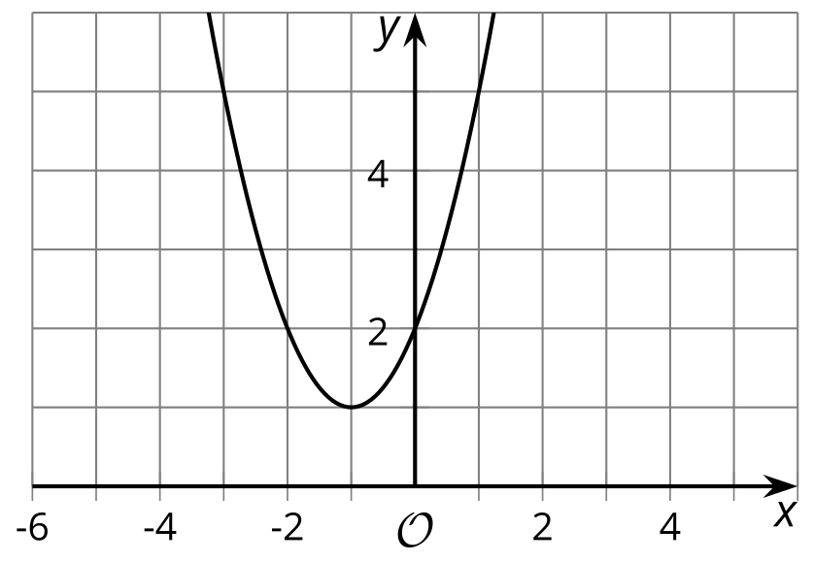
​​​​​
We can also tell by checking whether $4ac$ is greater than $b^{2}$. Since $a=1$, $b=2$, and $c=2$, $b^{2}−4ac=\text{-}4$, so the zeros of this function have an imaginary part. We can find out exactly what the zeros are by using the quadratic formula or completing the square.
© CC BY 2019 by Illustrative Mathematics®

