Lesson 8 Practice Problems
- The picture shows a circle divided into 8 equal wedges which are rearranged.
- 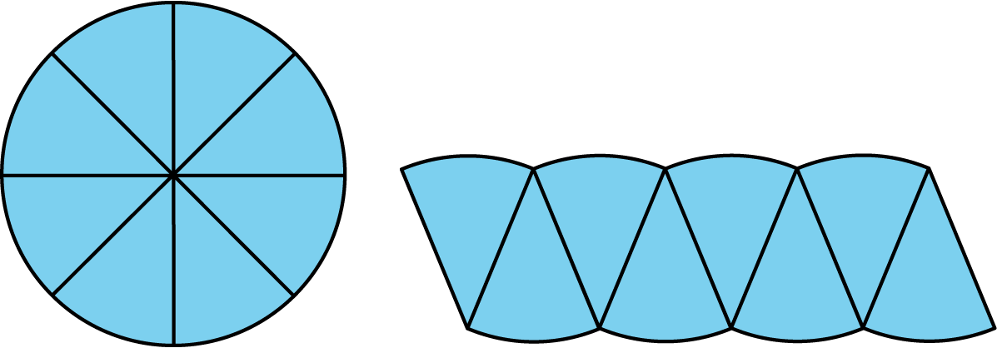
- The radius of the circle is $r$ and its circumference is $2πr$. How does the picture help to explain why the area of the circle is $πr^{2}$?
- A circle’s circumference is approximately 76 cm. Estimate the radius, diameter, and area of the circle.
- Jada paints a circular table that has a diameter of 37 inches. What is the area of the table?
- The Carousel on the National Mall has 4 rings of horses. Kiran is riding on the inner ring, which has a radius of 9 feet. Mai is riding on the outer ring, which is 8 feet farther out from the center than the inner ring is.
  - In one rotation of the carousel, how much farther does Mai travel than Kiran?
  - One rotation of the carousel takes 12 seconds. How much faster does Mai travel than Kiran?
- (From Unit 3, Lesson 4.)
- Here are the diameters of four coins:
- coin | - penny | - nickel | - dime | - quarter
- diameter | - 1.9 cm | - 2.1 cm | - 1.8 cm | - 2.4 cm
  - A coin rolls a distance of 33 cm in 5 rotations. Which coin is it?
  - A quarter makes 8 rotations. How far did it roll?
  - A dime rolls 41.8 cm. How many rotations did it make?
- (From Unit 3, Lesson 5.)
© CC BY Open Up Resources. Adaptations CC BY IM.

