Lesson 17: Graphs of Rational Functions (Part 1)
- Let’s explore graphs and equations of rational functions.

17.1: Biking 10 Miles (Part 1)
Kiran’s aunt plans to bike 10 miles.
- How long will it take if she bikes at an average rate of 8 miles per hour?
- How long will it take if she bikes at an average rate of $r$ miles per hour?
- Kiran wants to join his aunt, but he only has 45 minutes to exercise. What will their average rate need to be for him to finish on time?
- What will their average rate need to be if they have $t$ hours to exercise?

17.2: Biking 10 Miles (Part 2)
Kiran plans to bike 10 miles.
- Write an equation that gives his time $t$, in hours, as a function of his rate $r$, in miles per hour.
- Graph $y=t\left(r\right)$.
- What is the meaning of $t\left(8\right)$? Does this value make sense? Explain your reasoning.
- What is the meaning of $t\left(0\right)$? Does this value make sense? Explain your reasoning.
- As $r$ gets closer and closer to 0, what does the behavior of the function tell you about the situation?
- As $r$ gets larger and larger, what does the end behavior of the function tell you about the situation?

17.3: Card Sort: Graphs of Rational Functions
Your teacher will give you a set of cards. Match each rational function with its graphical representation.

Are you ready for more?
Priya and Han are bicycling. Han is going at a rate of 10 mph and begins 2 miles ahead of Priya. If Priya bikes at a rate of $r$ mph, when will Priya pass Han? Write an equation and sketch a graph. Then interpret the graph in terms of the situation.

Lesson 17 Summary
The distance $d$ that an object moving at constant speed travels is based on the length of time $t$ the object travels and the speed $r$ of the object. Often, this relationship is written as $d=r⋅t$. We could also write the relationship as $r=\frac{d}{t}$ or $t=\frac{d}{r}$. Depending on what we want to know, one form of this relationship may be more useful than another.
For example, the distance across the English Channel from Dover in England to Calais in France is 33.3 km. The time in hours it takes for a boat to make this crossing can be modeled by the function $T\left(r\right)=\frac{33.3}{r}$, where $r$ is measured in kilometers per hour.
For very small values of $r$, the journey takes a long time. For larger values of $r$ (and a fast boat!), the trip is shorter. The graph of the function shows how the travel time decreases as the speed of the boat increases.
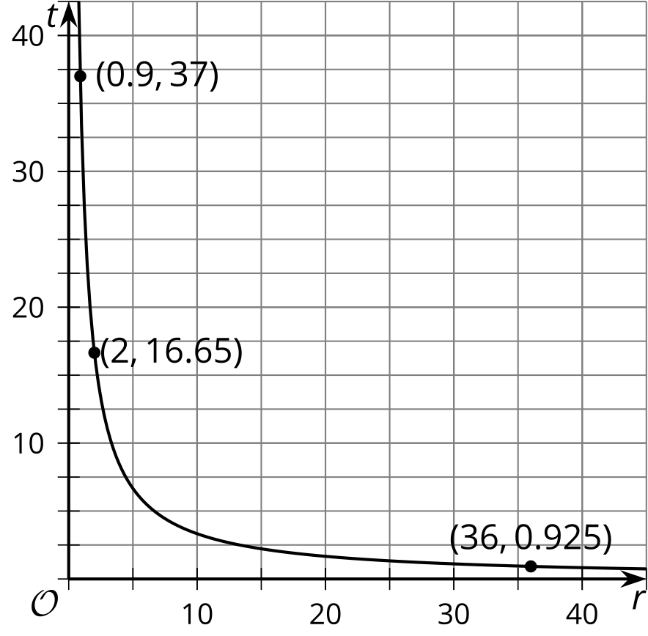
Unlike the graphs of polynomial functions that look smooth and connected, the graphs of some rational functions can look like separate pieces. For example, here is a graph of $f\left(x\right)=\frac{1}{x−3}$.
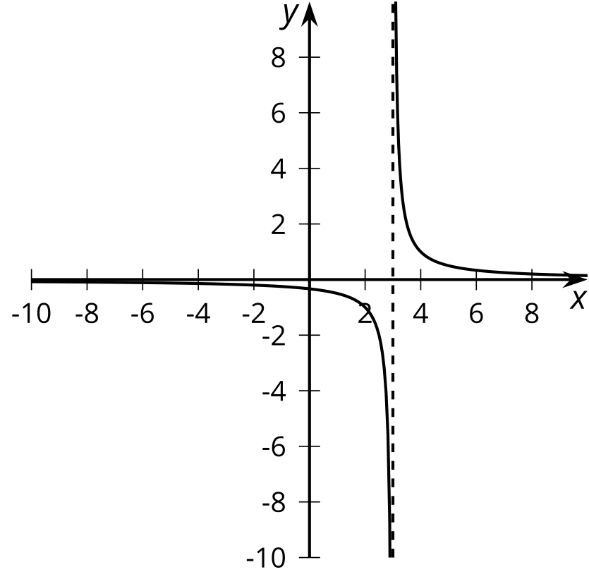
The dashed line at $x=3$ is a representation of a vertical asymptote. As $x$ gets closer and closer to 3, think about what happens to the value of the expression for $f\left(x\right)$. If we divide 1 by a very small negative number, we get a very big negative number, which is what happens on the left side of the vertical asymptote. If we divide 1 by a very small positive number, we get a very big positive number, which is what happens on the right side of the vertical asymptote. It is important to note that the drawn-in asymptote is not actually part of the graph of the function. Instead, it is a helpful reminder that the function has no value at $x=3$ and very large absolute values at inputs very close to $x=3$.
© CC BY 2019 by Illustrative Mathematics®

