Lesson 18: The Quadratic Formula and Complex Solutions
- Let’s use the quadratic formula to find complex solutions to quadratic equations.

18.1: Math Talk: Real or Not?
Mentally decide whether the solutions to each equation are real numbers or not.
$w^{2}=\text{-}367$
$x^{2}+25=0$
${\left(y+5\right)}^{2}=0$
${\left(z+5\right)}^{2}=\text{-}367$

18.2: Be Discriminating
Kiran was using the quadratic formula to solve the equation $x^{2}−12x+41=0$. He wrote this:
$x=\frac{12±\sqrt{144−164}}{2}$
Then he noticed that the number inside the square root is negative and said, “This equation doesn’t have any solutions.”
- Do you agree with Kiran? Explain your reasoning.
- Write $\sqrt{\text{-}20}$ as an imaginary number.
- Solve the equation $3x^{2}−10x+50=0$ and plot the solutions in the complex plane.
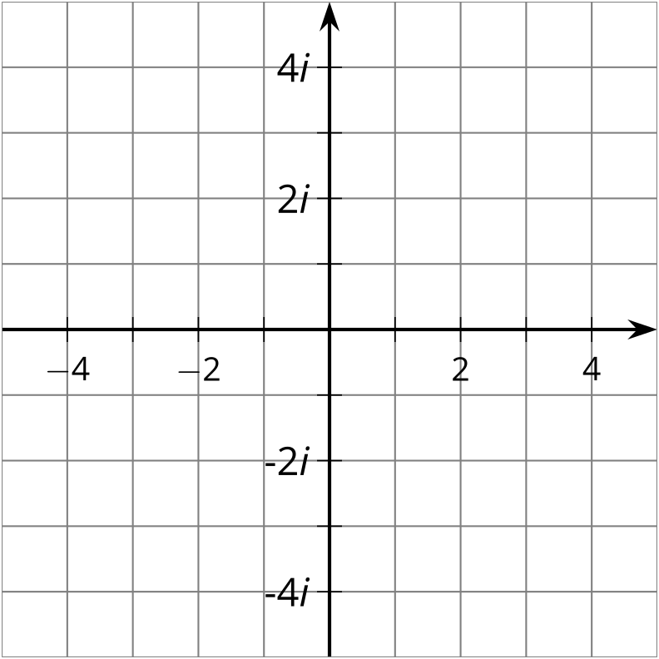

Are you ready for more?
Although imaginary numbers let us describe complex solutions to quadratic equations, they were actually discovered and accepted because they could help us find real solutions to equations with polynomials of degree 3. In the 16th century, mathematicians discovered a cubic formula for solving equations of degree 3, but to use it they sometimes had to work with complex numbers. Let’s see an example where this comes up.
- To find a solution to the equation $x^{3}−px−q=0$ the cubic formula would first tell us to find a complex number, $z$, which is $\frac{q}{2}+i\sqrt{{\left(\frac{p}{3}\right)}^{3}−{\left(\frac{q}{2}\right)}^{2}}$. Find $z$ when our equation is $x^{3}−15x−4=0$.
- The next step is to find a complex number $w$ so that $w^{3}=z$. Show that $w=2+i$ works for the $z$ we found in step 1.
- If we write $w=a+bi$ where $a$ and $b$ are real numbers, the solutions to our equation are $2a$, $\text{-}a+b\sqrt{3}$, and $\text{-}a−b\sqrt{3}$. What are the three solutions to our equation $x^{3}−15x−4=0$?

18.3: Solving All Kinds of Quadratics
For each row, you and your partner will each solve a quadratic equation. You should each get the same answer. If you disagree, work to reach agreement.
partner A | partner B
$x^{2}−4x−4=0$ | ${\left(x−2\right)}^{2}=8$
${\left(y−2\right)}^{2}=\text{-}8$ | $y^{2}−4y+12=0$
${\left(z+\frac{3}{2}\right)}^{2}=\text{-}\frac{29}{4}$ | $2z^{2}+6z=\text{-}19$
$w^{2}+3w=5$ | ${\left(w+\frac{3}{2}\right)}^{2}=\frac{29}{4}$
$4t^{2}−20t+25=0$ | $4\left(t^{2}−5t\right)=\text{-}25$

Lesson 18 Summary
Sometimes when we use the quadratic formula to solve a quadratic equation, we get a negative number inside the square root symbol. This means that the solutions to the equation must involve imaginary numbers. For example, consider the following equation:
$5x^{2}+x+10=0$
Using the quadratic formula, we know that:
$x=\frac{\text{-}1±\sqrt{1^{2}−4⋅5⋅10}}{2⋅5}$
or
$x=\frac{\text{-}1±\sqrt{\text{-}199}}{10}$
Which means that the two solutions are:
$x=\text{-}\frac{1}{10}+\frac{\sqrt{199}}{10}i$
and
$x=\text{-}\frac{1}{10}−\frac{\sqrt{199}}{10}i$
© CC BY 2019 by Illustrative Mathematics®

