Unit 2 Lesson 14: Making More New, True Equations

1 Criss Cross'll Make You Jump (Warm up)

Student Task Statement
Match each equation with its graph.
$x=7$ | $y=7$ | $x+y=7$

A
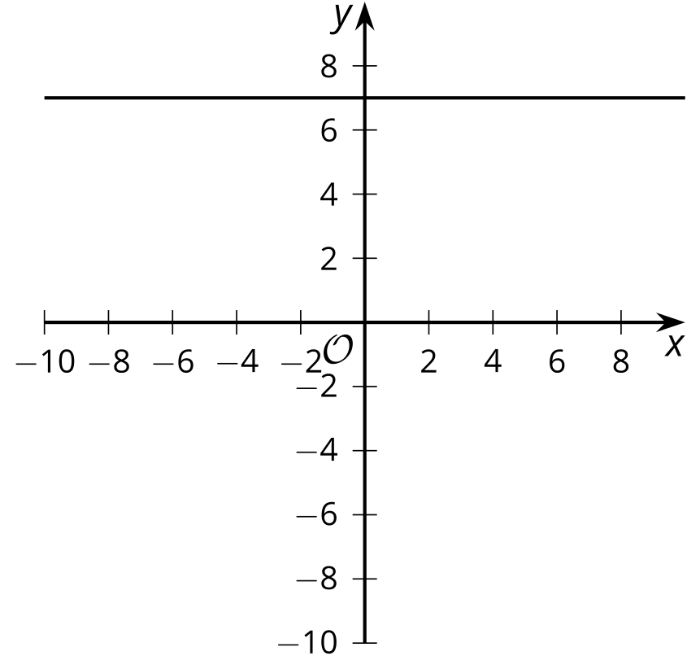

B
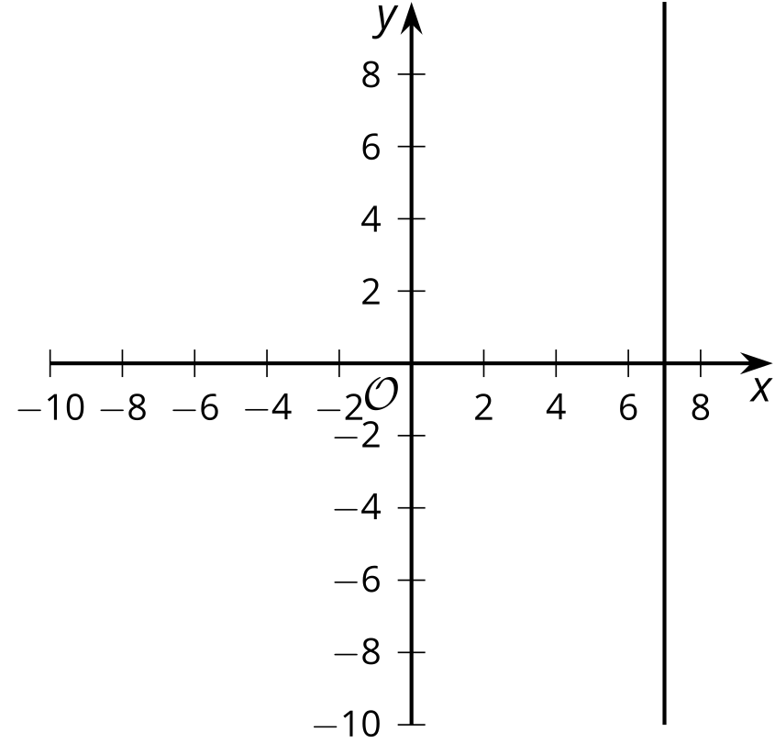

C
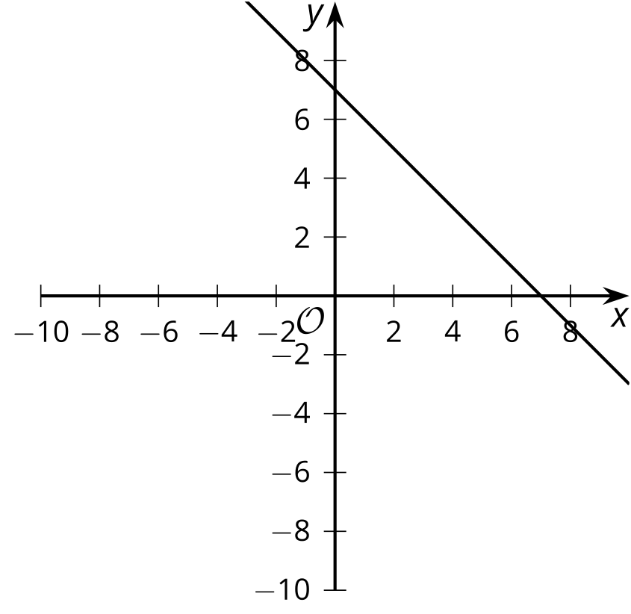

D
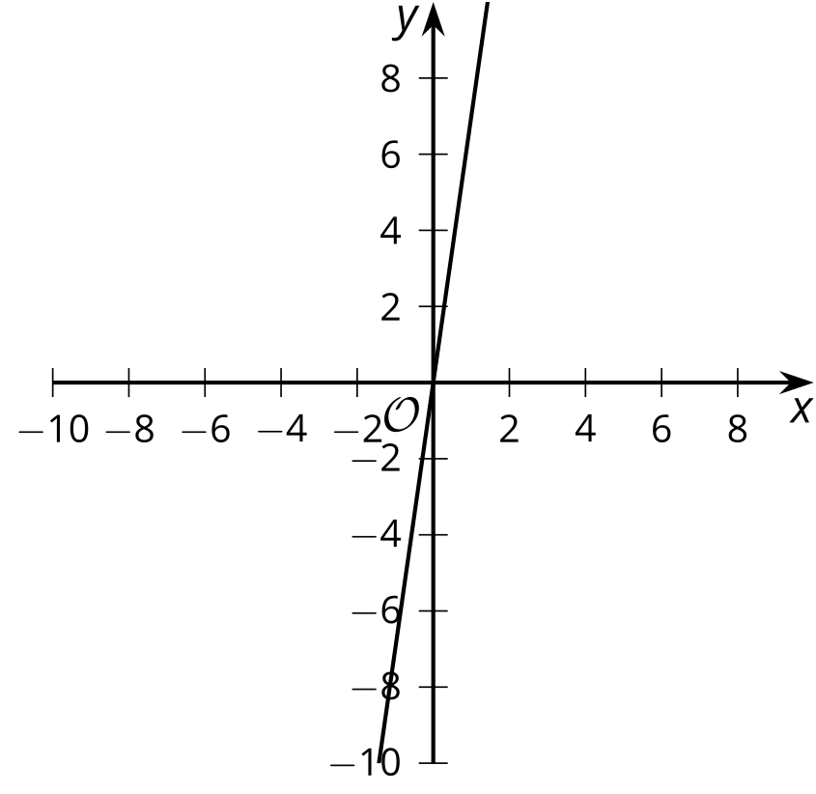

2 They're Like Terms, Man

Student Task Statement
Rewrite each expression by combining like terms.
- $11s−2s$
- $5t+3z−2t$
- $23s−\left(13t+7t\right)$
- $7t+18r+\left(2r−5t\right)$
- $\text{-}4x+6r−\left(7x+2r\right)$
- $3\left(c−5\right)+2c$
- $8x−3y+\left(3y−5x\right)$
- $5x+4y−\left(5x+7y\right)$
- $9x−2y−3\left(3x+y\right)$
- $6x+12y+2\left(3x−6y\right)$

3 Finding More Lines

Student Task Statement
For each system of equations:
- Solve the system of equations by graphing. Write the solution as an ordered pair.
- Write an equation that would represented by a vertical or horizontal line that also passes through the solution of the system of equations.
- Graph your new equation along with the system.
- $\left\{\begin{matrix}\begin{matrix}y=3x+5 \\ y=\text{-}x+1\end{matrix}\end{matrix}\right.$

- The line representing $y=3x+5$ is shown
- 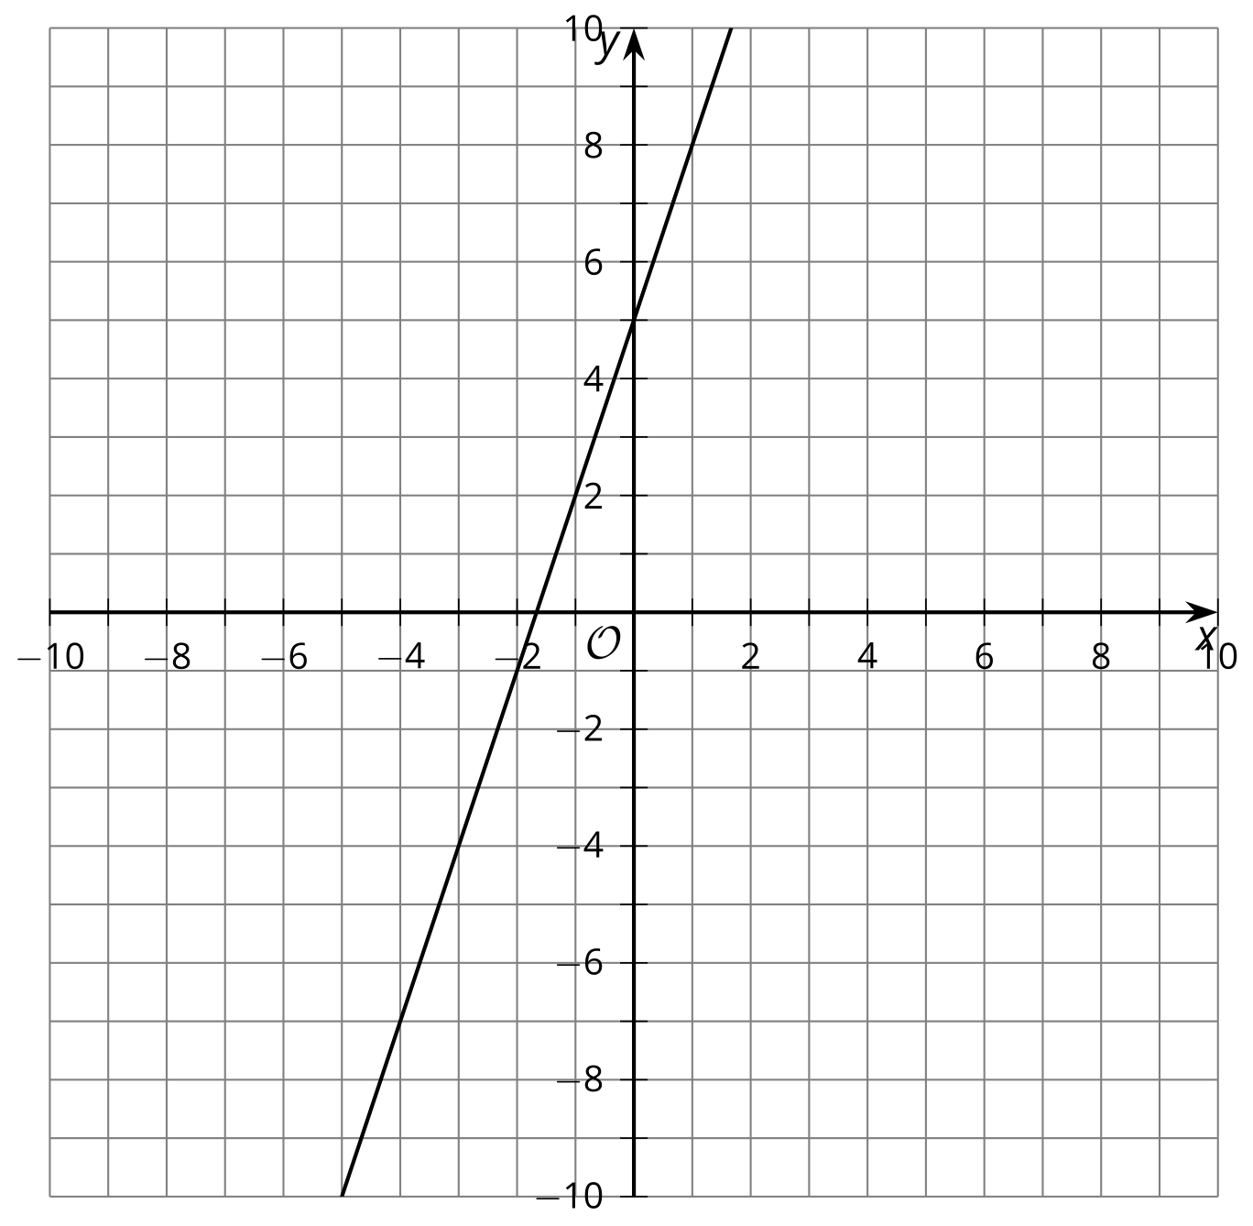
- $\left\{\begin{matrix}\begin{matrix}y=\frac{1}{3}x−2 \\ y=x−6\end{matrix}\end{matrix}\right.$

- The line representing $y=\frac{1}{3}x−2$ is shown
- 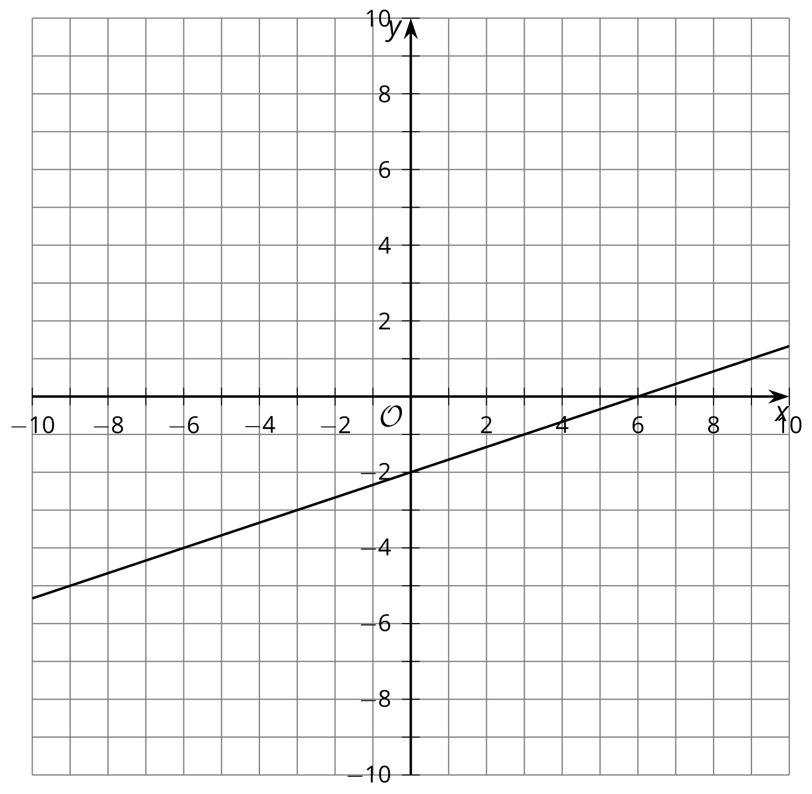
- $\left\{\begin{matrix}\begin{matrix}2x+3y=10 \\ x+y=3\end{matrix}\end{matrix}\right.$

- The line representing $2x+3y=10$ is shown
- 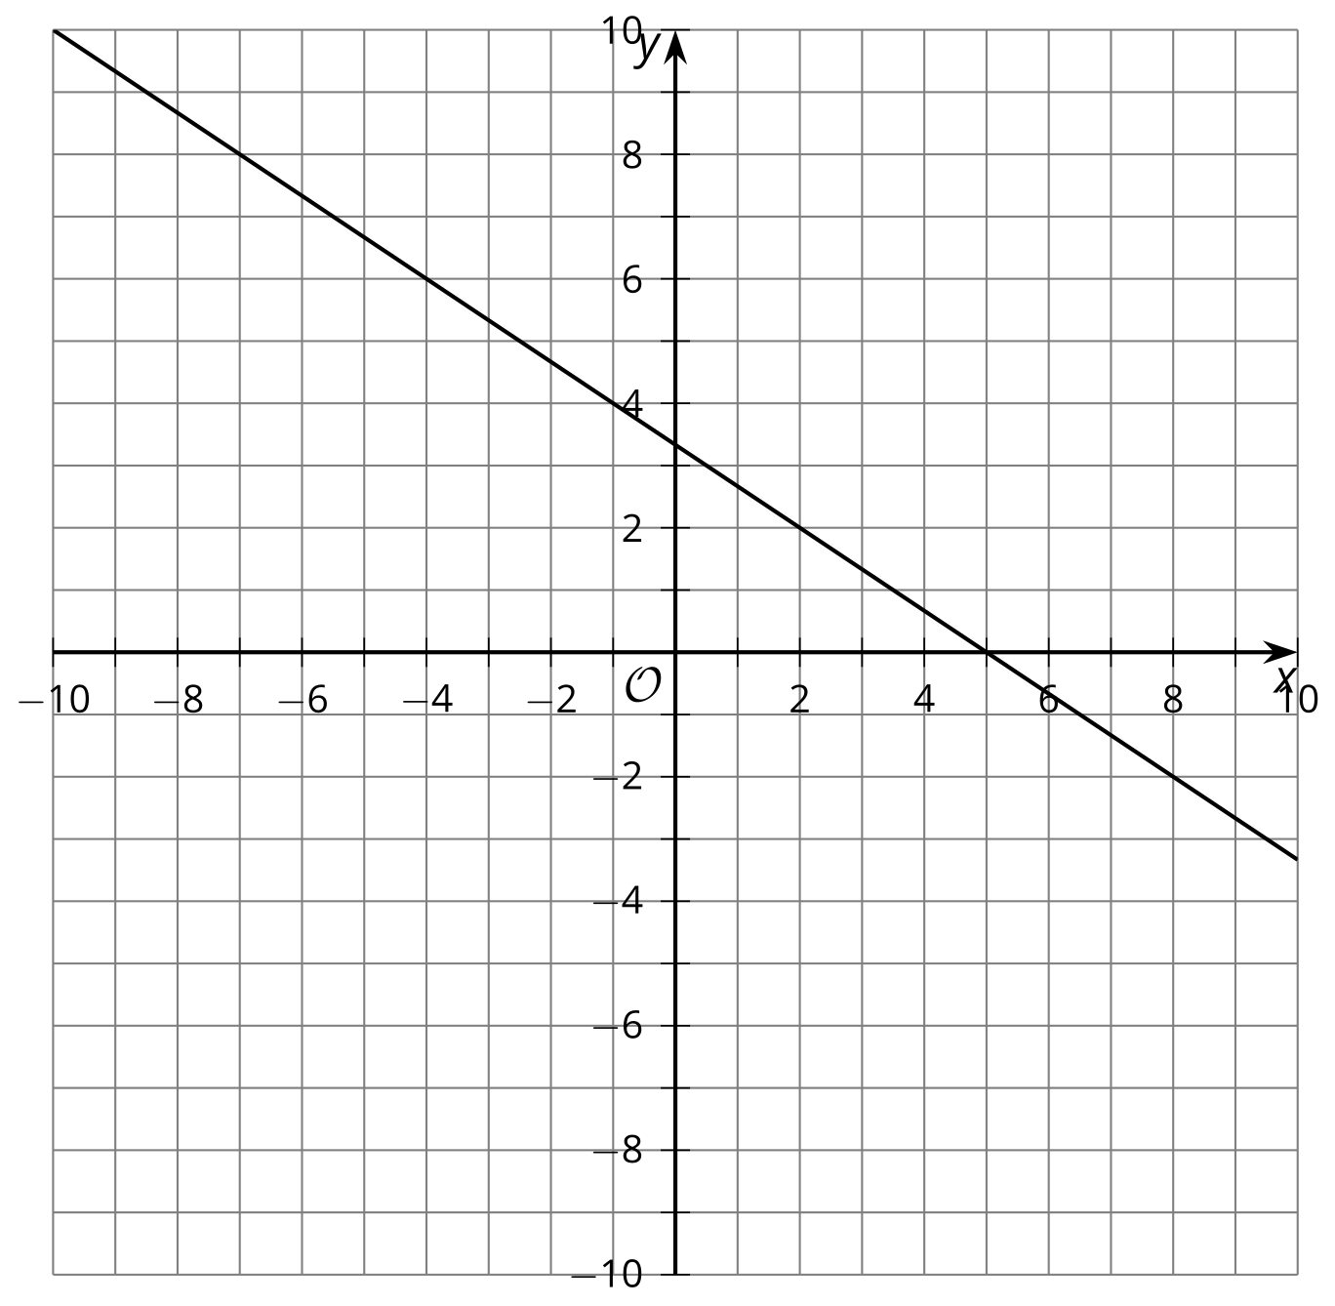
© CC BY 2019 by Illustrative Mathematics®

