Lesson 10 Practice Problems
- A chef is making pickles. He needs 15 gallons of vinegar. The store sells 2 gallons of vinegar for $3.00 and allows customers to buy any amount of vinegar. Decide whether each of the following ratios correctly represents the price of vinegar.
  - 4 gallons to $3.00
  - 1 gallon to $1.50
  - 30 gallons to $45.00
  - $2.00 to 30 gallons
  - $1.00 to $\frac{2}{3}$ gallon
- A caterer needs to buy 21 pounds of pasta to cater a wedding. At a local store, 8 pounds of pasta cost $12. How much will the caterer pay for the pasta there?
  - Write a ratio for the given information about the cost of pasta.
  - Would it be more helpful to write an equivalent ratio with 1 pound of pasta as one of the numbers, or with $1 as one of the numbers? Explain your reasoning, and then write that equivalent ratio.
  - Find the answer and explain or show your reasoning.
- Lin is reading a 47-page book. She read the first 20 pages in 35 minutes.
  - If she continues to read at the same rate, will she be able to complete this book in under 1 hour?
  - If so, how much time will she have left? If not, how much more time is needed? Explain or show your reasoning.
- Diego can type 140 words in 4 minutes.
  - At this rate, how long will it take him to type 385 words?
  - How many words can he type in 15 minutes?
- If you get stuck, consider creating a table.
- A train that travels 30 miles in $\frac{1}{3}$ hour at a constant speed is going faster than a train that travels 20 miles in $\frac{1}{2}$ hour at a constant speed. Explain or show why.
- (From Unit 2, Lesson 7.)
- Find the surface area of the polyhedron that can be assembled from this net. Show your reasoning.
- 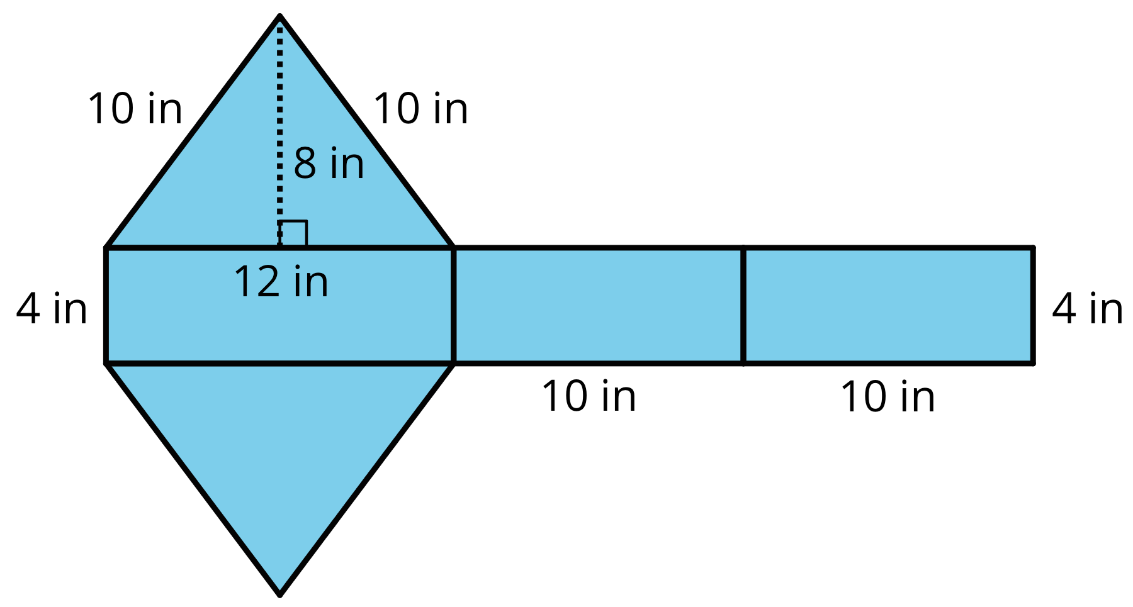
- (From Unit 1, Lesson 11.)
© CC BY Open Up Resources. Adaptations CC BY IM.

