Lesson 15: The Remainder Theorem
- Let’s learn about the Remainder Theorem.

15.1: Notice and Wonder: Division Leftovers
What do you notice? What do you wonder?
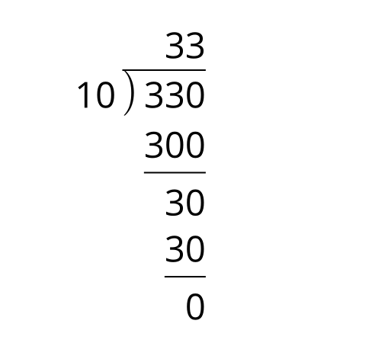
A. $330=33\left(10\right)+0$
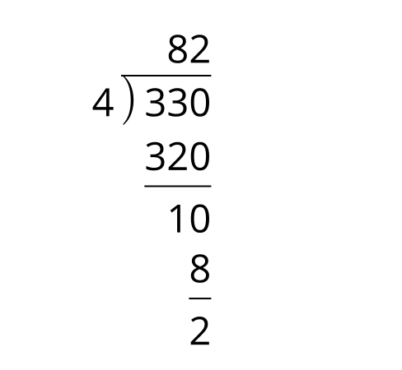
B. $330=4\left(82\right)+2$
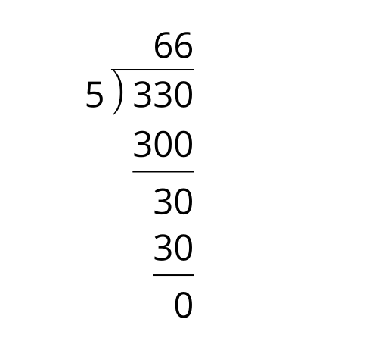
C. $330=5\left(66\right)+0$

15.2: The Unknown Coefficient
Consider the polynomial function $f\left(x\right)=x^{4}−ux^{3}+24x^{2}−32x+16$ where $u$ is an unknown real number. If $x−2$ is a factor, what is the value of $u$? Explain how you know.

Are you ready for more?
Here are some diagrams that show the same third-degree polynomial, $P\left(x\right)=2x^{3}+5x^{2}+x+10$, divided by a linear factor and by a quadratic factor.
$\frac{P\left(x\right)}{x+3}$
 | $2x^{2}$ | $\text{-}x$ | 4
$x$ | $2x^{3}$ | $\text{-}x^{2}$ | $4x$
3 | $6x^{2}$ | $\text{-}3x$ | 12
$\frac{P\left(x\right)}{x^{2}−x}$
 | $2x$ | 7
$x^{2}$ | $2x^{3}$ | $7x^{2}$
$\text{-}x$ | $\text{-}2x^{2}$ | $\text{-}7x$
- What is the remainder of each of these divisions?
- For each division, how does the degree of the remainder compare to the degree of the divisor?
- Could the remainder ever have the same degree as the divisor, or a higher degree? Give an example to show that this is possible, or explain why it is not possible.

15.3: A Study of Remainders
- Which of these polynomials could have $\left(x−2\right)$ as a factor?
  - $A\left(x\right)=6x^{2}−7x−5$
  - $B\left(x\right)=3x^{2}+15x−42$
  - $C\left(x\right)=2x^{3}+13x^{2}+16x+5$
  - $D\left(x\right)=3x^{3}−2x^{2}−15x+14$
  - $E\left(x\right)=8x^{4}−41x^{3}−18x^{2}+101x+70$
  - $F\left(x\right)=x^{4}+5x^{3}−27x^{2}−101x−70$
- Select one of the polynomials that you said doesn’t have $\left(x−2\right)$ as a factor.
  - Explain how you know $\left(x−2\right)$ is not a factor.
  - If you have not already done so, divide the polynomial by $\left(x−2\right)$. What is the remainder?
- List the remainders for each of the polynomials when divided by $\left(x−2\right)$. How do these values compare to the value of the functions at $x=2$?

Lesson 15 Summary
When we use long division to divide 1573 by 12, we get a remainder of 1, so $1573=12\left(131\right)+1$. When we divide by 11 instead, we get a remainder of 0, so $1573=11\left(143\right)$. A remainder of 0 means that 11 is a factor of 1573. The same thing happens with polynomials. While $\left(x^{3}+5x^{2}+7x+3\right)÷\left(x+2\right)$ results in a remainder that is not 0, if we divide $\left(x+1\right)$ into $x^{3}+5x^{2}+7x+3$, we do get a remainder of 0:
x2+4x+3x+1x3+5x2+7x+3-x3−x2_+7x+3334x2+7x+33-4x2−4x_+333x+3-3x−3_0
So $\left(x+1\right)$ is a factor of $x^{3}+5x^{2}+7x+3$.
Earlier we learned that if $\left(x−a\right)$ is a factor of a polynomial $p\left(x\right)$, then $p\left(a\right)=0$, meaning $a$ is a zero of the function. It turns out that the converse is also true: if $a$ is a zero, then $\left(x−a\right)$ is a factor.
To see that this is true, let’s think about what we know if we have a polynomial $p\left(x\right)$ with a known zero at $x=a$. If we divide $p\left(x\right)$ by the linear factor $\left(x−a\right)$, then $p\left(x\right)=\left(x−a\right)q\left(x\right)+r$, where $r$ is the remainder and $q\left(x\right)$ is a polynomial. Because $a$ is a zero of the function, we know that $p\left(a\right)=0$. This means we also know that the remainder is zero:
$p\left(a\right)=\left(a−a\right)q\left(x\right)+rp\left(a\right)=r0=r$
Which means that $p\left(x\right)=\left(x−a\right)q\left(x\right)$. So, if $a$ is a zero of a polynomial, then $\left(x−a\right)$ must be a factor of $p\left(x\right)$. Now we know that if we start with a linear factor of a polynomial, then we know one of the zeros of the polynomials, and if we start with a zero of a polynomial, then we know one of the linear factors.
Lastly, even if $a$ is not a zero of $p$, we can figure out what the remainder will be if we divide $p\left(x\right)$ by $\left(x−a\right)$, without having to do any division. If $p\left(x\right)=\left(x−a\right)q\left(x\right)+r$, then $p\left(a\right)=\left(a−a\right)q\left(x\right)+r$, so $p\left(a\right)=r$. So the remainder after division by $\left(x−a\right)$ is $p\left(a\right)$. This is the Remainder Theorem.
© CC BY 2019 by Illustrative Mathematics®

