Unit 5 Lesson 4: Tables, Equations, and Graphs of Functions

1 Notice and Wonder: Doubling Back (Warm up)

Student Task Statement
What do you notice? What do you wonder?
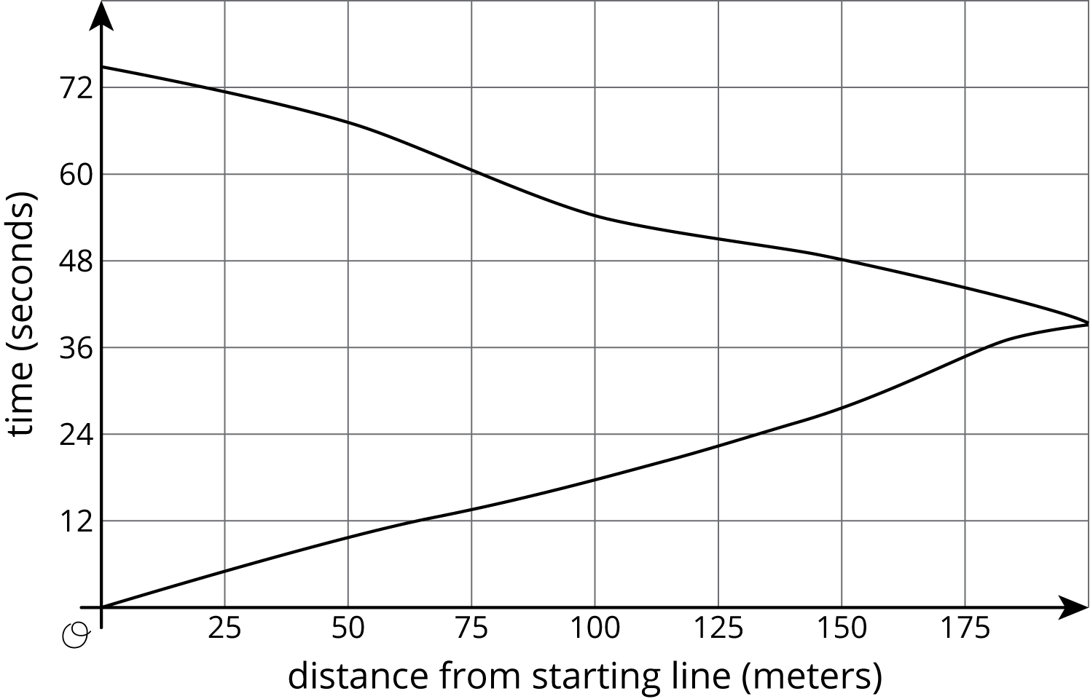

2 Equations and Graphs of Functions

Images for Launch
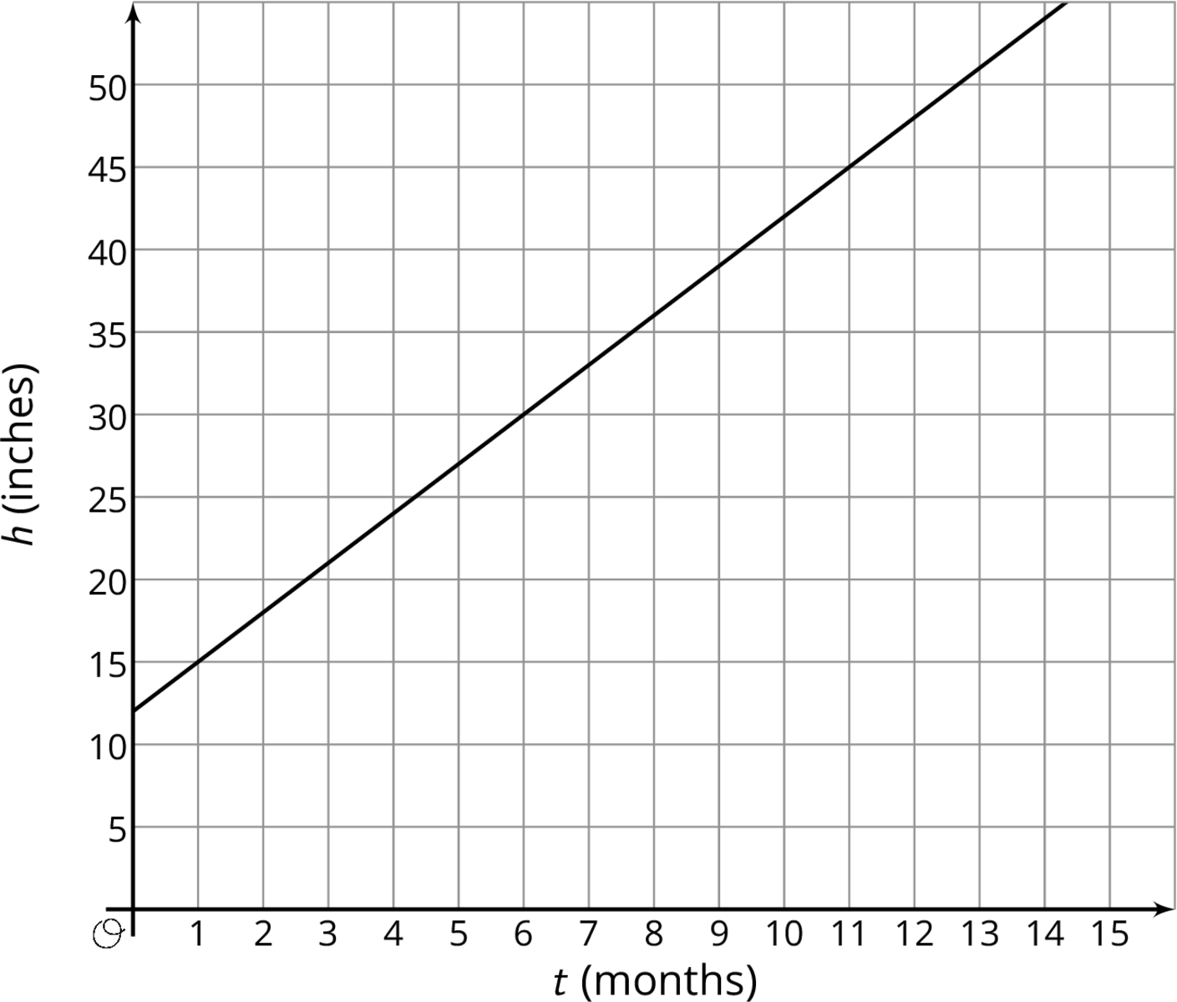

Student Task Statement
The graphs of three functions are shown.
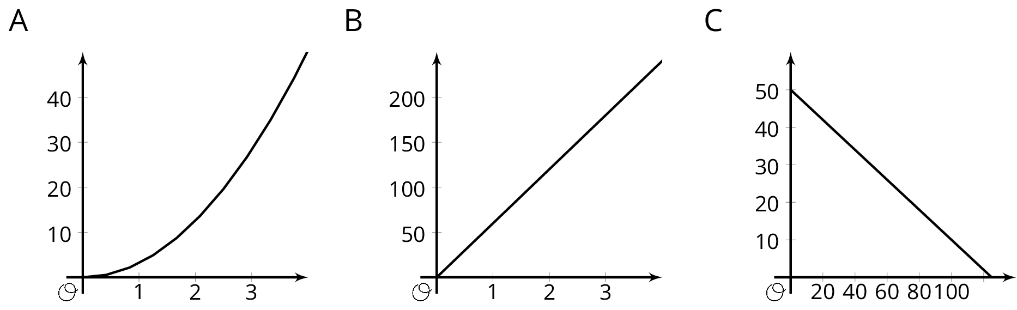
- Match one of these equations to each of the graphs.
  - $d=60t$, where $d$ is the distance in miles that you would travel in $t$ hours if you drove at 60 miles per hour.
  - $q=50−0.4d$, where $q$ is the number of quarters, and $d$ is the number of dimes, in a pile of coins worth $12.50.
  - $A=πr^{2}$, where $A$ is the area in square centimeters of a circle with radius $r$ centimeters.
- Label each of the axes with the independent and dependent variables and the quantities they represent.
- For each function: What is the output when the input is 1? What does this tell you about the situation? Label the corresponding point on the graph.
- Find two more input-output pairs. What do they tell you about the situation? Label the corresponding points on the graph.

3 Running around a Track

Student Task Statement
- Kiran was running around the track. The graph shows the time, $t$, he took to run various distances, $d$. The table shows his time in seconds after every three meters.
- 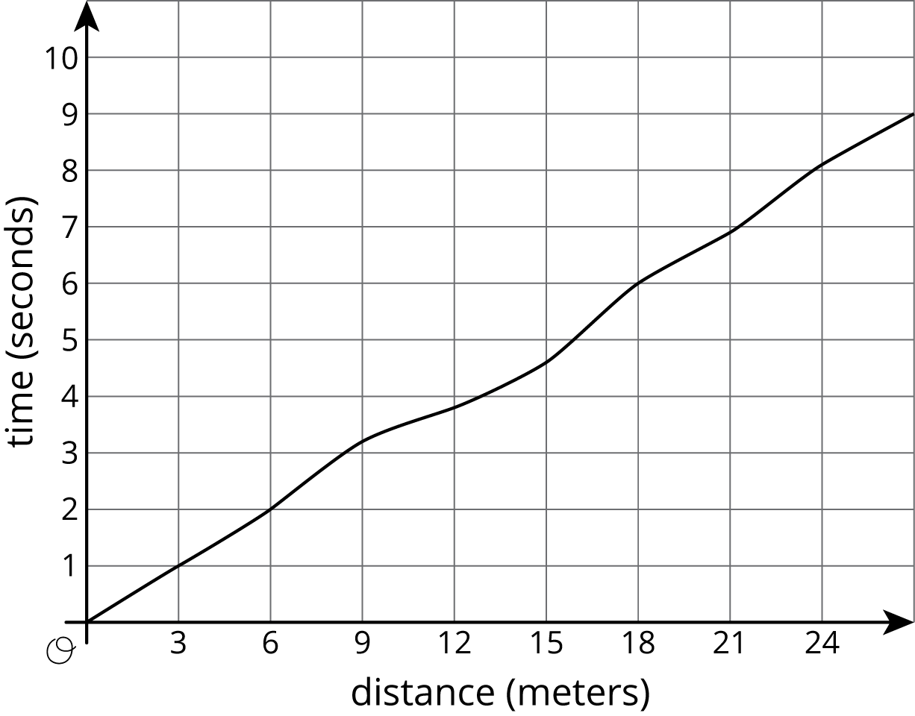
- $d$ | - 0 | - 3 | - 6 | - 9 | - 12 | - 15 | - 18 | - 21 | - 24 | - 27
- $t$ | - 0 | - 1.0 | - 2.0 | - 3.2 | - 3.8 | - 4.6 | - 6.0 | - 6.9 | - 8.09 | - 9.0
  - How long did it take Kiran to run 6 meters?
  - How far had he gone after 6 seconds?
  - Estimate when he had run 19.5 meters.
  - Estimate how far he ran in 4 seconds.
  - Is Kiran's time a function of the distance he has run? Explain how you know.
- Priya is running once around the track. The graph shows her time given how far she is from her starting point.
  - What was her farthest distance from her starting point?
  - Estimate how long it took her to run around the track.
  - Estimate when she was 100 meters from her starting point.
  - Estimate how far she was from the starting line after 60 seconds.
  - Is Priya's time a function of her distance from her starting point? Explain how you know.
© CC BY Open Up Resources. Adaptations CC BY IM.

