Lesson 16 Practice Problems
- A landscape architect is designing a pool that has this top view:
- 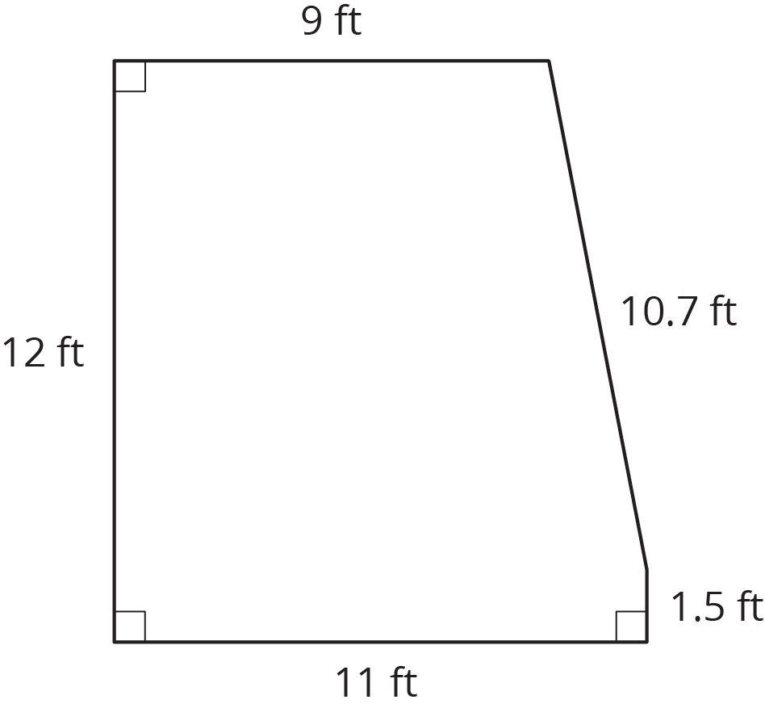
  - How much water will be needed to fill this pool 4 feet deep?
  - Before filling up the pool, it gets lined with a plastic liner. How much liner is needed for this pool?
  - Here are the prices for different amounts of plastic liner. How much will all the plastic liner for the pool cost?
- plastic liner (ft²) | - cost ($)
- 25 | - 3.75
- 50 | - 7.50
- 75 | - 11.25
- Shade in a base of the trapezoidal prism. (The base is not the same as the bottom.)
  - Find the area of the base you shaded.
  - Find the volume of this trapezoidal prism.
- 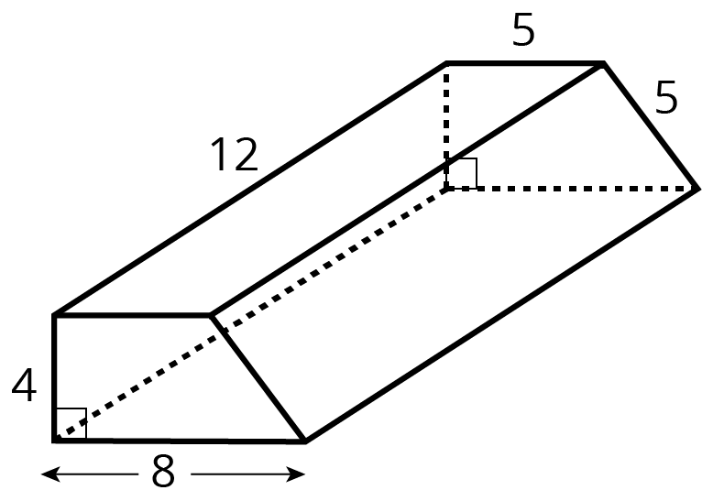
- (From Unit 7, Lesson 13.)
- For each diagram, decide if $y$ is an increase or a decrease of $x$. Then determine the percentage that $x$ increased or decreased to result in $y$.
- 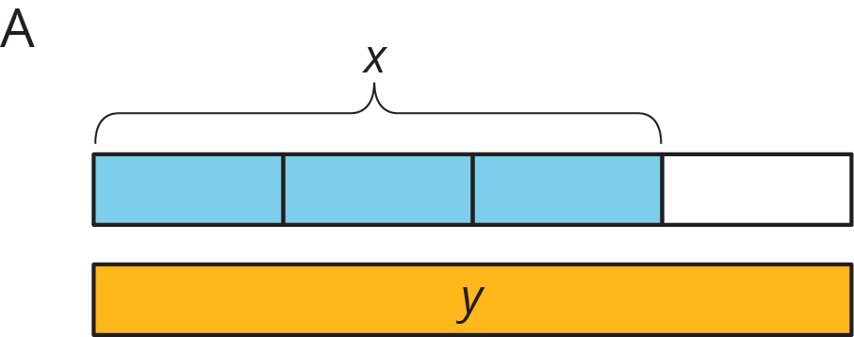
- 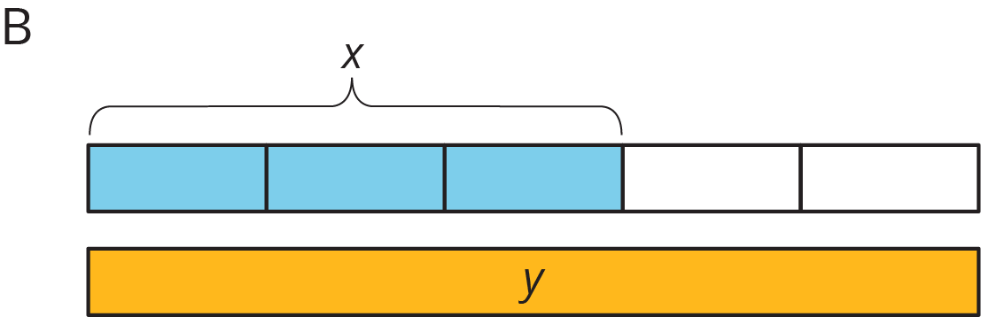
- 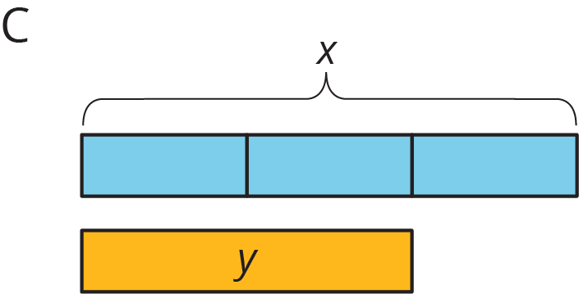
- 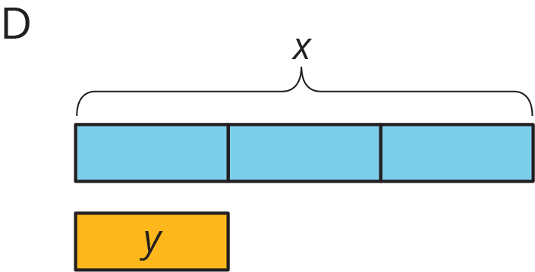
- (From Unit 4, Lesson 9.)
- Noah is visiting his aunt in Texas. He wants to buy a belt buckle whose price is $25. He knows that the sales tax in Texas is 6.25%.
  - How much will the tax be on the belt buckle?
  - How much will Noah spend for the belt buckle including the tax?
  - Write an equation that represents the total cost, $c$, of an item whose price is $p$.
- (From Unit 4, Lesson 10.)
© CC BY Open Up Resources. Adaptations CC BY IM.

