Lesson 7 Practice Problems
- The $x$-axis of each graph has the diameter of a circle in meters. Label the $y$-axis on each graph with the appropriate measurement of a circle:
radius (m), circumference (m), or area (m²).
- 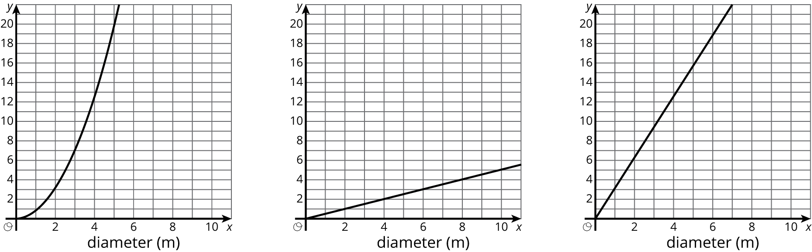
- Circle A has area 500 in². The diameter of circle B is three times the diameter of circle A. Estimate the area of circle B.
- Lin’s bike travels 100 meters when her wheels rotate 55 times. What is the circumference of her wheels?
- (From Unit 3, Lesson 5.)
- Priya drew a circle whose circumference is 25 cm. Clare drew a circle whose diameter is 3 times the diameter of Priya’s circle. What is the circumference of Clare’s circle?
- (From Unit 3, Lesson 3.)

  - Here is a picture of two squares and a circle. Use the picture to explain why the area of this circle is more than 2 square units but less than 4 square units.
  - 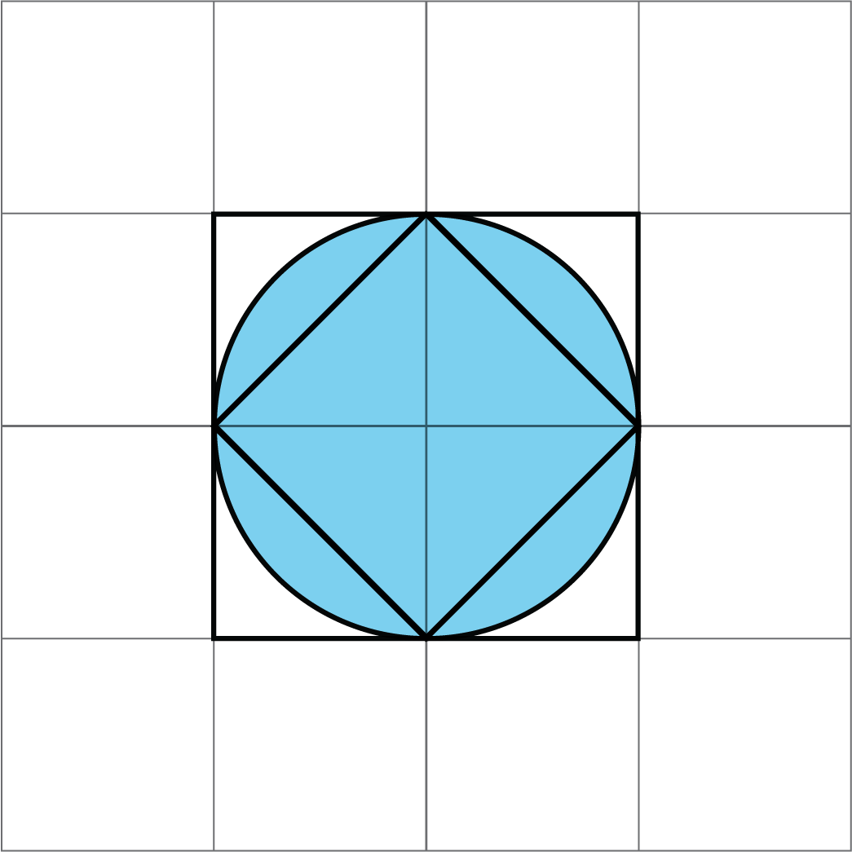
  - Here is another picture of two squares and a circle. Use the picture to explain why the area of this circle is more than 18 square units and less than 36 square units.
  - 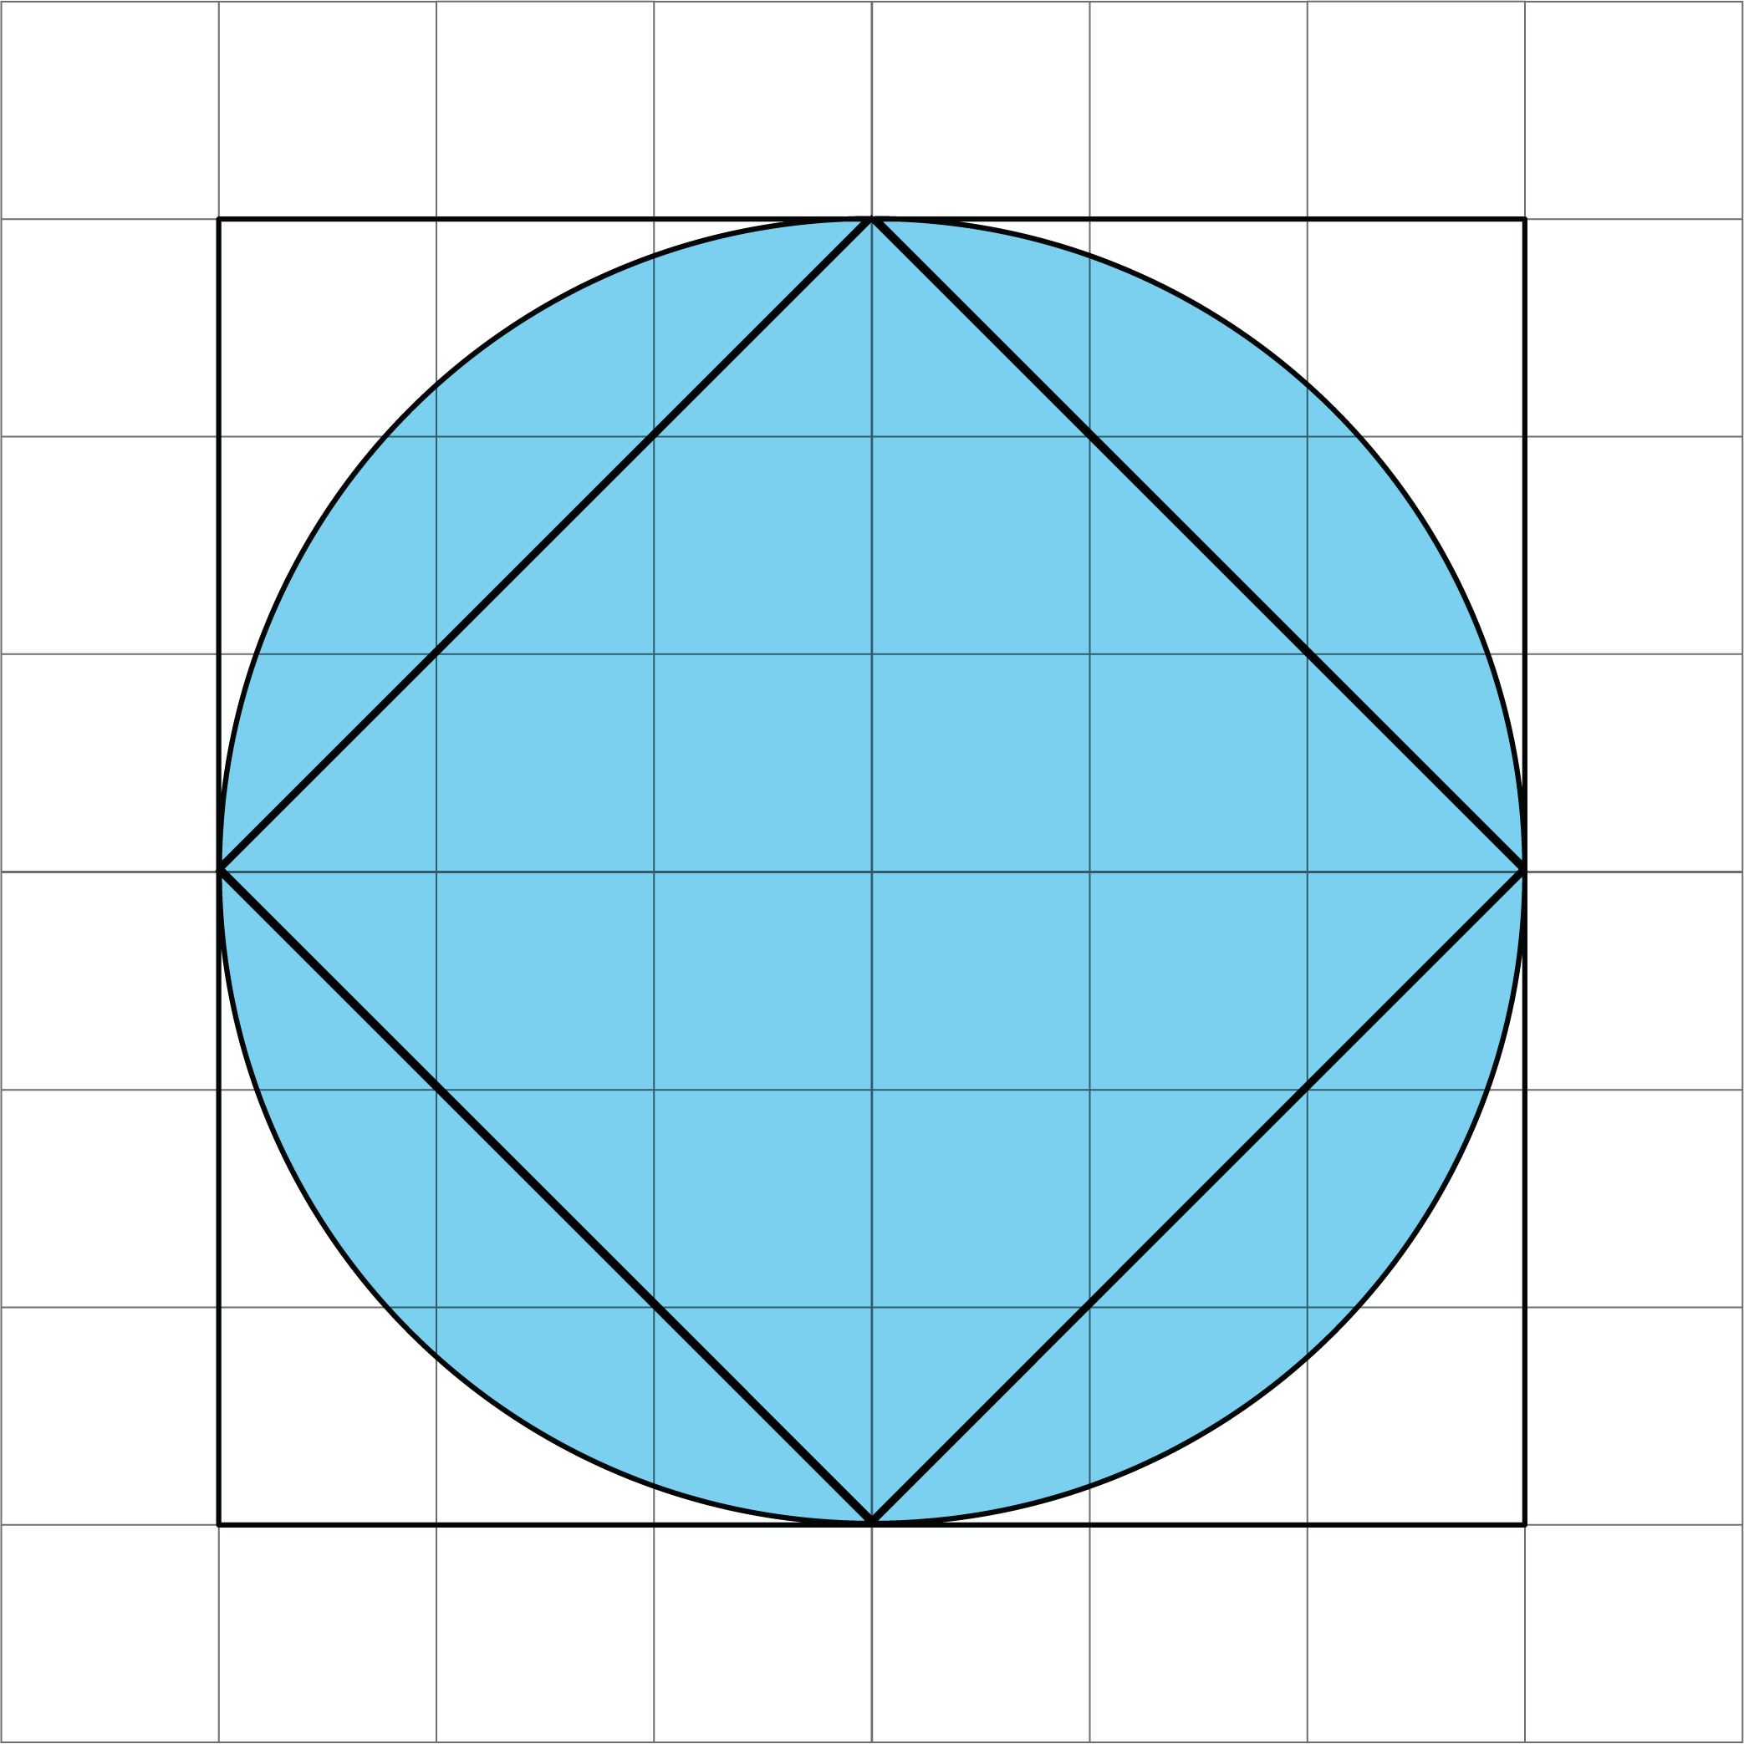
- Point $A$ is the center of the circle, and the length of $CD$ is 15 centimeters. Find the circumference of this circle.
- 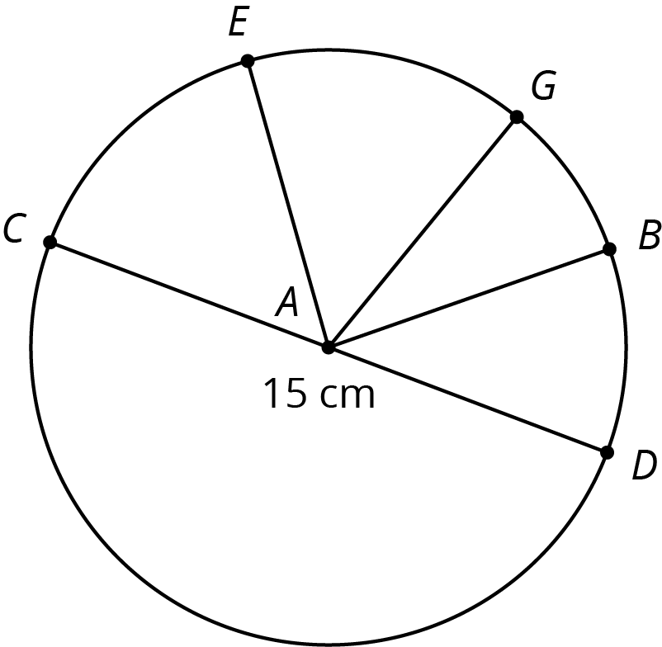
- (From Unit 3, Lesson 3.)
© CC BY Open Up Resources. Adaptations CC BY IM.

