Lesson 16 Practice Problems
- Triangle $ABC$ and its medians are shown.
- 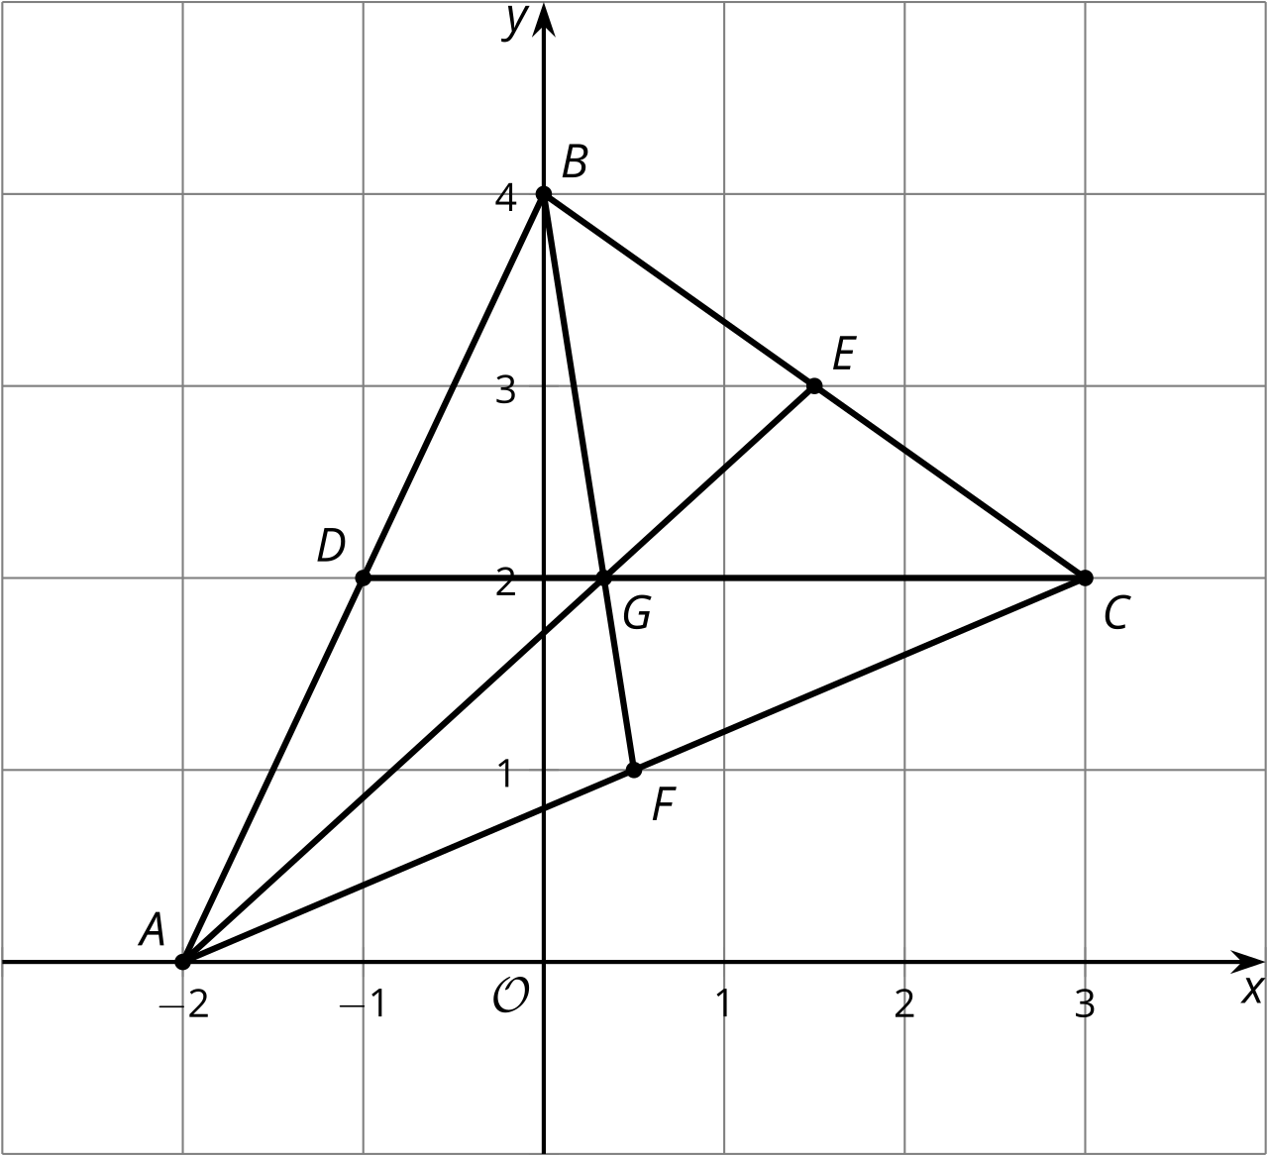
- Select all statements that are true.
  - The medians intersect at $\left(\frac{1}{3},2\right)$.
  - The medians and altitudes are the same for this triangle.
  - An equation for median $AE$ is $y=\frac{6}{7}\left(x+2\right)$.
  - Point $G$ is $\frac{2}{3}$ of the way from $A$ to $E$.
  - Median $BF$ is congruent to median $CD$.
- Triangle $ABC$ has vertices at $\left(\text{-}2,0\right),\left(\text{-}1,6\right),$ and $\left(6,0\right)$. What is the point of intersection of the triangle’s medians?
- Triangle $EFG$ and its medians are shown.
- 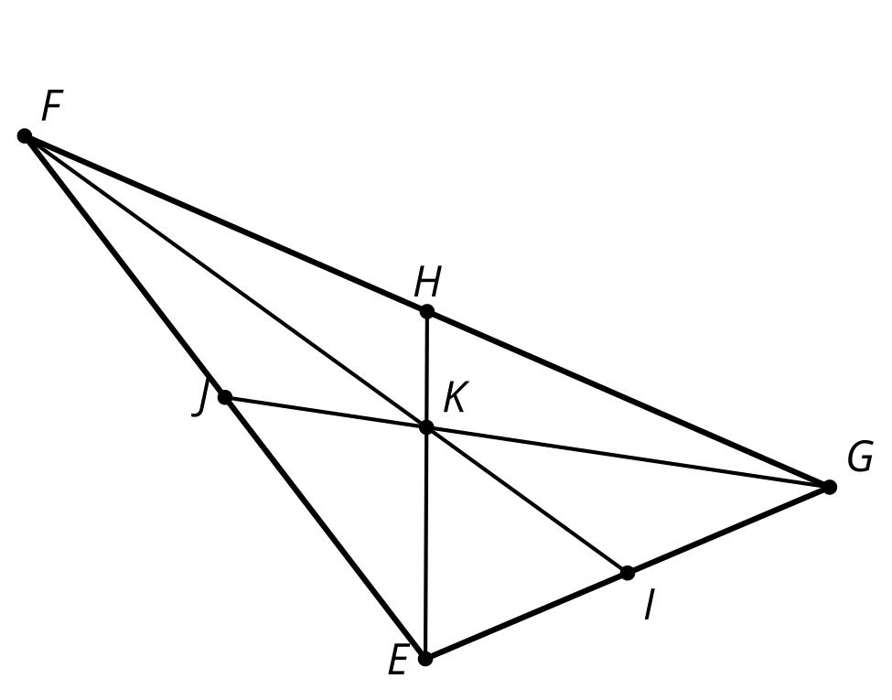
- Match each pair of segments with the ratios of their lengths.
  - $GK:KJ$
  - $GH:HF$
  - $HK:KE$
  - $1:1$
  - $1:2$
  - $2:1$
- Given $A=\left(\text{-}3,2\right)$ and $B=\left(7,\text{-}10\right)$, find the point that partitions segment $AB$ in a $1:4$ ratio.
- (From Unit 6, Lesson 15.)
- Graph the image of quadrilateral $ABCD$ under a dilation using center $A$ and scale factor $\frac{1}{3}$.
- 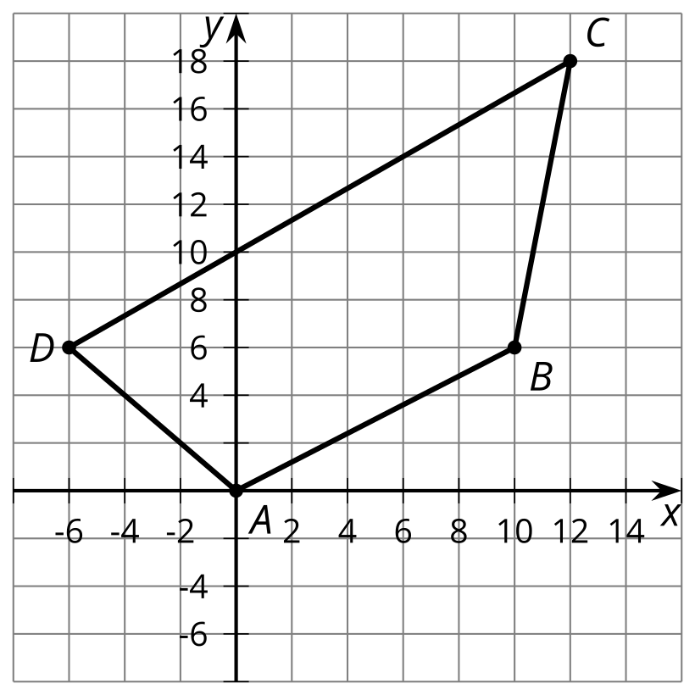
- (From Unit 6, Lesson 15.)
- A trapezoid is a quadrilateral with at least one pair of parallel sides. Show that the quadrilateral formed by the vertices $\left(0,0\right),\left(5,2\right),\left(10,10\right),$ and $\left(0,6\right)$ is a trapezoid.
- (From Unit 6, Lesson 14.)
- Here are the graphs of the circle centered at $\left(0,0\right)$ with radius 6 units and the line given by $2x+y=11$. Determine whether the circle and the line intersect at the point $\left(3,5\right)$. Explain or show your reasoning.
- 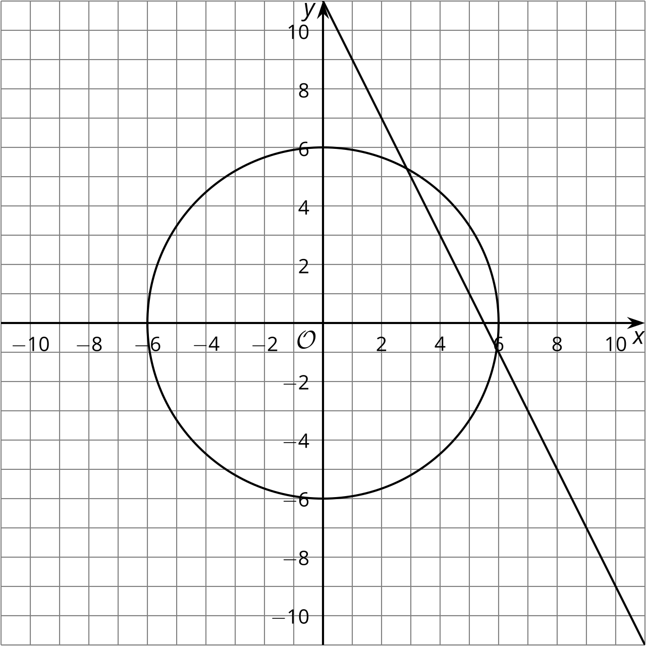
- (From Unit 6, Lesson 13.)
- A parabola has focus $\left(\text{-}3,2\right)$ and directrix $y=\text{-}3$. The point $\left(a,5\right)$ is on the parabola. How far is this point from the focus?
  - 8 units
  - 5 units
  - 3 units
  - 2 units
- (From Unit 6, Lesson 8.)
© CC BY 2019 by Illustrative Mathematics®

