Lesson 9 Practice Problems
- The number of people with the flu during an epidemic is a function, $f$, of the number of days, $d$, since the epidemic began. The equation $f\left(d\right)=50⋅{\left(\frac{3}{2}\right)}^{d}$ defines $f$.
  - How many people had the flu at the beginning of the epidemic? Explain how you know.
  - How quickly is the flu spreading? Explain how you can tell from the equation.
  - What does $f\left(1\right)$ mean in this situation?
  - Does $f\left(3.5\right)$ make sense in this situation?
- The function, $f$, gives the dollar value of a bond $t$ years after the bond was purchased. The graph of $f$ is shown.
  - What is $f\left(0\right)$? What does it mean in this situation?
  - What is $f\left(4.5\right)$? What does it mean in this situation?
  - When is $f\left(t\right)=1500$? What does this mean in this situation?
- 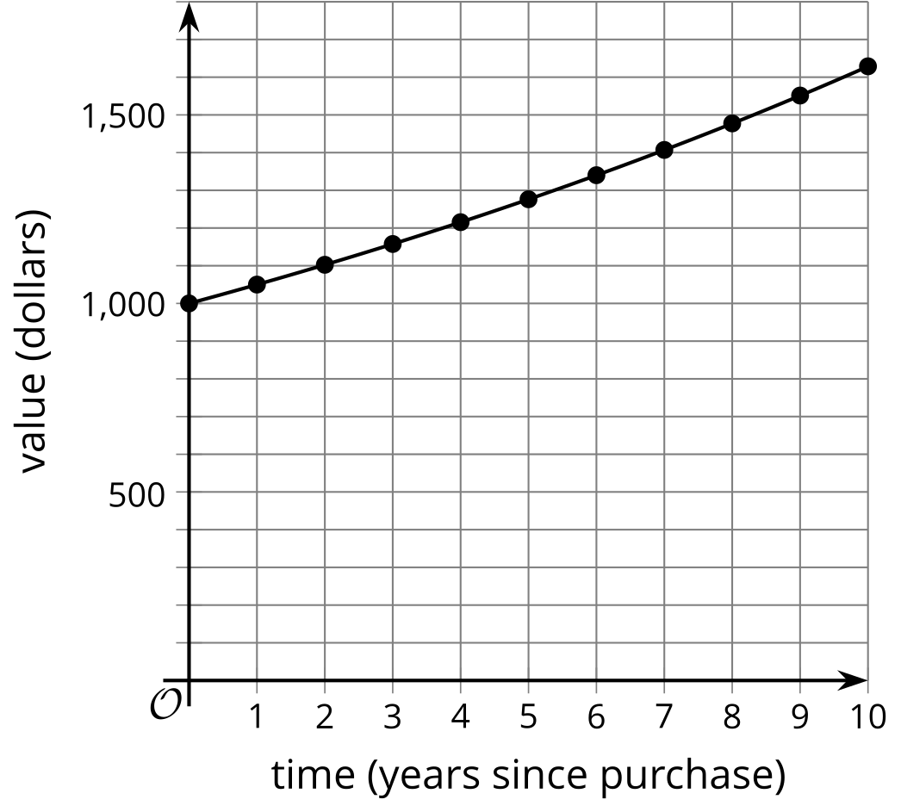
- Technology required. A function $f$ gives the number of stray cats in a town $t$ years since the town started an animal control program. The program includes both sterilizing stray cats and finding homes to adopt them. An equation representing $f$ is $f\left(t\right)=243{\left(\frac{1}{3}\right)}^{t}$.
  - What is the value of $f\left(t\right)$ when $t$ is 0? Explain what this value means in this situation.
  - What is the approximate value of $f\left(t\right)$ when $t$ is $\frac{1}{2}$? Explain what this value means in this situation.
  - What does the number $\frac{1}{3}$ tell you about the stray cat population?
  - Use technology to graph $f$ for values of $t$ between 0 and 4. What graphing window allows you to see values of $f\left(t\right)$ that correspond to these values of $t$?
- Function $g$ gives the amount of a chemical in a person's body, in milligrams, $t$ hours since the patient took the drug. The equation $g\left(t\right)=600⋅{\left(\frac{3}{5}\right)}^{t}$ defines this function.
  - What does the fraction $\frac{3}{5}$ mean in this situation?
  - Sketch a graph of $g$.
  - What are the domain and range of $g$? Explain what they mean in this situation.
- The dollar value of a moped is a function of the number of years, $t$, since the moped was purchased. The function, $f$, is defined by the equation $f\left(t\right)=2,​500⋅{\left(\frac{1}{2}\right)}^{t}$ .
- What is the best choice of domain for the function $f$?
  - $\text{-}10≤t≤10$
  - $\text{-}10≤t≤0$
  - $0≤t≤10$
  - $0≤t≤100$
- A patient receives 1,000 mg of a medicine. Each hour, $\frac{1}{5}$ of the medicine in the patient's body decays.
  - Complete the table with the amount of medicine in the patient's body.
  - Write an equation representing the number of mg of the medicine, $m$, in the patient's body $h$ hours after receiving the medicine.
  - Use your equation to find $m$ when $h=10$. What does this mean in terms of the medicine?
- hours since  ​​​​​​receiving medicine | - mg of medicine  left in body
- 0
- 1
- 2
- 3
- $h$
- (From Unit 5, Lesson 4.)
- The trees in a forest are suffering from a disease. The population of trees, $p$, in thousands, is modeled by the equation $p=90⋅{\left(\frac{3}{4}\right)}^{t}$, where $t$ is the number of years since 2000.
  - What was the tree population in 2001? What about in 1999?
  - What does the number $\frac{3}{4}$ in the equation for $p$ tell you about the population?
  - What is the last year when the population was more than 250,000? Explain how you know.
- (From Unit 5, Lesson 7.)
- All of the students in a classroom list their birthdays.
  - Is the birthdate, $b$, a function of the student, $s$?
  - Is the student, $s$, a function of the birthdate, $b$?
- (From Unit 5, Lesson 8.)
- Mai wants to graph the solution to the inequality $5x−4>2x−19$ on a number line. She solves the equation $5x−4=2x−19$ for $x$ and gets $x=\text{-}5$.
- Which graph shows the solution to the inequality?
- (From Unit 2, Lesson 19.)
© CC BY 2019 by Illustrative Mathematics®

