Lesson 3 Practice Problems
- Diego measured the diameter and circumference of several circular objects and recorded his measurements in the table.
- object | - diameter (cm) | - circumference (cm)
- half dollar coin | - 3 | - 10
- flying disc | - 23 | - 28
- jar lid | - 8 | - 25
- flower pot | - 15 | - 48
- One of his measurements is inaccurate. Which measurement is it? Explain how you know.
- Complete the table. Use one of the approximate values for $π$ discussed in class (for example 3.14, $\frac{22}{7}$, 3.1416). Explain or show your reasoning.
- object | - diameter | - circumference
- hula hoop | - 35 in
- circular pond |  | - 556 ft
- magnifying glass | - 5.2 cm
- car tire |  | - 71.6 in
- $A$ is the center of the circle, and the length of $CD$ is 15 centimeters.
  - Name a segment that is a radius. How long is it?
  - Name a segment that is a diameter. How long is it?
- 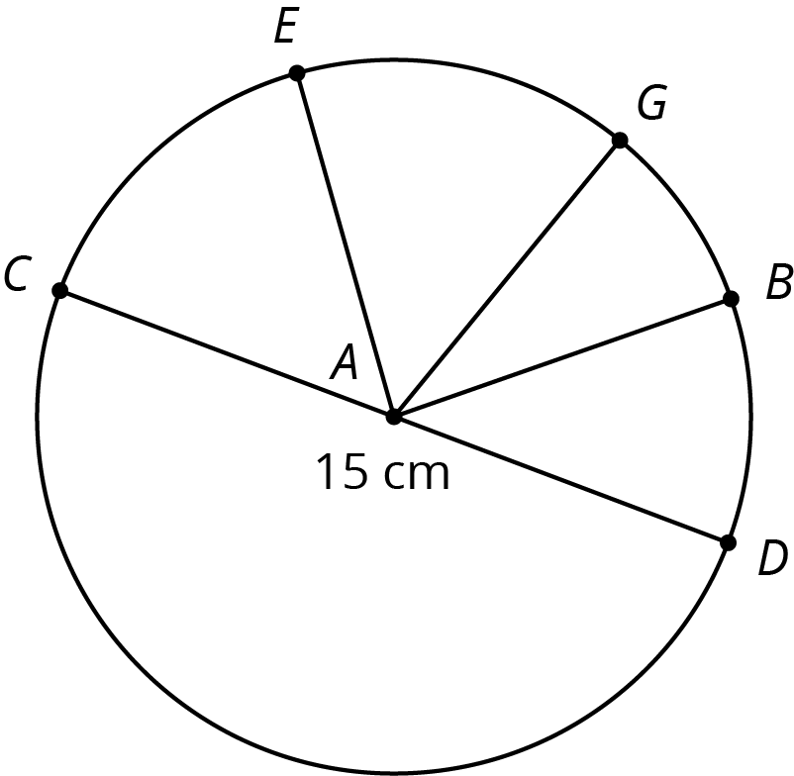
- (From Unit 3, Lesson 2.)

  - Consider the equation $y=1.5x+2$. Find four pairs of $x$ and $y$ values that make the equation true. Plot the points $\left(x,y\right)$ on the coordinate plane.
  - 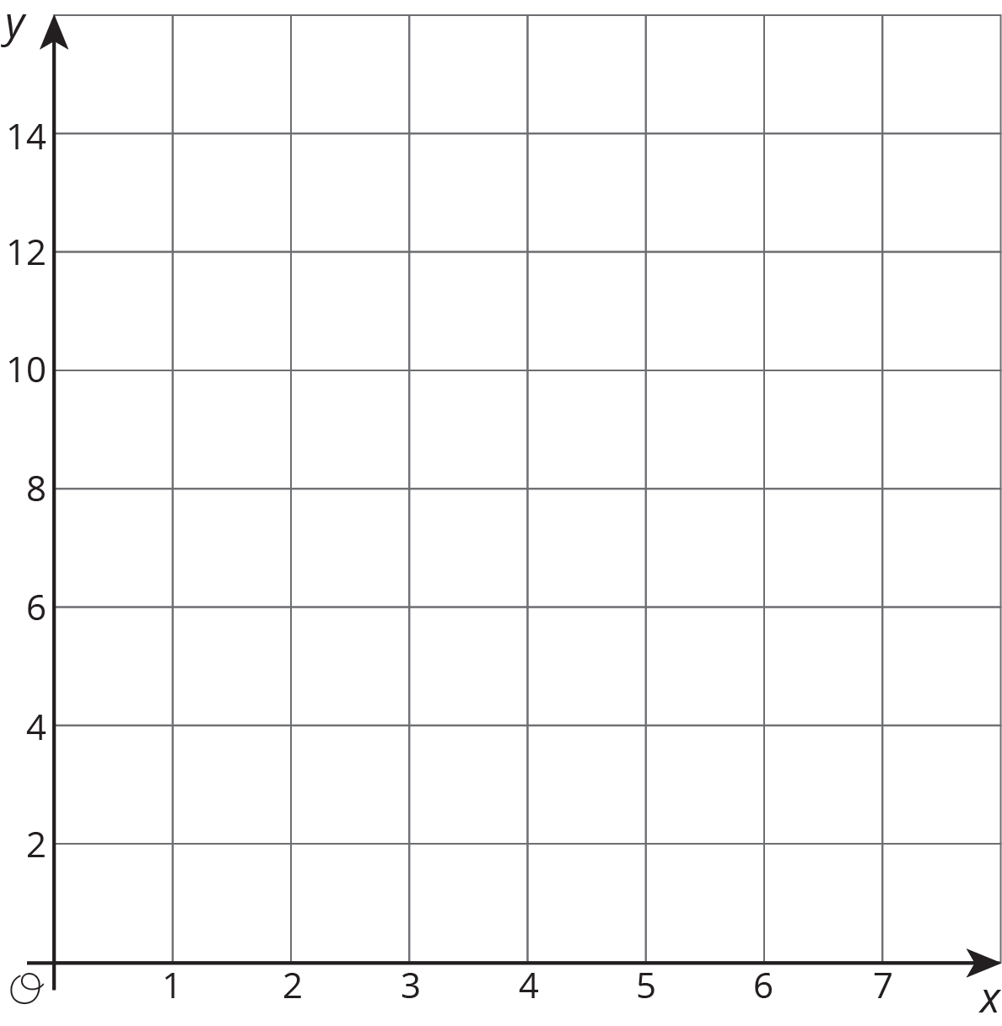
  - Based on the graph, can this be a proportional relationship? Why or why not?
- (From Unit 2, Lesson 10.)
© CC BY Open Up Resources. Adaptations CC BY IM.

