Lesson 12: Polynomial Division (Part 1)
- Let’s learn a way to divide polynomials.

12.1: Notice and Wonder: A Different Use for Diagrams
What do you notice? What do you wonder?
A. $\left(x−3\right)\left(x+5\right)=x^{2}+2x−15$
 | $x$ | 5
$x$ | $x^{2}$ | $5x$
-3 | $\text{-}3x$ | -15
B. $\left(x−1\right)\left(x^{2}+3x−4\right)=x^{3}+2x^{2}−7x+4$
 | $x^{2}$ | $3x$ | -4
$x$ | $x^{3}$ | $3x^{2}$ | $\text{-}4x$
-1 | $\text{-}x^{2}$ | $\text{-}3x$ | +4
C. $\left(x−2\right)\left(?\right)=\left(x^{3}−x^{2}−4x+4\right)$
$x$ | $x^{3}$
-2

12.2: Factoring with Diagrams
Priya wants to sketch a graph of the polynomial $f$ defined by $f\left(x\right)=x^{3}+5x^{2}+2x−8$. She knows $f\left(1\right)=0$, so she suspects that $\left(x−1\right)$ could be a factor of $x^{3}+5x^{2}+2x−8$ and writes $\left(x^{3}+5x^{2}+2x−8\right)=\left(x−1\right)\left(?x^{2}+?x+?\right)$ and draws a diagram.
$x$ | $x^{3}$
-1
- Finish Priya’s diagram.
- Write $f\left(x\right)$ as the product of $\left(x−1\right)$ and another factor.
- Write $f\left(x\right)$ as the product of three linear factors.
- Make a sketch of $y=f\left(x\right)$.
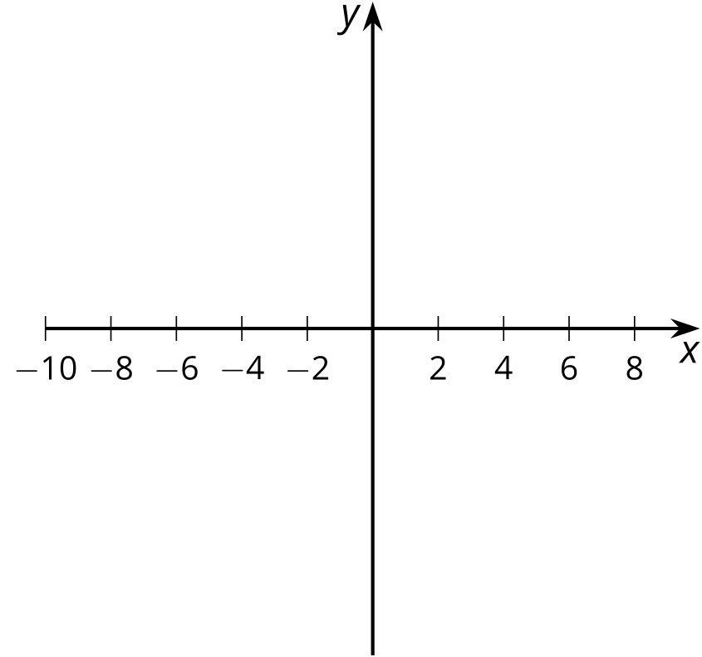

12.3: More Factoring with Diagrams
Here are some polynomial functions with known factors. Rewrite each polynomial as a product of linear factors. Note: you may not need to use all the columns in each diagram. For some problems, you may need to make another diagram.
- $A\left(x\right)=x^{3}−7x^{2}−16x+112$, $\left(x−7\right)$
 | - $x^{2}$
- $x$ | - $x^{3}$ | - 0
- -7 | - $\text{-}7x^{2}$
- $B\left(x\right)=2x^{3}−x^{2}−27x+36$, $\left(x−\frac{3}{2}\right)$
 | - $2x^{2}$
- $x$ | - $2x^{3}$ | - $2x^{2}$
- $\text{-}\frac{3}{2}$ | - $\text{-}3x^{2}$
- $C\left(x\right)=x^{3}−3x^{2}−13x+15$, $\left(x+3\right)$
- $x$
- 3
- $D\left(x\right)=x^{4}−13x^{2}+36$, $\left(x−2\right)$, $\left(x+2\right)$
- (Hint: $x^{4}−13x^{2}+36=x^{4}+0x^{3}−13x^{2}+0x+36$)
- $F\left(x\right)=4x^{4}−15x^{3}−48x^{2}+109x+30$, $\left(x−5\right)$, $\left(x−2\right)$, $\left(x+3\right)$

Are you ready for more?
A diagram can also be used to divide polynomials even when a factor is not linear. Suppose we know $\left(x^{2}−2x+5\right)$ is a factor of $x^{4}+x^{3}−5x^{2}+23x−20$. We could write $\left(x^{4}+x^{3}−5x^{2}+23x−20\right)=\left(x^{2}−2x+5\right)\left(?x^{2}+?x+?\right)$. Make a diagram and find the missing factor.

Lesson 12 Summary
What are some things that could be true about the polynomial function defined by $p\left(x\right)=x^{3}−5x^{2}−2x+24$ if we know $p\left(\text{-}2\right)=0$? If we think about the graph of the polynomial, the point $\left(\text{-}2,0\right)$ must be on the graph as a horizontal intercept. If we think about the expression written in factored form, $\left(x+2\right)$ could be one of the factors, since $x+2=0$ when $x=\text{-}2$. How can we figure out whether $\left(x+2\right)$ actually is a factor?
Well, if we assume $\left(x+2\right)$ is a factor, there is some other polynomial $q\left(x\right)=ax^{2}+bx+c$ where $a$, $b$, and $c$ are real numbers and $p\left(x\right)=\left(x+2\right)q\left(x\right)$. (Can you see why $q\left(x\right)$ has to have a degree of 2?) In the past, we have done things like expand $\left(x+2\right)\left(ax^{2}+bx+c\right)$ to find $p\left(x\right)$. Since we already know the expression for $p\left(x\right)$, we can instead work out the values of $a$, $b$, and $c$ by thinking through the calculation.
One way to organize our thinking is to use a diagram. We first fill in $\left(x+2\right)$ and the leading term of $p\left(x\right)$, $x^{3}$. From this start, we see the leading term of $q\left(x\right)$ must be $x^{2}$, meaning $a=1$, since $x⋅x^{2}=x^{3}$.
 | $x^{2}$
$x$ | $x^{3}$
+2
We then fill in the rest of the diagram using similar thinking and paying close attention to the signs of each term. For example, we put in a $2x^{2}$ in the bottom left cell because that’s the product of $2$ and $x^{2}$. But that means we need to have a $\text{-}7x^{2}$ in the middle cell of the middle row, since that’s the only other place we will get an $x^{2}$ term, and we need to get $\text{-}5x^{2}$ once all the terms are collected. Continuing in this way, we get the completed table:
 | $x^{2}$ | $\text{-}7x$ | +12
$x$ | $x^{3}$ | $\text{-}7x^{2}$ | $+12x$
+2 | $+2x^{2}$ | $\text{-}14x$ | +24
Collecting all the terms in the interior of the diagram, we see that $x^{3}−5x^{2}−2x+24=\left(x+2\right)\left(x^{2}−7x+12\right)$, so $q\left(x\right)=x^{2}−7x+12$. Notice that the 24 in the bottom right was exactly what we needed, and it’s how we know that $\left(x+2\right)$ is a factor of $p\left(x\right)$. In a future lesson, we will see why this happened. With a bit more factoring, we can say that $p\left(x\right)=\left(x+2\right)\left(x−3\right)\left(x−4\right)$.
© CC BY 2019 by Illustrative Mathematics®

