Lesson 12 Practice Problems
- For each equation, is the graph of the equation parallel to the line shown, perpendicular to the line shown, or neither?
- 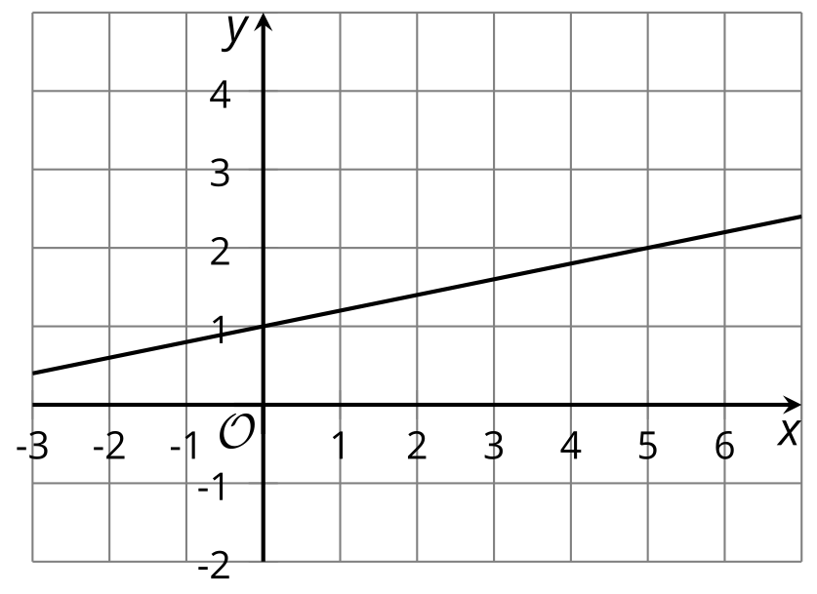
  - $y=0.2x$
  - $y=\text{-}2x+1$
  - $y=5x−3$
  - $\left(y−3\right)=\text{-}5\left(x−4\right)$
  - $\left(y−1\right)=2\left(x−3\right)$
  - $5x+y=3$
- Main Street is parallel to Park Street. Park Street is parallel to Elm Street. Elm is perpendicular to Willow. How does Willow compare to Main?
- The line which is the graph of $y=2x−4$ is transformed by the rule $\left(x,y\right)→\left(\text{-}x,\text{-}y\right)$. What is the slope of the image?
- Select all equations whose graphs are lines perpendicular to the graph of $3x+2y=6$.
  - $3x−2y=4$
  - $2x+3y=6$
  - $2x−3y=8$
  - $\left(y−4\right)=\frac{2}{3}\left(x−6\right)$
  - $\left(y−2\right)=\text{-}\frac{3}{2}\left(x−8\right)$
  - $y=\frac{2}{3}x$
  - $y=\frac{3}{2}x+3$
- (From Unit 6, Lesson 11.)
- Match each line with a perpendicular line.
  - the line through $\left(12,4\right)$ and $\left(9,19\right)$
  - $2x−5y=10$
  - $y−4=\frac{2}{3}\left(x+1\right)$
  - the line through $\left(3,1\right)$ and $\left(1,4\right)$
  - $y=\frac{1}{5}x+7$
  - $y−1=\text{-}2.5\left(x+3\right)$
- (From Unit 6, Lesson 11.)
- The graph of $y=\text{-}4x+2$ is translated by the directed line segment $AB$ shown. What is the slope of the image?
- 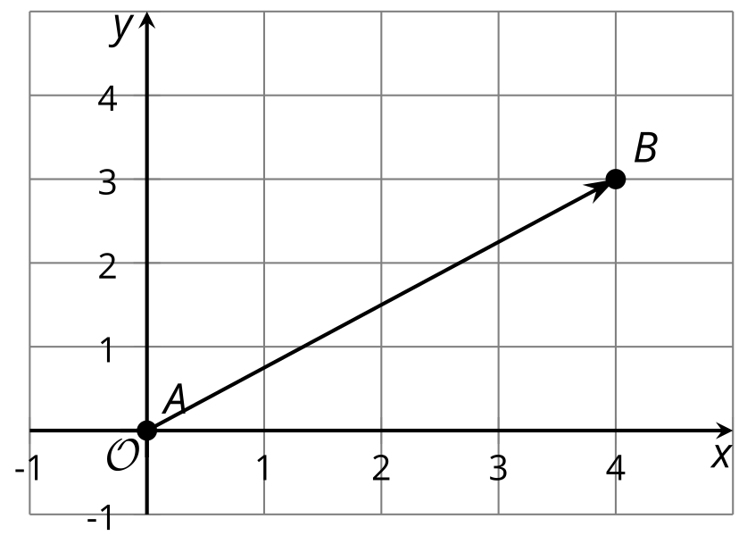
- (From Unit 6, Lesson 10.)
- Select all points on the line with a slope of $\text{-}\frac{1}{2}$ that go through the point $\left(4,\text{-}1\right)$.
  - $\left(\text{-}2,2\right)$
  - $\left(0,2\right)$
  - $\left(4,\text{-}1\right)$
  - $\left(0,1\right)$
  - $\left(\text{-}3,8\right)$
- (From Unit 6, Lesson 9.)
- One way to define a circle is that it is the set of all points that are the same distance from a given center. How does the equation ${\left(x−h\right)}^{2}+{\left(y−k\right)}^{2}=r^{2}$ relate to this definition? Draw a diagram if it helps you explain.
- (From Unit 6, Lesson 4.)
© CC BY 2019 by Illustrative Mathematics®

