Lesson 11 Practice Problems
- A cube is cut into two pieces by a single slice that passes through points $A$, $B$, and $C$. What shape is the cross section?
- 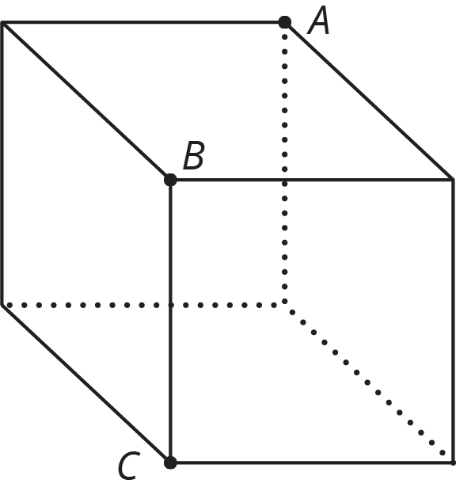
- Describe how to slice the three-dimensional figure to result in each cross section.
- Three-dimensional figure:
- Cross sections:
- 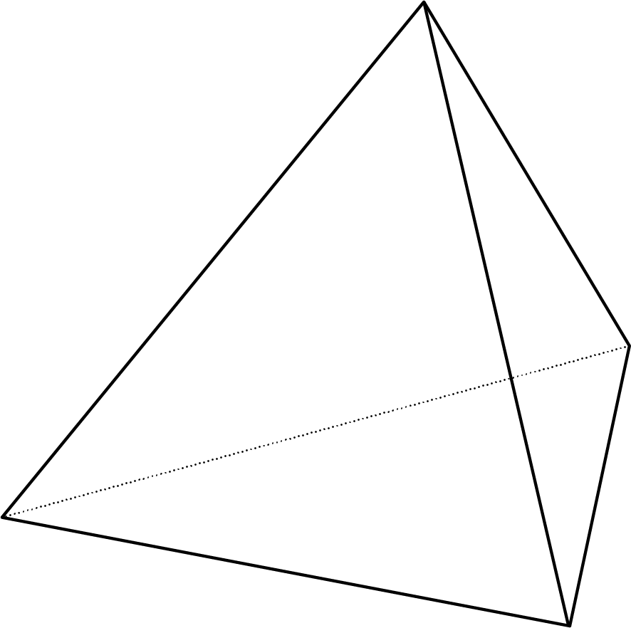

- Here are two three-dimensional figures.
- 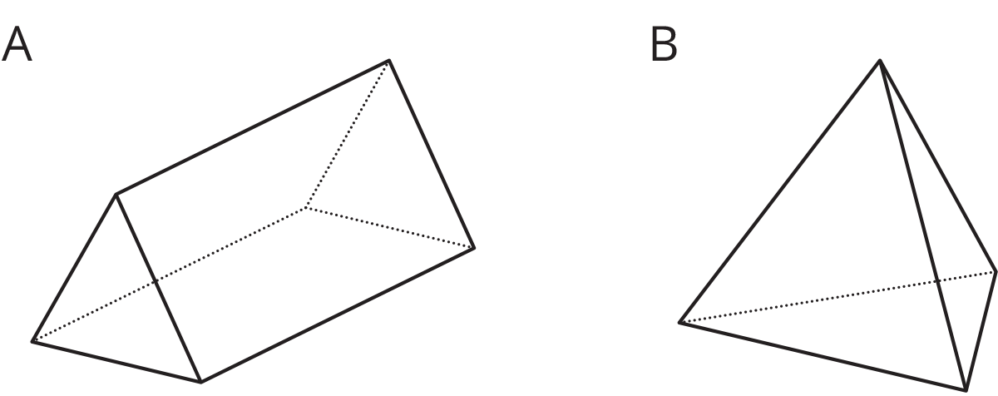
- Describe a way to slice one of the figures so that the cross section is a rectangle.
- Each row contains the degree measures of two supplementary angles. Complete the table.
- measure of an angle | - measure of its supplement
- ${80}^{∘}$
- ${25}^{∘}$
- ${119}^{∘}$
- $x$
- (From Unit 7, Lesson 2.)
- Two months ago, the price, in dollars, of a cell phone was $c$.
  - Last month, the price of the phone increased by 10%. Write an expression for the price of the phone last month.
  - This month, the price of the phone decreased by 10%. Write an expression for the price of the phone this month.
  - Is the price of the phone this month the same as it was two months ago? Explain your reasoning.
- (From Unit 4, Lesson 8.)
© CC BY Open Up Resources. Adaptations CC BY IM.

