Lesson 11: Finding Intersections
- Let’s think about two polynomials at once.

11.1: Math Talk: When $f$ Meets $g$
Mentally identify a point where the graphs of the two functions intersect, if one exists.
$f\left(x\right)=x$ and $g\left(x\right)=3$
$j\left(x\right)=\left(x+3\right)\left(x−3\right)$ and $k\left(x\right)=0$
$m\left(x\right)=\left(x+3\right)\left(x−3\right)$ and $n\left(x\right)=\left(x−3\right)$
$p\left(x\right)=\left(x+5\right)\left(x−5\right)$ and $q\left(x\right)=\left(x+3\right)\left(x−3\right)$

11.2: More Points of Intersection
For each pair of polynomials given, find all points of intersection of their graphs.
- $c\left(x\right)=x^{2}−7$ and $d\left(x\right)=2$
- $f\left(x\right)=\left(x+7\right)\left(x−4\right)$ and $g\left(x\right)=x−4$
- $m\left(x\right)=\left(x+7\right)\left(x−4\right)$ and $n\left(x\right)=\left(2x+5\right)\left(x−4\right)$
- $p\left(x\right)=\left(x+1\right)\left(x−8\right)$ and $q\left(x\right)=\left(x+2\right)\left(x−4\right)$

Are you ready for more?
Find all points of intersection of the graphs of the equations $p\left(x\right)=\left(2x+3\right)\left(x−5\right)$ and $q\left(x\right)=\left(x+5\right)\left(x+1\right)\left(x−3\right)$. Use graphing technology to check your solutions.

11.3: Graphing to Find Points of Intersection
Consider the functions $p\left(x\right)=5x^{3}+6x^{2}+4x$ and $q\left(x\right)=5640$.
- Use graphing technology to find a value of $x$ that makes $p\left(x\right)=q\left(x\right)$ true.
- For the $x$-value at the point of intersection, what can you say about the value of $5x^{3}+6x^{2}+4x−5640$?
- What does your answer suggest is a possible factor of $5x^{3}+6x^{2}+4x−5640$?

  - Write your own polynomial $m\left(x\right)$ of degree 3 or higher.
  - Use graphing technology to estimate the values of $x$ that make $m\left(x\right)=q\left(x\right)$ true.

Lesson 11 Summary
When asked to find all values of $x$ that make an equation like $\left(x+4\right)\left(x−8\right)=\left(2−x\right)\left(x−8\right)$ true, one way to consider the question is to ask where the graphs of the functions $f\left(x\right)=\left(x+4\right)\left(x−8\right)$ and $g\left(x\right)=\left(2−x\right)\left(x−8\right)$ intersect.
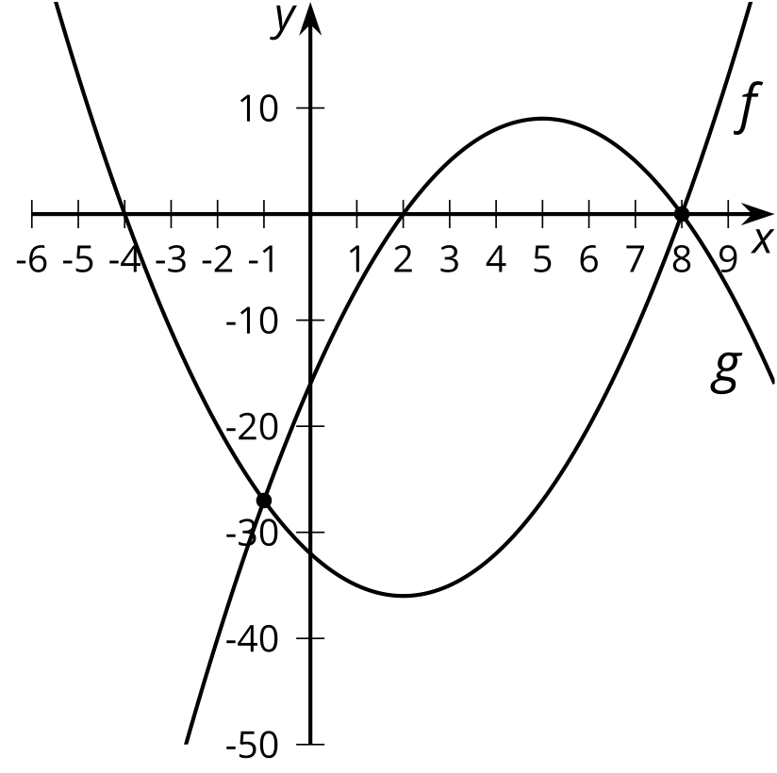
Since the coordinate of any point of intersection has the form $\left(a,f\left(a\right)\right)=\left(a,g\left(a\right)\right)$, these points must make $f\left(x\right)=g\left(x\right)$ true when $x=a$. In our example, we can tell from the graph that both $x=\text{-}1$ and $x=8$ are solutions to the original equation.
We can also use algebra to identify solutions to $\left(x+4\right)\left(x−8\right)=\left(2−x\right)\left(x−8\right)$ by rearranging and then recognizing that both parts have a factor of $\left(x−8\right)$ in common:
$\begin{matrix}\left(x+4\right)\left(x−8\right) & =\left(2−x\right)\left(x−8\right) \\ \left(x+4\right)\left(x−8\right)−\left(2−x\right)\left(x−8\right) & =0 \\ \left(x−8\right)\left(x+4−2+x\right) & =0 \\ \left(x−8\right)\left(2x+2\right) & =0 \\ x & =8,\text{-}1\end{matrix}$
For polynomials created to model specific situations that have a more messy structure, solving without using technology can be challenging, especially because the graphs of two polynomials can intersect at multiple points because of the way they curve. Fortunately, this type of solving challenge is one that computer algebra systems are usually very good at, leaving the interpretation of the solution up to humans.
© CC BY 2019 by Illustrative Mathematics®

