Lesson 11 Practice Problems
- Write an equation for a line that passes through the origin and is perpendicular to $y=5x−2$.
- Match each line with a perpendicular line.
  - $y=5x+2$
  - $y−2.25=\text{-}2\left(x−2\right)$
  - the line through $\left(\text{-}1,5\right)$ and $\left(1,9\right)$
  - the line through $\left(2,12\right)$ and $\left(17,9\right)$
  - $y=\text{-}\frac{1}{2}x+5$
  - $2x−4y=10$
- The rule $\left(x,y\right)→\left(y,\text{-}x\right)$ takes a line to a perpendicular line. Select all the rules that take a line to a perpendicular line.
  - $\left(x,y\right)→\left(2y,\text{-}x\right)$
  - $\left(x,y\right)→\left(\text{-}y,\text{-}x\right)$
  - $\left(x,y\right)→\left(\text{-}y,x\right)$
  - $\left(x,y\right)→\left(0.5y,\text{-}2x\right)$
  - $\left(x,y\right)→\left(4y,\text{-}4x\right)$

  - Write an equation of the line with $x$-intercept $\left(3,0\right)$ and $y$-intercept $\left(0,\text{-}4\right)$.
  - Write an equation of a line parallel to the line $y−5=\frac{4}{3}\left(x−2\right)$.
- (From Unit 6, Lesson 10.)
- Lines $ℓ$ and $p$ are parallel. Select all true statements.
- 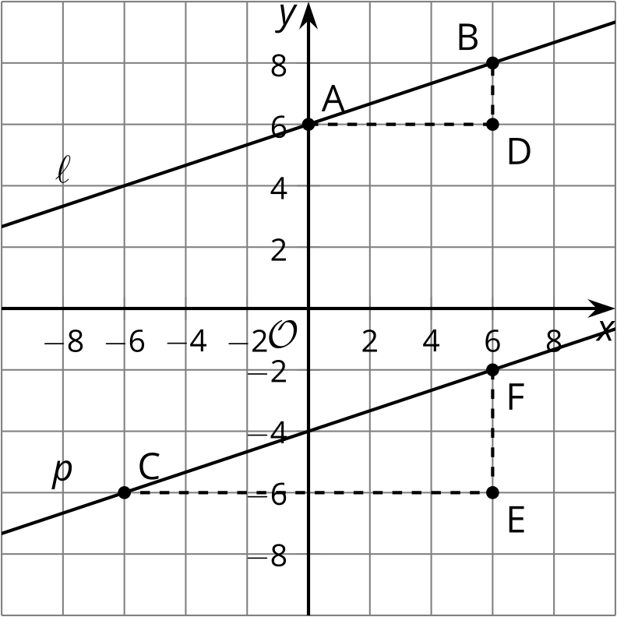
  - Triangle $ADB$ is similar to triangle $CEF$.
  - Triangle $ADB$ is congruent to triangle $CEF$.
  - The slope of line $ℓ$ is equal to the slope of line $p$.
  - $sin\left(A\right)=sin\left(C\right)$
  - $sin\left(B\right)=cos\left(C\right)$
- (From Unit 6, Lesson 10.)
- Select the equation that states $\left(x,y\right)$ is the same distance from $\left(0,5\right)$ as it is from the line $y=\text{-}3$.
  - $x^{2}+{\left(y+5\right)}^{2}={\left(y+3\right)}^{2}$
  - $x^{2}+{\left(y−5\right)}^{2}={\left(y+3\right)}^{2}$
  - $x^{2}+{\left(y+5\right)}^{2}={\left(y−3\right)}^{2}$
  - $x^{2}+{\left(y−5\right)}^{2}={\left(y−3\right)}^{2}$
- (From Unit 6, Lesson 8.)
- Select all equations that represent the graph shown.
- 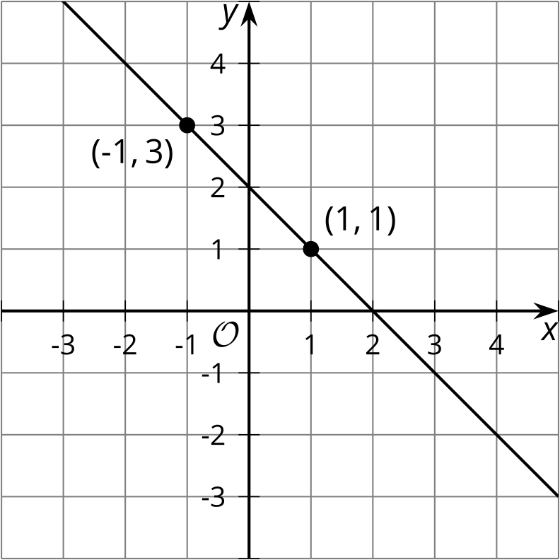
  - $y=\text{-}x+2$
  - $\left(y−3\right)=\text{-}\left(x+1\right)$
  - $\left(y−3\right)=\text{-}x−1$
  - $\left(y−3\right)=\left(x−1\right)$
  - $\left(y+1\right)=\text{-}\left(x−3\right)$
- (From Unit 6, Lesson 9.)
- Write a rule that describes this transformation.
- original figure | - image
- $\left(3,2\right)$ | - $\left(6,4\right)$
- $\left(4,\text{-}1\right)$ | - $\left(8,\text{-}2\right)$
- $\left(5,1\right)$ | - $\left(10,2\right)$
- $\left(7,3\right)$ | - $\left(14,6\right)$
- (From Unit 6, Lesson 3.)
© CC BY 2019 by Illustrative Mathematics®

