Unit 4 Lesson 4: Ratios in Right Triangles

1 Ratio Rivalry (Warm up)

Student Task Statement
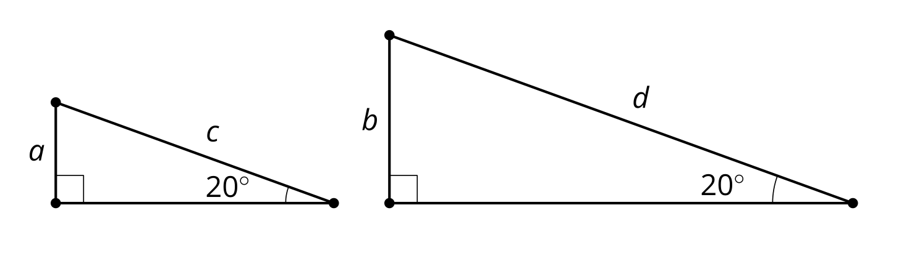
Consider $\frac{a}{c}\text{ and }\frac{b}{d}$. Which is greater, or are they equal? Explain how you know.

2 Tons of Triangles

Student Task Statement
Your teacher will give you some angles.
- Draw several right triangles using the angles you receive.
- Precisely measure the side lengths of the triangles.
- Complete the tables by computing 3 quotients for the acute angles in each triangle:
  - The length of the leg adjacent to your angle divided by the length of the hypotenuse
  - The length of the leg opposite from your angle divided by the length of the hypotenuse
  - The length of the leg opposite from your angle divided by the length of the leg adjacent to your angle
- Find the mean of each column in your table.
- What do you notice about your table? What do you wonder about your table?

3 Tons of Ratios

Student Task Statement
- Compare the row for 20 degrees and the row for 70 degrees in the right triangle table. What is the same? What is different?
- The row for 55 degrees is given here. Complete the row for 35 degrees.
- angle | - adjacent leg $÷$ hypotenuse | - opposite leg $÷$ hypotenuse | - opposite leg $÷$ adjacent leg
- ${35}^{∘}$
- ${55}^{∘}$ | - 0.574 | - 0.819 | - 1.428
- What do you know about a triangle with an adjacent leg to hypotenuse ratio value of 0.839?
© CC BY 2019 by Illustrative Mathematics®

