Lesson 12: Arithmetic with Complex Numbers
- Let’s work with complex numbers.

12.1: Math Talk: Telescoping Sums
Find the value of these expressions mentally.
$2−2+20−20+200−200$
$100−50+10−10+50−100$
$3+2+1+0−1−2−3$
$1+2+4+8+16+32−16−8−4−2−1$

12.2: Adding Complex Numbers
- This diagram represents $\left(2+3i\right)+\left(\text{-}8−8i\right)$.
- 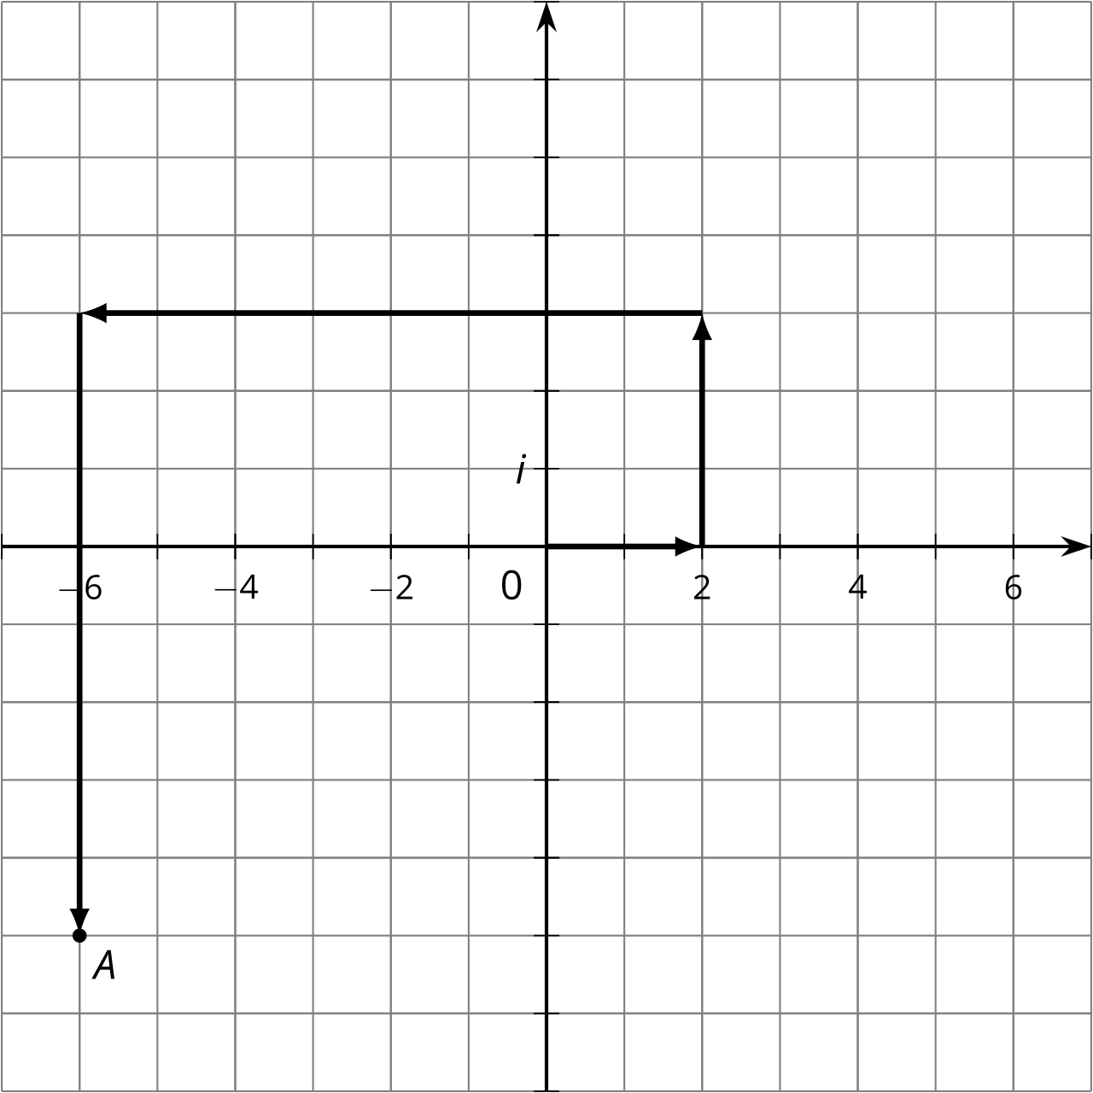
  - How do you see $2+3i$ represented?
  - How do you see $\text{-}8−8i$ represented?
  - What complex number does $A$ represent?
  - Add “like terms” in the expression $\left(2+3i\right)+\left(\text{-}8−8i\right)$. What do you get?
- Write these sums and differences in the form $a+bi$, where $a$ and $b$ are real numbers.
  - $\left(\text{-}3+2i\right)+\left(4−5i\right)$ (Check your work by drawing a diagram.)
  - $\left(\text{-}37−45i\right)+\left(11+81i\right)$
  - $\left(\text{-}3+2i\right)−\left(4−5i\right)$
  - $\left(\text{-}37−45i\right)−\left(11+81i\right)$

12.3: Multiplication on the Complex Plane
- Draw points to represent 2, 2², 2³, and 2⁴ on the real number line.

  - Write $2i$, ${\left(2i\right)}^{2}$, ${\left(2i\right)}^{3}$, and ${\left(2i\right)}^{4}$ in the form $a+bi$.
  - Plot $2i$, ${\left(2i\right)}^{2}$, ${\left(2i\right)}^{3}$, and ${\left(2i\right)}^{4}$ on the complex plane.
  - 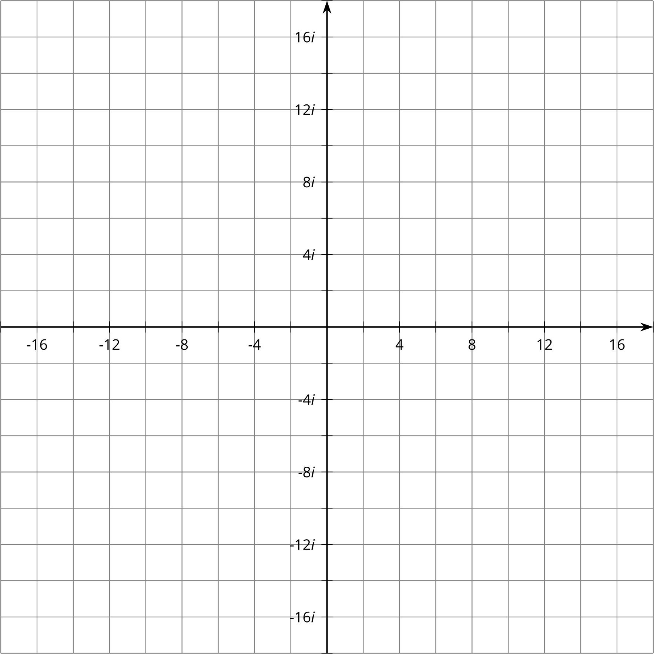

Are you ready for more?
- If $a$ and $b$ are positive numbers, is it true that $\sqrt{ab}=\sqrt{a}\sqrt{b}$? Explain how you know.
- If $a$ and $b$ are negative numbers, is it true that $\sqrt{ab}=\sqrt{a}\sqrt{b}$? Explain how you know.

Lesson 12 Summary
When we add a real number with an imaginary number, we get a complex number. We usually write complex numbers as:
$a+bi$
where $a$ and $b$ are real numbers. We say that $a$ is the real part and $bi$ is the imaginary part.
To add (or subtract) two complex numbers, we add (or subtract) the real parts and add (or subtract) the imaginary parts. For example:
$\left(2+3i\right)+\left(4+5i\right)=\left(2+4\right)+\left(3i+5i\right)=6+8i$
$\left(2+3i\right)−\left(4+5i\right)=\left(2−4\right)+\left(3i−5i\right)=\text{-}2−2i$
In general:
$\left(a+bi\right)+\left(c+di\right)=\left(a+c\right)+\left(b+d\right)i$
and:
$\left(a+bi\right)−\left(c+di\right)=\left(a−c\right)+\left(b−d\right)i$
When we raise an imaginary number to a power, we can use the fact that $i^{2}=\text{-}1$ to write the result in the form $a+bi$. For example, ${\left(4i\right)}^{3}=4i⋅4i⋅4i$. We can group the $i$ factors together to see how to rewrite this.
$\begin{matrix}4i⋅4i⋅4i & =\left(4⋅4⋅4\right)⋅\left(i⋅i⋅i\right) \\ & =64⋅\left(i^{2}⋅i\right) \\ & =64⋅\text{-}1⋅i \\ & =\text{-}64i\end{matrix}$
So in this example, $a$ is 0 and $b$ is -64.
© CC BY 2019 by Illustrative Mathematics®

