Unit 2 Lesson 8: Reasoning About Equations

1 Math Talk: Multiplying (Warm up)

Student Task Statement
Evaluate mentally.
$3⋅10$
$3⋅13$
Apply the distributive property.
$3\left(13+x\right)$
$3x\left(8−y\right)$

2 Keeping It Equal

Images for Launch
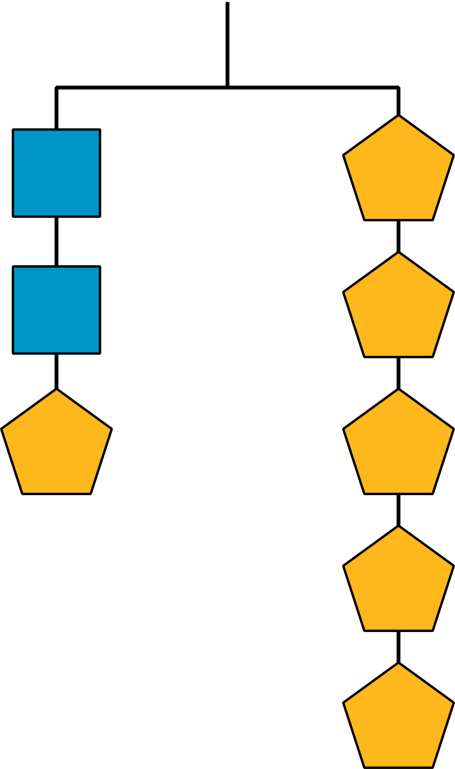
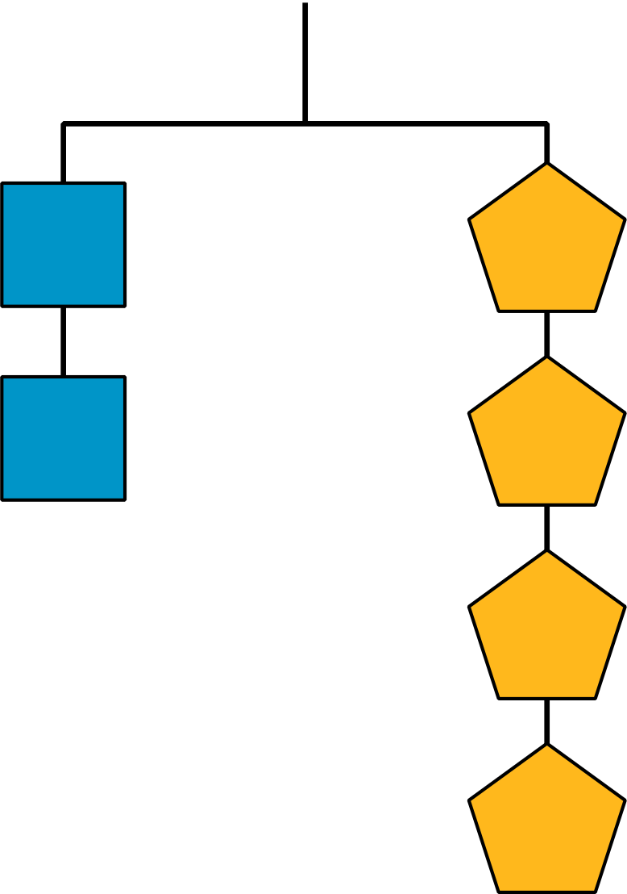
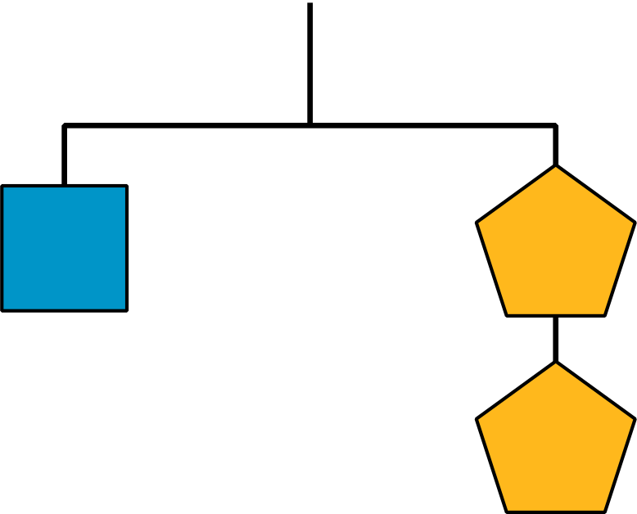

Student Task Statement
- Here is Diego’s work.
- $\begin{matrix}\frac{\left(4x+1\right)}{5} & =2x \\ 5⋅\frac{\left(4x+1\right)}{5} & =5⋅2x \\ 4x+1 & =10x \\ 4x+1−4x & =10x−4x \\ 1 & =6x \\ \frac{1}{6}⋅1 & =\frac{1}{6}⋅6x \\ \frac{1}{6} & =x\end{matrix}$
- For each step, explain:
  - What did Diego do?
  - Why did Diego do that? How did it help him find the value of $x$ that made the equation true?
  - How could Diego justify each move?
- Here is an equation and the solution. What moves could you make to get from the equation to the solution? Justify each move you make:
- $\begin{matrix}12\left(x−4\right) & =2 \\ x & =4\frac{1}{6} \end{matrix}$

3 Turn Up the Volume

Student Task Statement
Here are some geometric formulas. In the given problems, you will get some information and be asked to figure out one of the measurements.
As you work, look for patterns or a set of steps that you could use to quickly figure out one measurement, given the others.
Perimeter of a Rectangle: $P=2l+2w$
Area of a Rectangle: $A=lw$
Area of a Triangle: $A=\frac{1}{2}bh$
Volume of a Cylinder: $V=πr^{2}h$
- Find the missing measurement of the rectangle.
  - A rectangle has a length of 3.5 units and a width of 9 units. Find its perimeter.
  - A rectangle has a perimeter of 25 units and a width of 9 units. Find its length.
  - A rectangle has a perimeter 18 units and a width of 4 units. Find its length.
  - Look at your steps and answers so far. Are there any patterns you could use to help you solve the next two problems easily?
  - A rectangle has a perimeter of 24 units and a width of 11 units. Find its length.
  - A rectangle has a perimeter of 15 units and a width of 3 units. Find its length.
  - How would you teach someone else to find the length of a rectangle using the patterns you noticed?
- Find the missing measurement of the rectangle.
  - A rectangle has a length of 4 units and a width of 9 units. Find its area.
  - A rectangle has an area of 36 square units and a width of 9 units. Find its length.
  - A rectangle has an area 50 square units and a width of 10 units. Find its length.
  - Look at your steps and answers so far. Are there any patterns you could use to help you solve the next two problems easily?
  - A rectangle has an area of 25 square units and a width of 5 units. Find its length.
  - A rectangle has an area of 39 square units and a width of 6 units. Find its length.
  - How would you teach someone else to find the length of a rectangle using the patterns you noticed?
- Find the missing measurement of the triangle.
  - A triangle has a base of 5 units and a height of 4 units. Find its area.
  - A triangle has an area of 10 square units and a height of 4 units. Find its base.
  - A triangle has an area of 12 square units and a height of 8 units. Find its base.
  - Look at your steps and answers so far. Are there any patterns you could use to help you solve the next two problems easily?
  - A triangle has an area of 6 square units and a height of 3 units. Find its base.
  - A triangle has an area of 13 square units and a height of 5 units. Find its base.
  - How would you teach someone else to find the base of a triangle using the patterns you noticed?
- Find the missing measurement of the cylinder.
  - A cylinder has a height of 3 units and a radius of 5 units. Find its volume.
  - A cylinder has a volume of $75π$ cubic units and a radius of 5 units. Find its height.
  - A cylinder has a volume of $90π$ cubic units and a radius of 3 units. Find its height.
  - Look at your steps and answers so far. Are there any patterns you could use to help you solve the next two problems easily?
  - A cylinder has a volume of $20π$ cubic units and a radius of 2 units. Find its height.
  - A cylinder has a volume of 100 cubic units and a radius of 5 units. Find its height.
  - How would you teach someone else to find the height of a cylinder using the patterns you noticed?
© CC BY 2019 by Illustrative Mathematics®

