Lesson 5 Practice Problems
- A recipe for cinnamon rolls uses 2 tablespoons of sugar per teaspoon of cinnamon for the filling. Complete the double number line diagram to show the amount of cinnamon and sugar in 3, 4, and 5 batches.
- 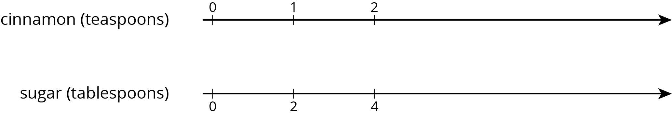
- One batch of meatloaf contains 2 pounds of beef and $\frac{1}{2}$ cup of bread crumbs. Complete the double number line diagram to show the amounts of beef and bread crumbs needed for 1, 2, 3, and 4 batches of meatloaf.
- A recipe for tropical fruit punch says, “Combine 4 cups of pineapple juice with 5 cups of orange juice.”
  - Create a double number showing the amount of each type of juice in 1, 2, 3, 4, and 5 batches of the recipe.
  - If 12 cups of pineapple juice are used with 20 cups of orange juice, will the recipe taste the same? Explain your reasoning.
  - The recipe also calls for $\frac{1}{3}$ cup of lime juice for every 5 cups of orange juice. Add a line to your diagram to represent the amount of lime juice in different batches of tropical fruit punch.
- One batch of pink paint uses 2 cups of red paint and 7 cups of white paint. Mai made a large amount of pink paint using 14 cups of red paint.
  - How many batches of pink paint did she make?
  - How many cups of white paint did she use?
- (From Unit 2, Lesson 2.)

  - Find three different ratios that are equivalent to the ratio $3:11$.
  - Explain why your ratios are equivalent.
- (From Unit 2, Lesson 3.)
- Here is a diagram that represents the pints of red and yellow paint in a mixture.
- 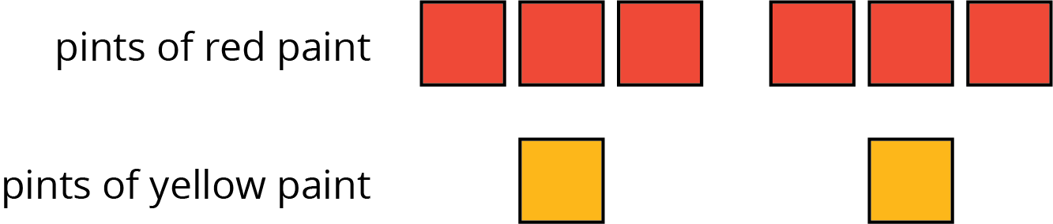
- Select all statements that accurately describe the diagram.
  - The ratio of yellow paint to red paint is 2 to 6.
  - For every 3 pints of red paint, there is 1 pint of yellow paint.
  - For every pint of yellow paint, there are 3 pints of red paint.
  - For every pint of yellow paint there are 6 pints of red paint.
  - The ratio of red paint to yellow paint is $6:2$.
- (From Unit 2, Lesson 1.)
© CC BY Open Up Resources. Adaptations CC BY IM.

