Unit 4 Lesson 2: Half a Square

1 Diagonals of Rectangles (Warm up)

Student Task Statement
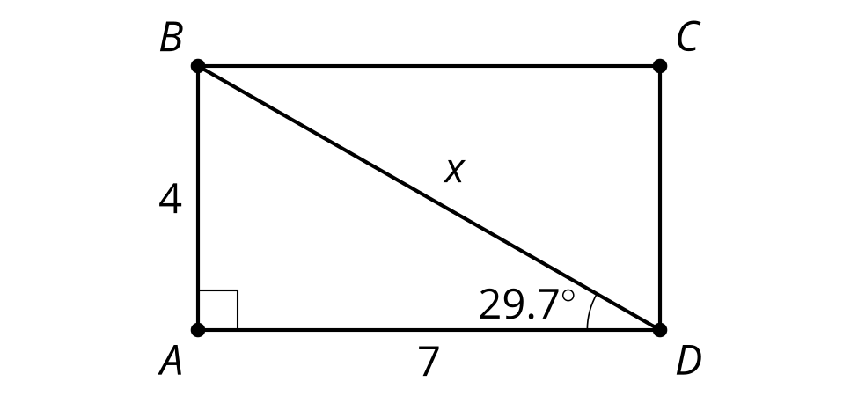
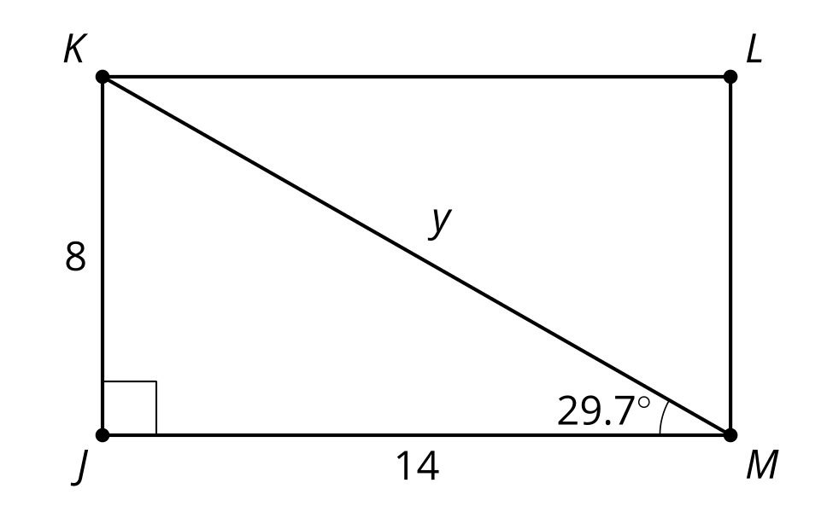
Calculate the values of $x$ and $y$.

2 Decomposing Squares (Optional)

Student Task Statement
- Draw a square with side lengths of 1 cm. Estimate the length of the diagonal. Then calculate the length of the diagonal.
- Measure the side length and diagonal length of several squares, in centimeters. Compute the ratio of side to diagonal length for each.
- Make a conjecture.

3 Generalize Half Squares (Optional)

Student Task Statement
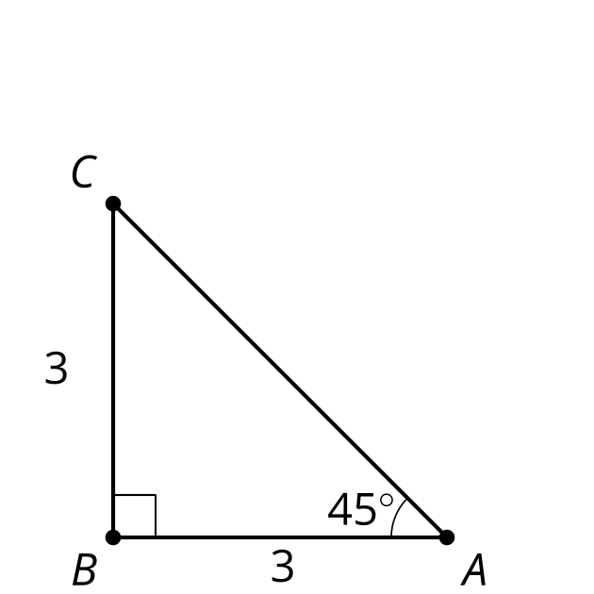
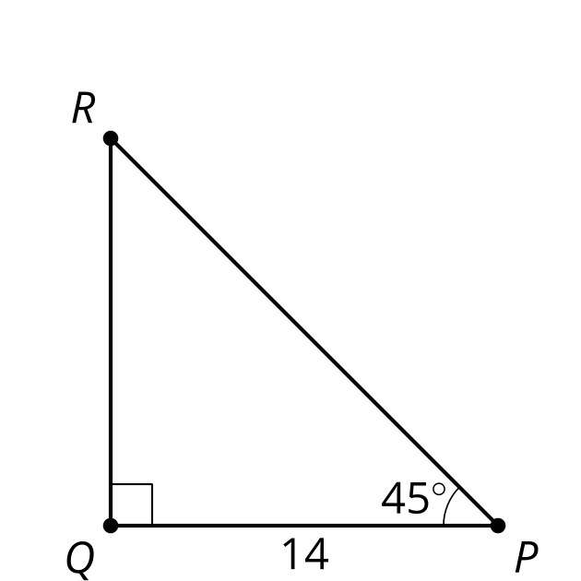
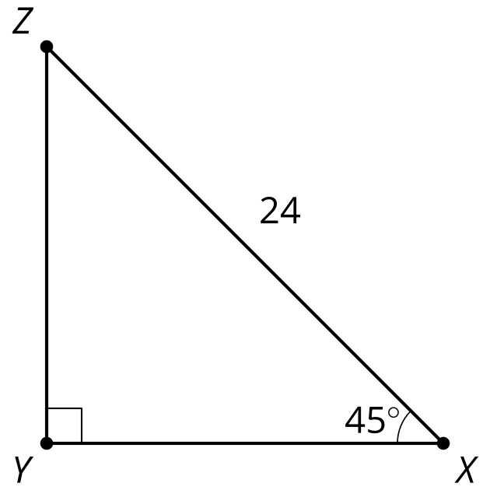
Calculate the lengths of the 5 unlabeled sides.

Images for Activity Synthesis
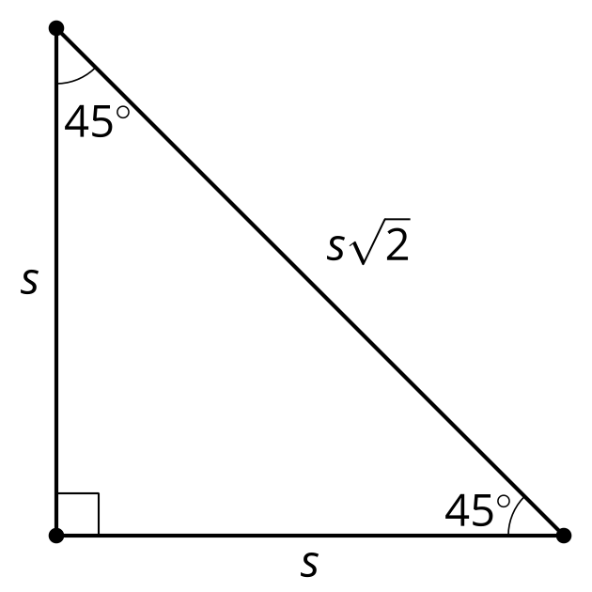
© CC BY 2019 by Illustrative Mathematics®

