Lesson 9 Practice Problems
- Andre says that $10x+6$ and $5x+11$ are equivalent because they both equal 16 when $x$ is 1. Do you agree with Andre? Explain your reasoning.
- Select all expressions that can be subtracted from $9x$ to result in the expression $3x+5$.
  - $\text{-}5+6x$
  - $5−6x$
  - $6x+5$
  - $6x−5$
  - $\text{-}6x+5$
- Select all the statements that are true for any value of $x$.
  - $7x+\left(2x+7\right)=9x+7$
  - $7x+\left(2x−1\right)=9x+1$
  - $\frac{1}{2}x+\left(3−\frac{1}{2}x\right)=3$
  - $5x−\left(8−6x\right)=\text{-}x−8$
  - $0.4x−\left(0.2x+8\right)=0.2x−8$
  - $6x−\left(2x−4\right)=4x+4$
- For each situation, would you describe it with $x<25$, $x>25$, $x≤25$, or $x≥25$?
  - The library is having a party for any student who read at least 25 books over the summer. Priya read $x$ books and was invited to the party.
  - Kiran read $x$ books over the summer but was not invited to the party.

- (From Unit 4, Lesson 3.)
- A line is represented by the equation $\frac{y}{x−2}=\frac{3}{11}$. What are the coordinates of some points that lie on the line? Graph the line on graph paper.
- (From Unit 2, Lesson 17.)
- Select all the statements that must be true for any scaled copy Q of Polygon P.
- 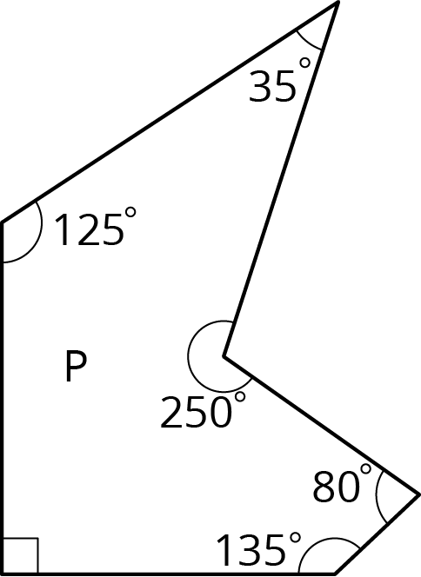
  - The side lengths are all whole numbers.
  - The angle measures are all whole numbers.
  - Q has exactly 1 right angle.
  - If the scale factor between P and Q is $\frac{1}{5}$, then each side length of P is multiplied by $\frac{1}{5}$ to get the corresponding side length of Q.
  - If the scale factor is 2, each angle in P is multiplied by 2 to get the corresponding angle in Q.
  - Q has 2 acute angles and 3 obtuse angles.
- (From Unit 2, Lesson 3.)
© CC BY Open Up Resources. Adaptations CC BY IM.

