Lesson 3 Practice Problems
- Each of these is a pair of equivalent ratios. For each pair, explain why they are equivalent ratios or draw a diagram that shows why they are equivalent ratios.
  - $4:5$ and $8:10$
  - $18:3$ and $6:1$
  - $2:7$ and $10,​000:35,​000$
- Explain why $6:4$ and $18:8$ are not equivalent ratios.
- Are the ratios $3:6$ and $6:3$ equivalent? Why or why not?
- This diagram represents 3 batches of light yellow paint. Draw a diagram that represents 1 batch of the same shade of light yellow paint.
- 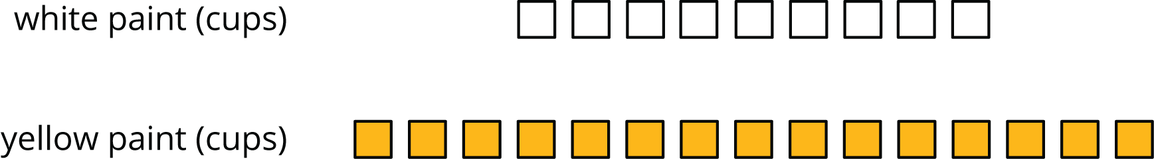
- (From Unit 2, Lesson 2.)
- In the fruit bowl there are 6 bananas, 4 apples, and 3 oranges.
  - For every 4 __________________, there are 3 __________________.
  - The ratio of __________________ to __________________ is $6:3$.
  - The ratio of __________________ to __________________ is 4 to 6.
  - For every 1 orange, there are ______ bananas.
- (From Unit 2, Lesson 1.)
- Write fractions for points $A$ and $B$ on the number line.
- (From Unit 2, Lesson 1.)
© CC BY Open Up Resources. Adaptations CC BY IM.

