Lesson 8 Practice Problems
- Find the exact value of each variable that represents a side length in a right triangle.
- 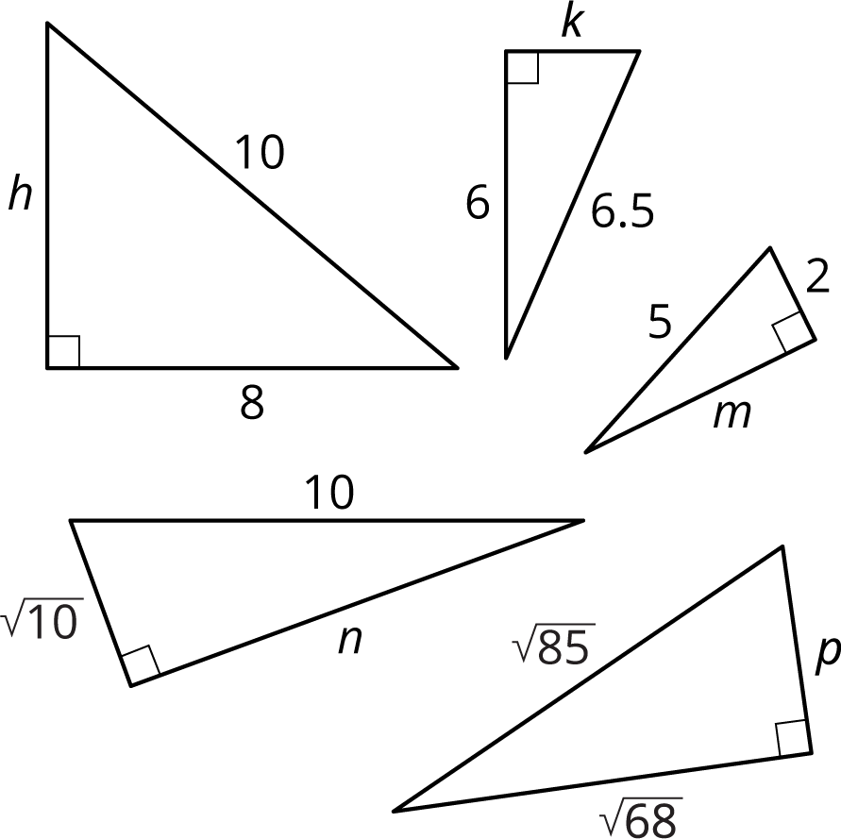

- A right triangle has side lengths of $a$, $b$, and $c$ units. The longest side has a length of $c$ units. Complete each equation to show three relations among $a$, $b$, and $c$.
  - $c^{2}=$
  - $a^{2}=$
  - $b^{2}=$

- (From Unit 8, Lesson 7.)
- What is the exact length of each line segment? Explain or show your reasoning. (Each grid square represents 1 square unit.)
- a.
- b.
- c.
- 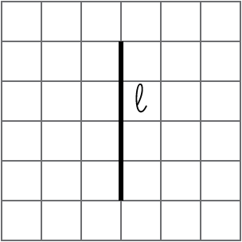
- 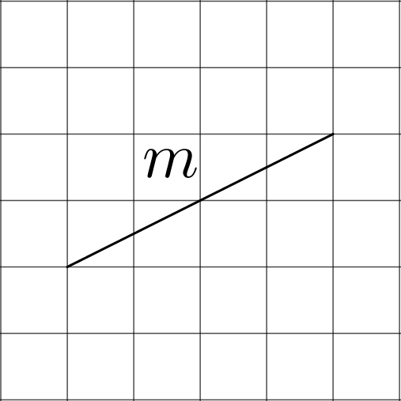
- 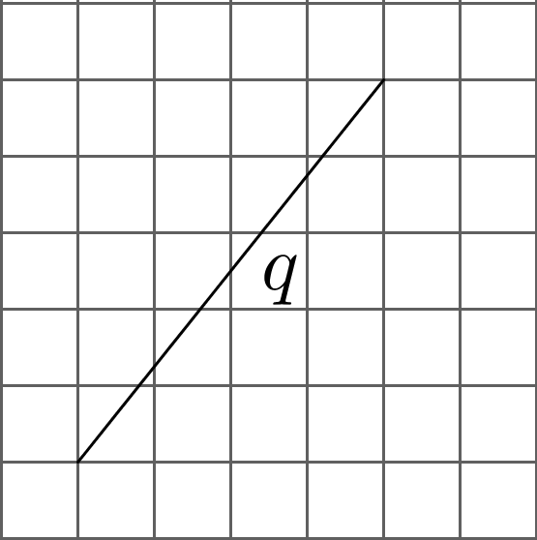
- (From Unit 8, Lesson 7.)
- In 2015, there were roughly $1×{10}^{6}$ high school football players and $2×{10}^{3}$ professional football players in the United States. About how many times more high school football players are there? Explain how you know.

- (From Unit 7, Lesson 15.)
- Evaluate:
  - ${\left(\frac{1}{2}\right)}^{3}$
  - ${\left(\frac{1}{2}\right)}^{\text{-}3}$
- (From Unit 7, Lesson 6.)
- Here is a scatter plot of weight vs. age for different Dobermans. The model, represented by $y=2.45x+1.22$, is graphed with the scatter plot. Here, $x$ represents age in weeks, and $y$ represents weight in pounds.
- 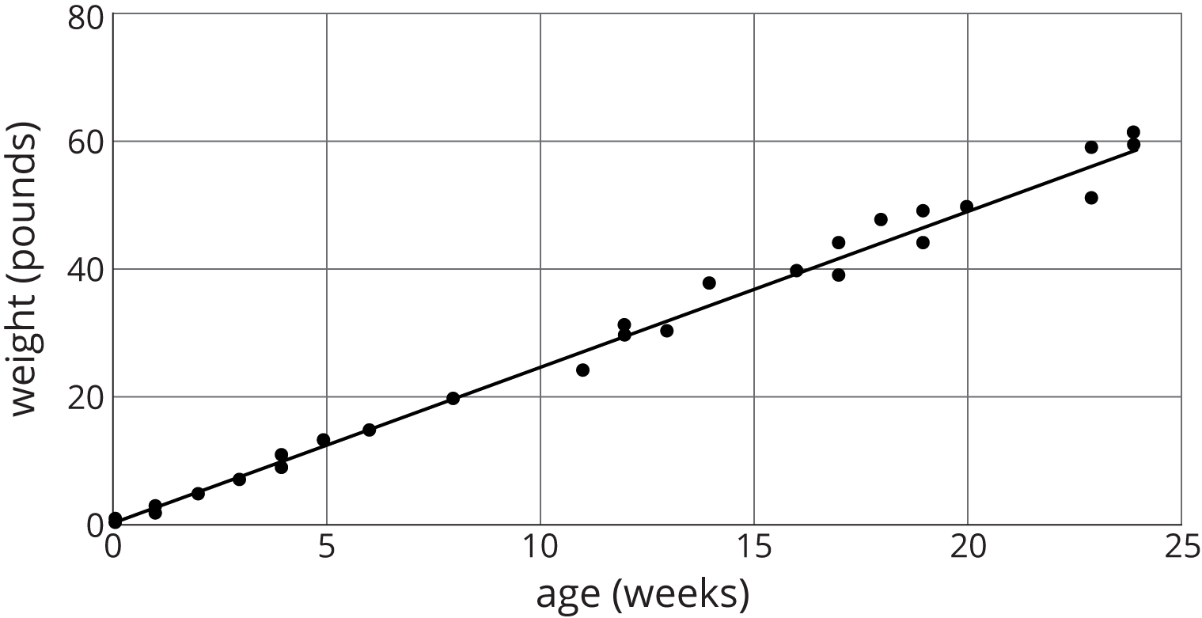
  - What does the slope mean in this situation?
  - Based on this model, how heavy would you expect a newborn Doberman to be?
- (From Unit 6, Lesson 6.)
© CC BY Open Up Resources. Adaptations CC BY IM.

