Lesson 1 Practice Problems
- Which expression equals $2^{7}$?
  - $2+2+2+2+2+2+2$
  - $2⋅2⋅2⋅2⋅2⋅2⋅2$
  - $2⋅7$
  - $2+7$
- Evaluate the expression $3⋅5^{x}$ when $x$ is 2.
- The graph shows the yearly balance, in dollars, in an investment account.
- 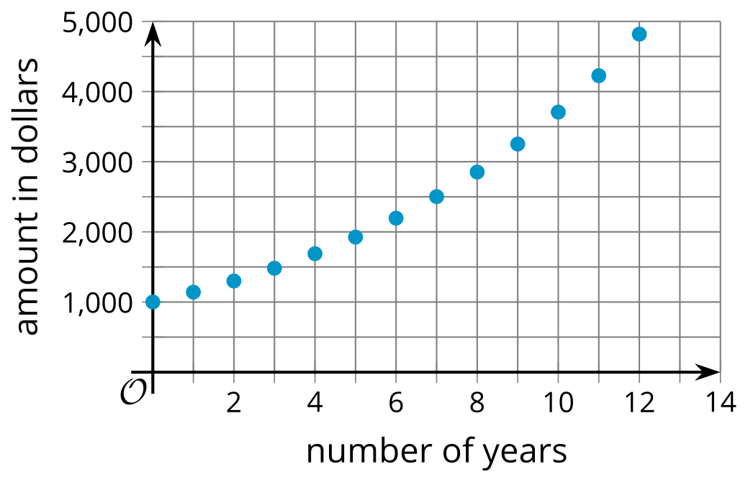
  - What is the initial balance in the account?
  - Is the account growing by the same number of dollars each year? Explain how you know.
  - A second investment account starts with $2,000 and grows by $150 each year. Sketch the values of this account on the graph.
  - How does the growth of balances in the two account balances compare?
- Jada rewrites $5⋅3^{x}$ as $15x$. Do you agree with Jada that these are equivalent expressions? Explain your reasoning.
- Investment account 1 starts with a balance of $200 and doubles every year. Investment account 2 starts with $1,000 and increases by $100 each year.
  - How long does it take for each account to double?
  - How long does it take for each account to double again?
  - How does the growth in these two accounts compare? Explain your reasoning.
- A study of 100 recent high school graduates investigates a link between their childhood reading habits and achievement in high school.
- Participants are asked if they read books every night with another person when they were ages 2 to 5, as well as their grade average for all of their high school classes. The results are represented in the table.
 | - read books nightly | - did not read books nightly
- A average | - 16 | - 10
- B average | - 21 | - 14
- C average | - 12 | - 16
- D average | - 3 | - 8
  - What does the 21 in the table represent?
  - What does the 10 in the table represent?
- (From Unit 3, Lesson 1.)
- Lin says that a snack machine is like a function because it outputs an item for each code input. Explain why Lin is correct.
- (From Unit 4, Lesson 1.)
- At a gas station, a gallon of gasoline costs $3.50. The relationship between the dollar cost of gasoline and the gallons purchased can be described with a function.
  - Identify the input variable and the output variable in this function.
  - Describe the function with a sentence of the form "$\underset{_}{}$ is a function of $\underset{_}{}$."
  - Identify an input-output pair of the function and explain its meaning in this situation.
- (From Unit 4, Lesson 1.)
© CC BY 2019 by Illustrative Mathematics®

