Unit 2 Lesson 5: Graphs, Tables, and Equations

1 Math Talk: Solving Equations (Warm up)

Student Task Statement
Solve each equation mentally.
$100=10\left(x−5\right)$
$300=30\left(x−5\right)$
$15−971=x−4−971$
$\frac{10}{7}=\frac{1}{7}\left(x−19\right)$

2 On the Line

Student Task Statement
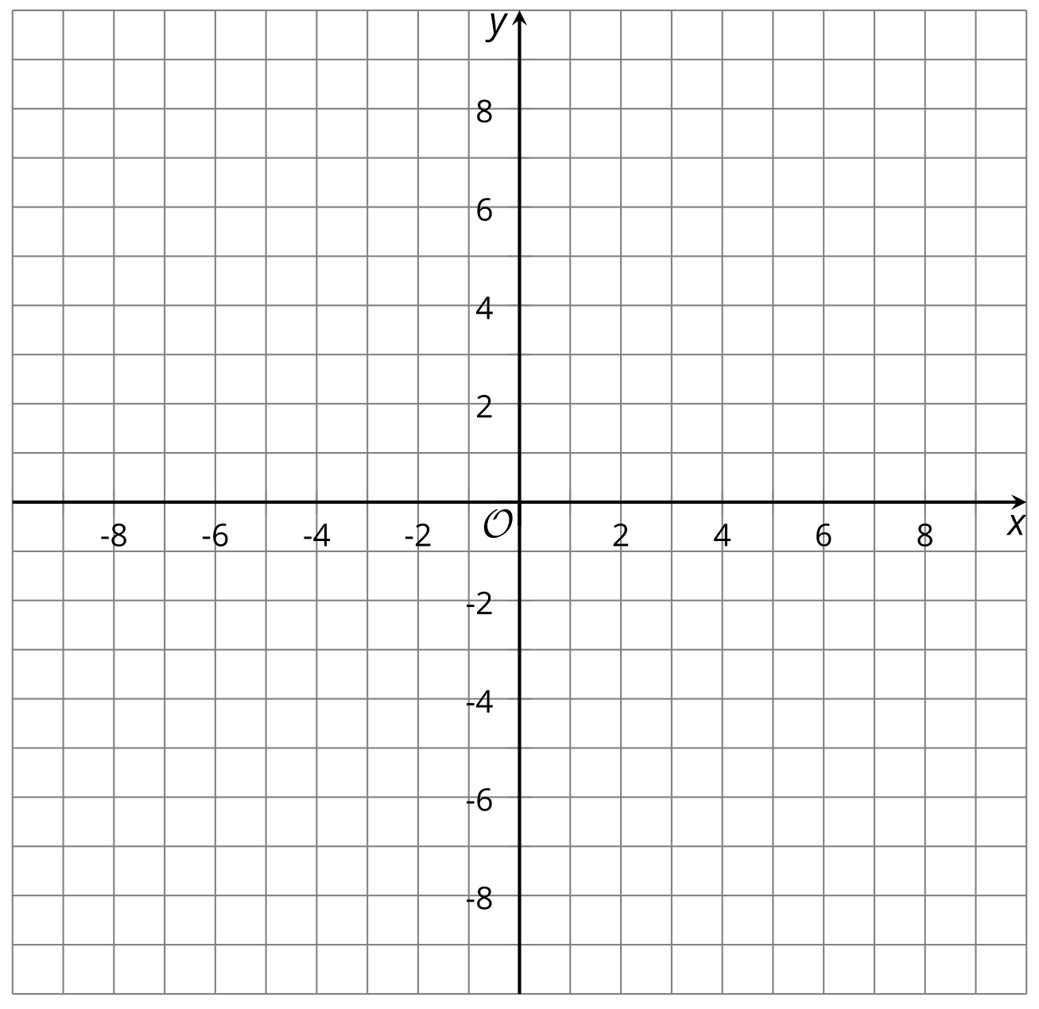
- Sketch a graph representing each of these equations.
  - $y=2x$
  - $y=\frac{1}{2}x$
  - $y=x+2$
- For each point, which graph or graphs is it on? How can you tell by using the equation?
  - $\left(1,3\right)$
  - ​​​​​​​$\left(0,0\right)$
  - ​​​​​​​$\left(3,6\right)$
  - ​​​​​​​$\left(3,1.5\right)$

3 Take Turns: Graphs, Tables, Equations, and Situations

Student Task Statement
- Take turns with your partner to match a graph with each set of matching cards. Eventually all the cards will be sorted into groups of 4 cards (an equation, situation, table, and graph).
- For each match that you find, explain to your partner how you know it’s a match. Ask your partner if they agree with your thinking.
- For each match that your partner finds, listen carefully to their explanation. If you disagree, discuss your thinking and work to reach an agreement.

Activity Synthesis
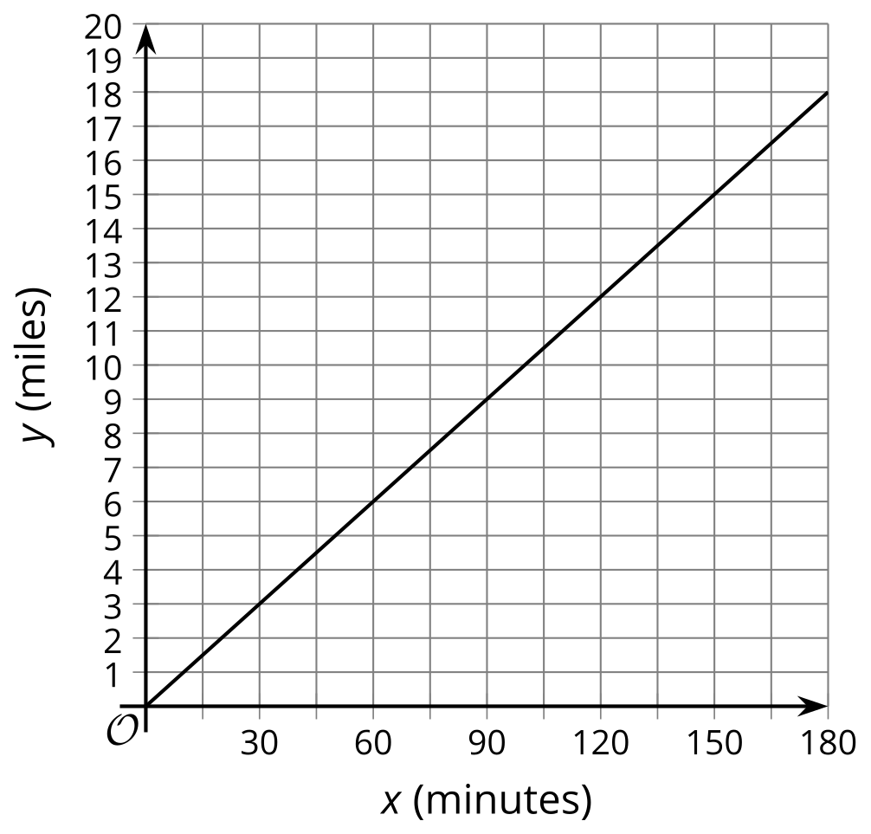
© CC BY 2019 by Illustrative Mathematics®

