Lesson 2 Practice Problems
- A recipe for 1 batch of spice mix says, “Combine 3 teaspoons of mustard seeds, 5 teaspoons of chili powder, and 1 teaspoon of salt.” How many batches are represented by the diagram? Explain or show your reasoning.
- 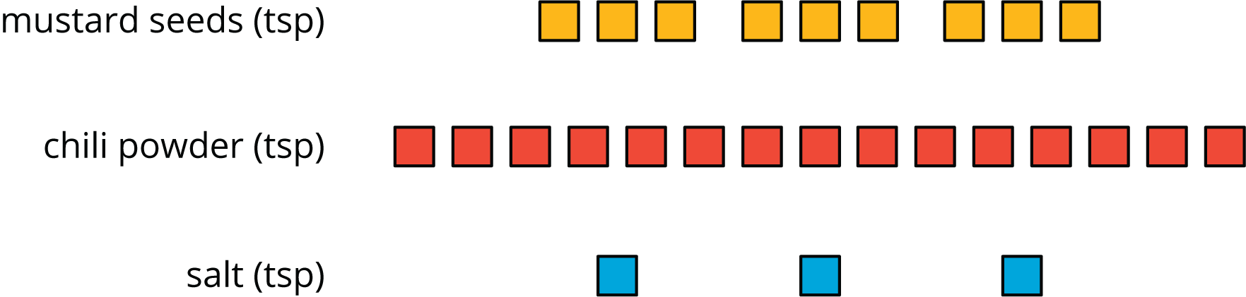

- In a recipe for fizzy grape juice, the ratio of cups of sparkling water to cups of grape juice concentrate is 3 to 1.
  - Find two more ratios of cups of sparkling water to cups of juice concentrate that would make a mixture that tastes the same as this recipe.
  - Describe another mixture of sparkling water and grape juice that would taste different than this recipe.
- Here is a diagram showing a mixture of red paint and green paint needed for 1 batch of a particular shade of brown.
- 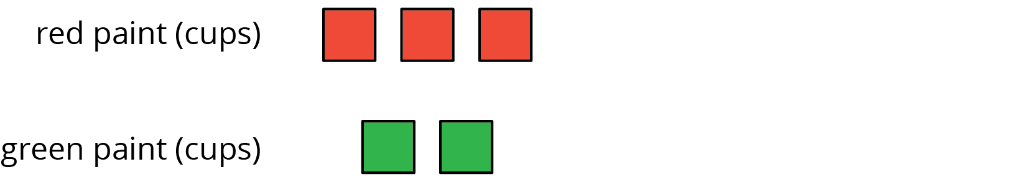
- Add to the diagram so that it shows 3 batches of the same shade of brown paint.
- To make 1 batch of sky blue paint, Clare mixes 2 cups of blue paint with 1 gallon of white paint.
  - Explain how Clare can make 2 batches of sky blue paint.
  - Explain how to make a mixture that is a darker shade of blue than the sky blue.
  - Explain how to make a mixture that is a lighter shade of blue than the sky blue.
- Write the missing number under each tick mark on the number line.
- (From Unit 2, Lesson 1.)
- Find the area of the parallelogram. Show your reasoning.
- (From Unit 1, Lesson 4.)
© CC BY Open Up Resources. Adaptations CC BY IM.

