Lesson 8: Cubes and Cube Roots
- Let’s compare equations with cubes and cube roots.

8.1: Put Your Arm(s) Up
How are these graphs the same? How are they different?
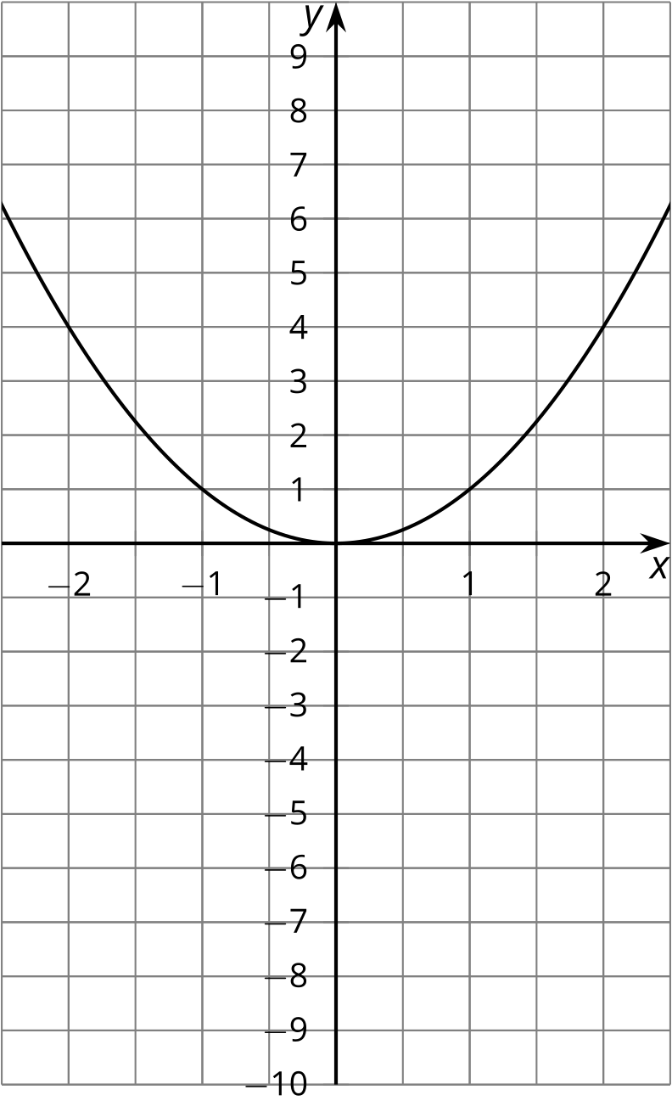
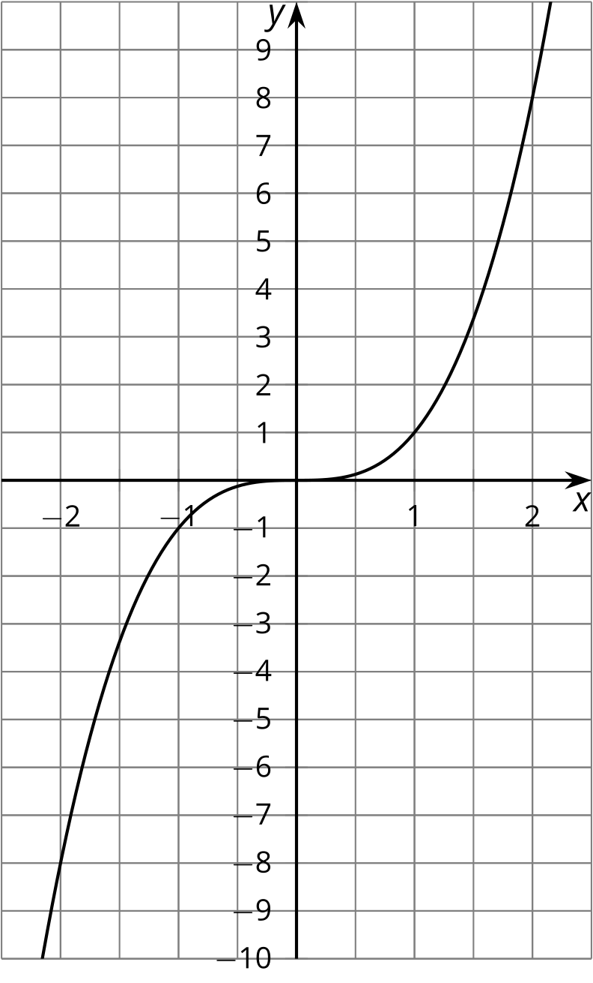
​​​​​​

8.2: Finding Cube Roots with a Graph
How many solutions are there to each of the following equations? Estimate the solution(s) from the graph of $y=x^{3}$. Check your estimate by substituting it back into the equation.
- $x^{3}=8$
- $x^{3}=2$
- $x^{3}=0$
- $x^{3}=\text{-}8$
- $x^{3}=\text{-}2$
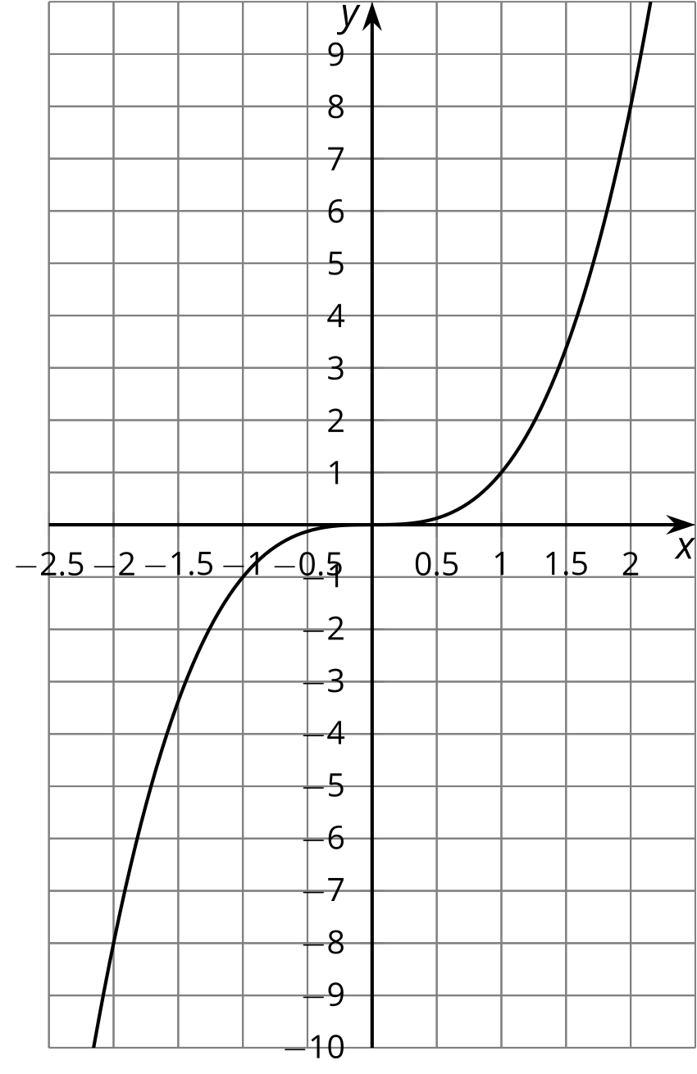

8.3: Cube Root Equations
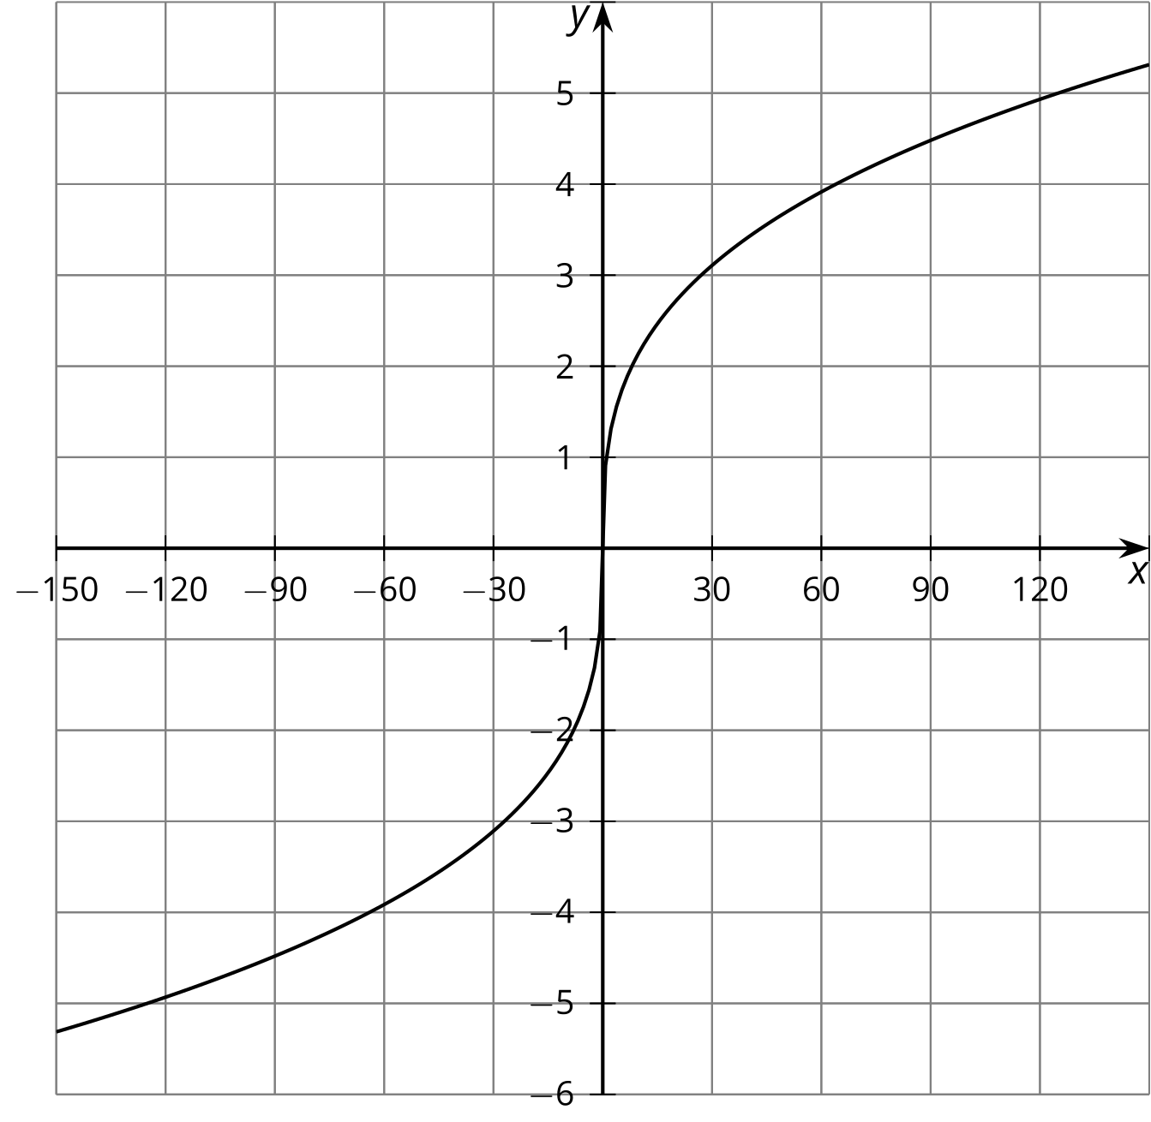
- Use the graph of $y=\sqrt[3]{x}$ to estimate the solution(s) to $\sqrt[3]{x}=\text{-}4$.
- Use the meaning of cube roots to find an exact solution to the equation $\sqrt[3]{x}=\text{-}4$. How close was your estimate?
- Find the solution of the equation $\sqrt[3]{x}=3.5$ using the meaning of cube roots. Use the graph to check that your solution is reasonable.

8.4: Solve These Equations With Cube Roots in Them
Here are a lot of equations:
- $\sqrt[3]{t+4}=3$
- $\text{-}10=\text{-}\sqrt[3]{a}$
- $\sqrt[3]{3−w}−4=0$
- $\sqrt[3]{z}+9=0$
- $\sqrt[3]{r^{3}−19}=2$
- $5−\sqrt[3]{k+1}=\text{-}1$
- $\sqrt[3]{p+4}−2=1$
- $6−\sqrt[3]{b}=0$
- $\sqrt[3]{2n}+3=\text{-}5$
- $4+\sqrt[3]{\text{-}m}+4=6$
- $\text{-}\sqrt[3]{c}=5$
- $\sqrt[3]{s−7}+3=0$
- Without solving, identify 3 equations that you think would be the least difficult to solve and 3 equations that you think would be the most difficult to solve. Be prepared to explain your reasoning.
- Choose 4 equations and solve them. At least one should be from your “least difficult” list and at least one should be from your “most difficult” list.

Are you ready for more?
All of these equations were equivalent to equations that could be written in the form $\sqrt[3]{ax+b}+c=0$ for some constants $a$, $b$, and $c$. Find a formula that would solve any such equation for $x$ in terms of $a$, $b$, and $c$.

Lesson 8 Summary
Every number has exactly one cube root. You can see this by looking at the graph of $y=x^{3}$.
If $y$ is any number, for example, -4, then we can see that $y=\text{-}4$ crosses the graph in one and only one place, so the equation $x^{3}=\text{-}4$ will have the solution $\text{-}\sqrt[3]{4}$. This is true for any number $a$: $y=a$ will cross the graph in exactly one place, and $x^{3}=a$ will have one solution, $\sqrt[3]{a}$.
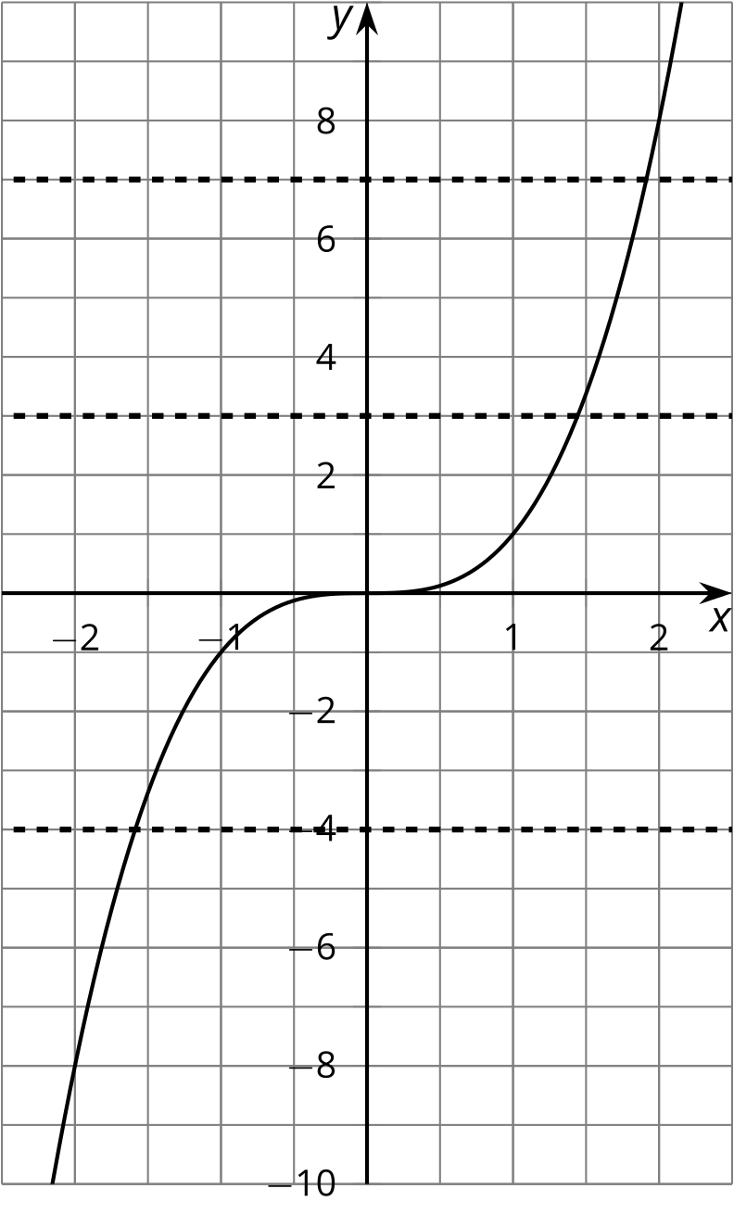
In an equation like $\sqrt[3]{t}+6=0$, we can isolate the cube root and cube each side:
$\begin{matrix}\sqrt[3]{t}+6 & =0 \\ \sqrt[3]{t} & =\text{-}6 \\ t & ={\left(\text{-}6\right)}^{3} \\ t & =\text{-}216\end{matrix}$
While cubing each side of an equation won’t create an equation with solutions that are different than the original equation, it is still a good idea to always check solutions in the original equation because little mistakes can creep in along the way.
© CC BY 2019 by Illustrative Mathematics®

