Lesson 10: Multiplicity
- Let’s sketch some polynomial functions.

10.1: Notice and Wonder: Duplicate Factors
What do you notice? What do you wonder?

$y={\left(x−3\right)}^{2}$
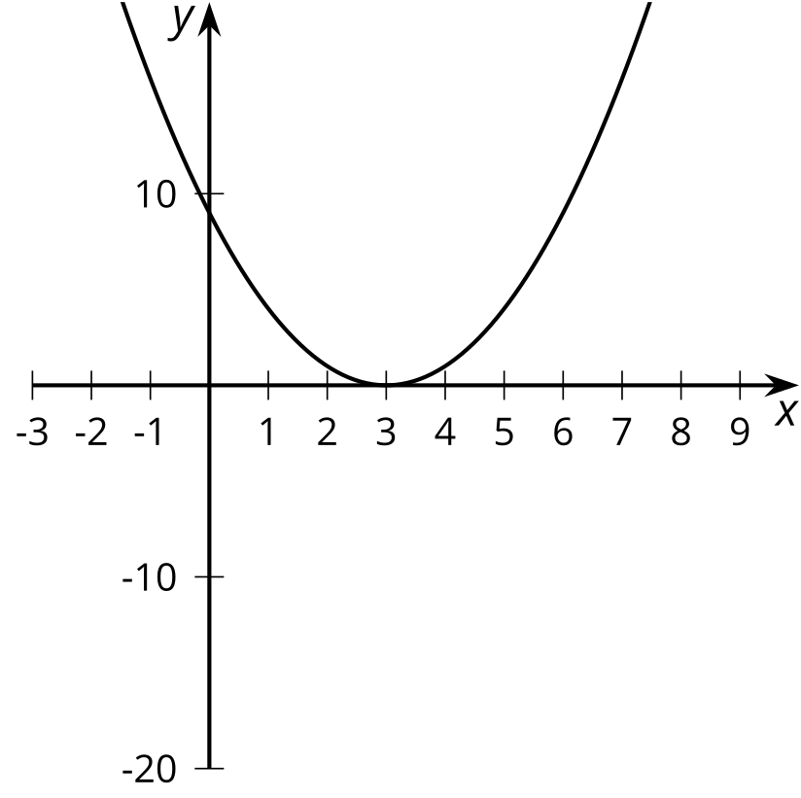

$y=\left(x+1\right){\left(x−3\right)}^{2}$
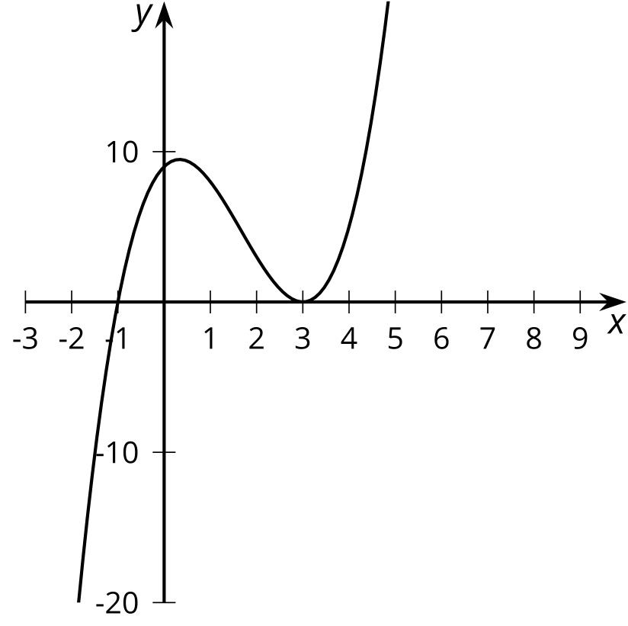

$y={\left(x−3\right)}^{3}$
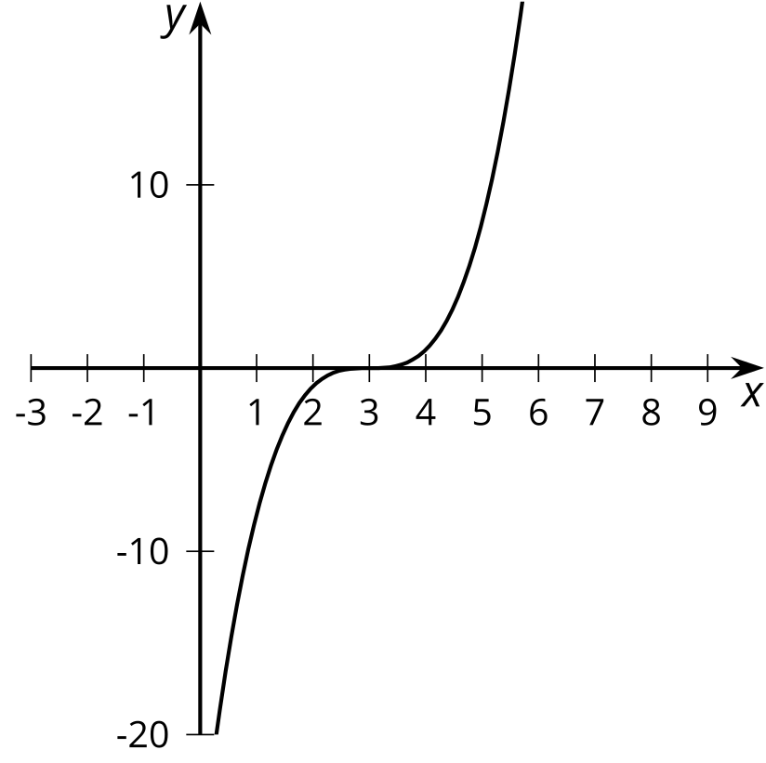

$y=\left(x−6\right){\left(x−3\right)}^{2}$
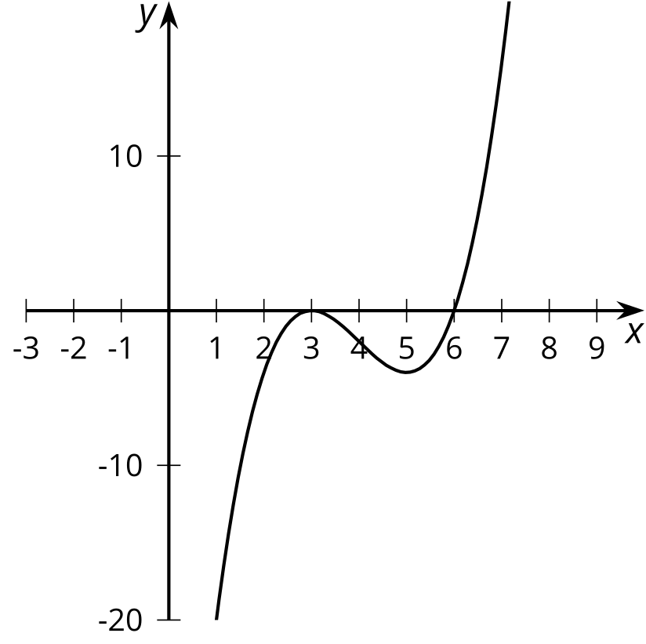

10.2: Sketching Polynomials
- For polynomials $A$–$F$:
  - Write the degree, all zeros, and complete the sentence about the end behavior.
  - Sketch a possible graph.
  - Check your sketch using graphing technology.
  - Pause here for your teacher to check your work.
- Create your own polynomial for your partner to figure out.
  - Create a polynomial with degree greater than 2 and less than 8 and write the equation in the space given.
  - Trade papers with a partner, then fill out the information about their polynomial and complete a sketch.
  - Trade papers back. Check your partner’s sketch using graphing technology.

$A\left(x\right)=\left(x+2\right)\left(x−2\right)\left(x−8\right)$
Degree: Zeros:
End behavior: As $x$ gets larger and larger in the negative direction,

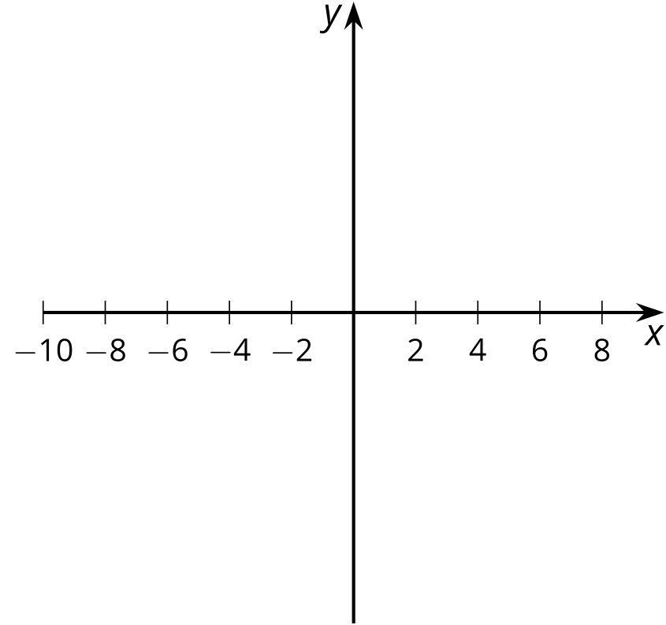
$B\left(x\right)=\text{-}\left(x+2\right){\left(x−2\right)}^{2}$
Degree: Zeros:
End behavior: As $x$ gets larger and larger in the negative direction,

$C\left(x\right)=\left(x+6\right){\left(x+2\right)}^{2}$
Degree: Zeros:
End behavior: As $x$ gets larger and larger in the negative direction,

$D\left(x\right)=\text{-}{\left(x+6\right)}^{2}\left(x+2\right)$
Degree: Zeros:
End behavior: As $x$ gets larger and larger in the negative direction,

​​​​​​
$E\left(x\right)=\left(x+4\right){\left(x−2\right)}^{3}$
Degree: Zeros:
End behavior: As $x$ gets larger and larger in the negative direction,

$F\left(x\right)=x^{3}\left(x+4\right){\left(x−3\right)}^{2}$
Degree: Zeros:
End behavior: As $x$ gets larger and larger in the negative direction,

Your polynomial:
Degree: Zeros:
End behavior: As $x$ gets larger and larger in the negative direction,

10.3: Using Knowledge of Zeros
- Sketch a graph for a polynomial function $y=f\left(x\right)$ that has 3 different zeros and $f\left(x\right)≥0$ for all values of $x$.
- 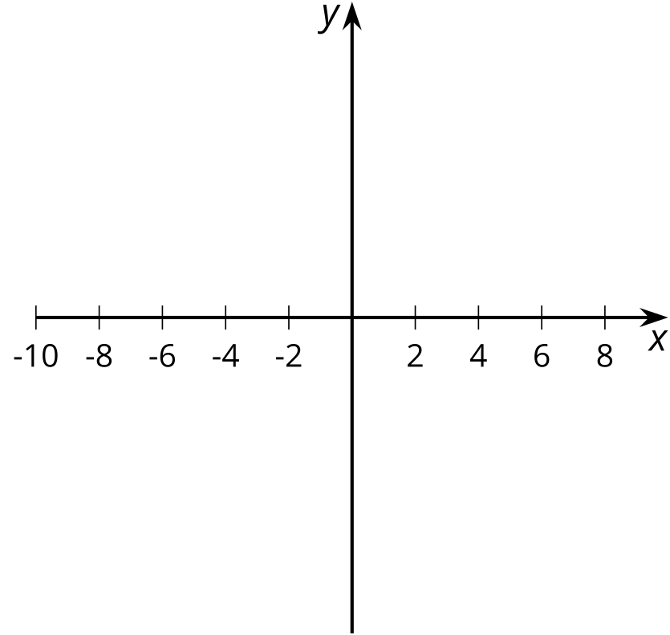
- What is the smallest degree the polynomial could have?
- What is a possible equation for the polynomial? Use graphing technology to see if your equation matches your sketch.

Are you ready for more?
What is a possible equation of a polynomial function that has degree 5 but whose graph has exactly three horizontal intercepts and crosses the $x$-axis at all three intercepts? Explain why it is not possible to have a polynomial function that has degree 4 with this property.

Lesson 10 Summary
Earlier, we learned to identify the zeros of a polynomial function from the factored expression. These factors let us figure out the points where the graph of the polynomial intersects the horizontal axis. The number of times a factor is repeated also gives us important information: it tells us the shape of the graph at that point on the horizontal axis.
For example, $y=\left(x+3\right)\left(x−1\right)\left(x−4\right)$ has three factors with no duplicates. This results in a graph that looks a bit like a linear function near $x=\text{-}3$, $x=1$, and $x=4$ when we zoom in on each of those places.

$y=\left(x+3\right)\left(x−1\right)\left(x−4\right)$
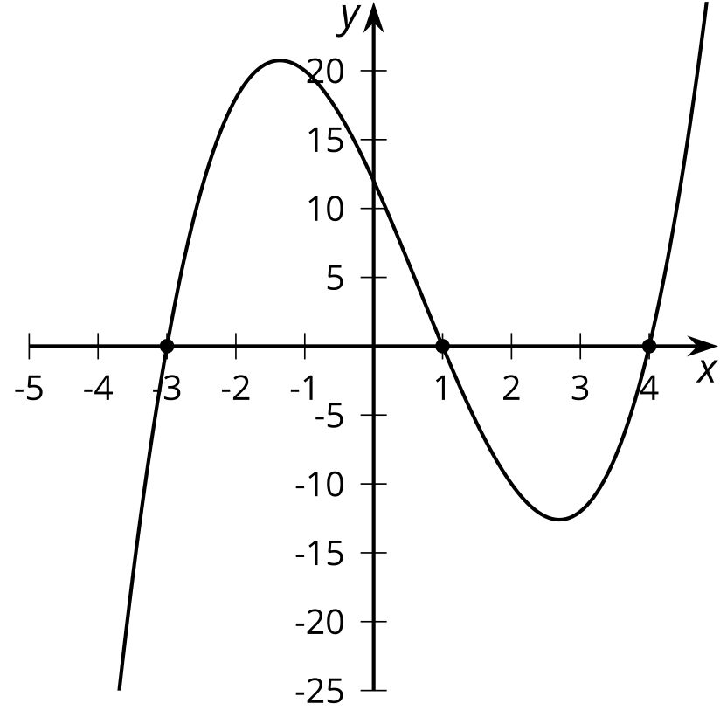

near $x=\text{-}3$
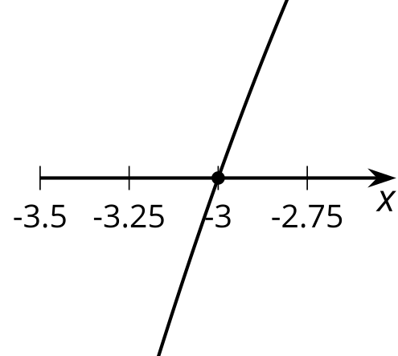

near $x=1$
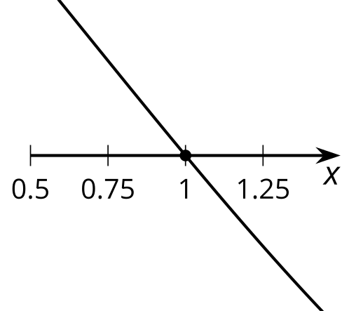

near $x=4$
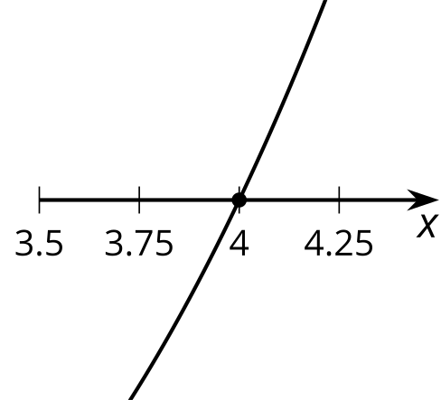
We say that each factor, $\left(x+3\right)$, $\left(x−1\right)$, and $\left(x−4\right)$, has a multiplicity of 1.
For $y={\left(x+3\right)}^{2}\left(x−4\right)$, there are still three factors, but two of them are $\left(x+3\right)$. This results in a graph that looks a bit like a quadratic near $x=\text{-}3$ and a bit like a linear function near $x=4$. We say that the factor $\left(x+3\right)$ has a multiplicity of 2 while the factor $\left(x−4\right)$ has a multiplicity of 1.

$y={\left(x+3\right)}^{2}\left(x−4\right)$
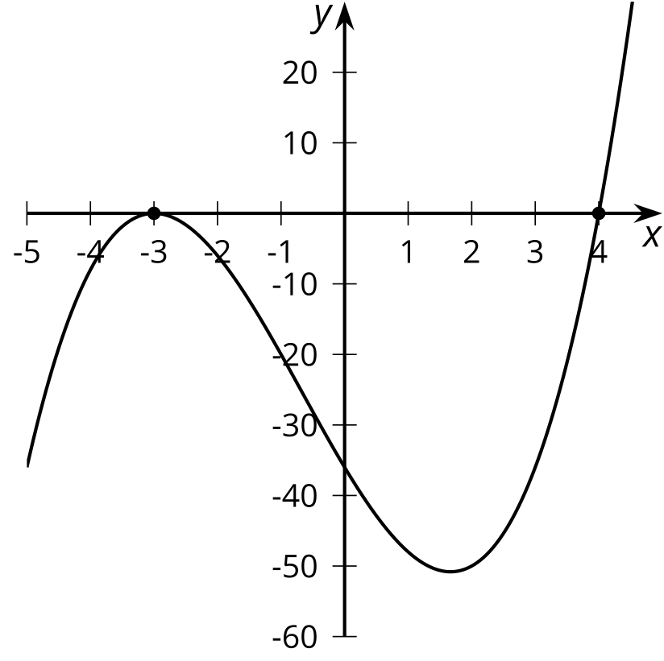

near $x=\text{-}3$
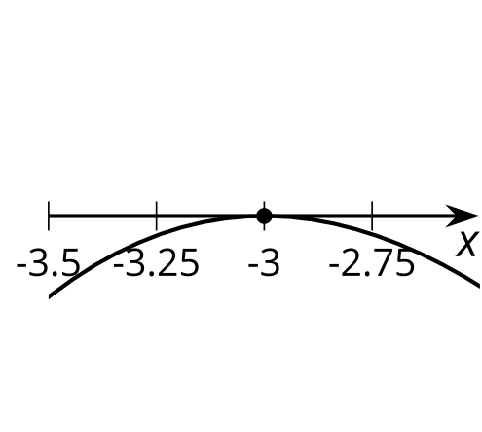

near $x=4$
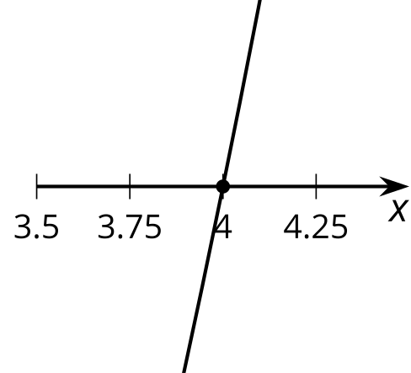
Combining what we know about factors, degree, end behavior, the sign of the leading coefficient, and multiplicity gives us the ability to sketch polynomials written in factored form.
For example, consider what the graph of $y=\left(x+3\right){\left(x−4\right)}^{3}$ would look like. The factors help us identify that the function has zeros at -3 and 4. We also know that since $\left(x+3\right)$ has a multiplicity of 1 and $\left(x−4\right)$ has a multiplicity of 3, the graph looks a bit like a linear polynomial crossing the $x$-axis at -3 and a bit like a cubic polynomial crossing the $x$-axis at 4. Since this is a 4th degree polynomial with a positive leading coefficient, we know that as $x$ gets larger and larger in either the negative or positive direction, $y$ gets larger and larger in the positive direction.

$y=\left(x+3\right){\left(x−4\right)}^{3}$
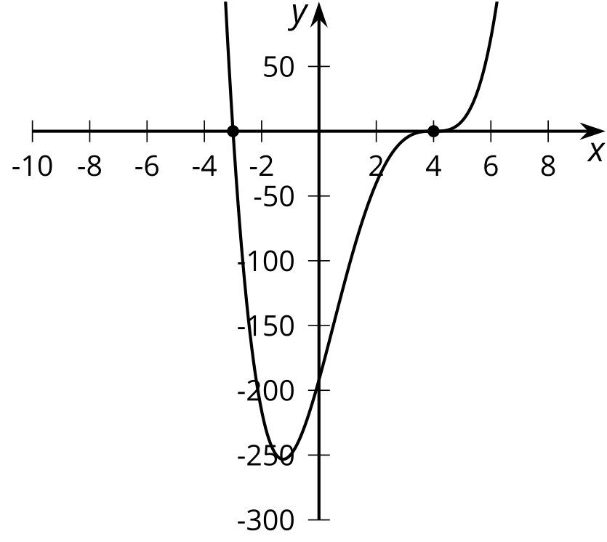
© CC BY 2019 by Illustrative Mathematics®

