Lesson 10 Practice Problems
- Select all equations that are parallel to the line $2x+5y=8$.
  - $y=\frac{2}{5}x+4$
  - $y=\text{-}\frac{2}{5}x+4$
  - $y−2=\frac{5}{2}\left(x+1\right)$
  - $y−2=\text{-}\frac{2}{5}\left(x+1\right)$
  - $10x+5y=40$
- Prove that $ABCD$ is not a parallelogram.
- 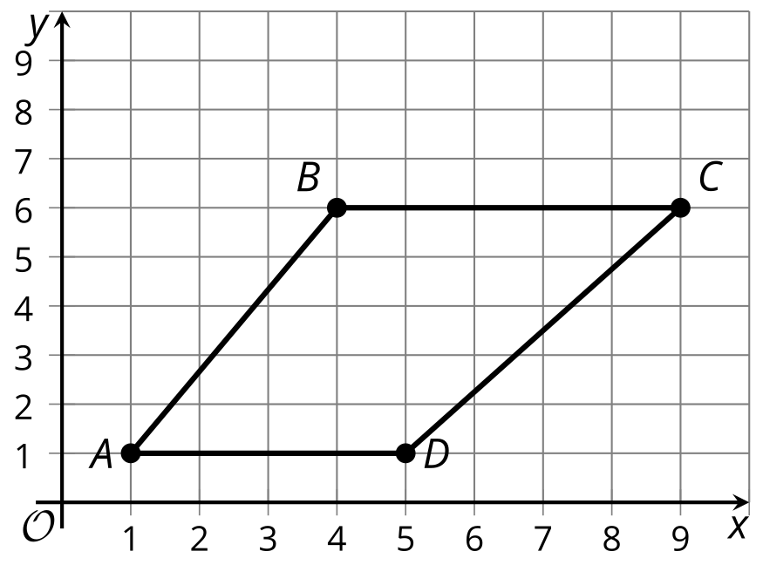
- Write an equation of a line that passes through $\left(\text{-}1,2\right)$ and is parallel to a line with $x$-intercept $\left(3,0\right)$ and $y$-intercept $\left(0,1\right)$.
- Write an equation of the line with slope $\frac{2}{3}$ that goes through the point $\left(\text{-}2,5\right)$.
- (From Unit 6, Lesson 9.)
- Priya and Han each wrote an equation of a line with slope $\frac{1}{3}$ that passes through the point $\left(1,2\right)$. Priya’s equation is $y−2=\frac{1}{3}\left(x−1\right)$ and Han’s equation is $3y−x=5$. Do you agree with either of them? Explain or show your reasoning.
- (From Unit 6, Lesson 9.)
- Match each equation with another equation whose graph is the same parabola.
  - ${\left(x−3\right)}^{2}+{\left(y−2\right)}^{2}=y^{2}$
  - ${\left(x−2\right)}^{2}+{\left(y−3\right)}^{2}={\left(y+3\right)}^{2}$
  - ${\left(x−3\right)}^{2}+{\left(y−4\right)}^{2}={\left(y+2\right)}^{2}$
  - ${\left(x−2\right)}^{2}+{\left(y−2\right)}^{2}={\left(y+2\right)}^{2}$
  - $y=\frac{1}{8}{\left(x−2\right)}^{2}$
  - $y=\frac{1}{12}{\left(x−2\right)}^{2}$
  - $y=\frac{1}{4}{\left(x−3\right)}^{2}+1$
  - $y=\frac{1}{12}{\left(x−3\right)}^{2}+1$
- (From Unit 6, Lesson 8.)
- A parabola is defined as the set of points the same distance from $\left(\text{-}1,3\right)$ and the line $y=5$. Select the point that is on this parabola.
  - $\left(\text{-}1,3\right)$
  - $\left(0,5\right)$
  - $\left(3,0\right)$
  - $\left(0,0\right)$
- (From Unit 6, Lesson 7.)
- Here are some transformation rules. For each rule, describe whether the transformation is a rigid motion, a dilation, or neither.
  - $\left(x,y\right)→\left(2x,y+2\right)$
  - $\left(x,y\right)→\left(2x,2y\right)$
  - $\left(x,y\right)→\left(x+2,y+2\right)$
  - $\left(x,y\right)→\left(x−2,y\right)$
- (From Unit 6, Lesson 2.)
© CC BY 2019 by Illustrative Mathematics®

