Unit 1 Lesson 8: The $n^{\text{th}}$ Term

1 Which One Doesn’t Belong: Repeated Operations (Warm up)

Student Task Statement
Which one doesn’t belong?
A. $5+2+2+2+2+2+2$
B. $5+6⋅2$
C. $5⋅2^{6}$
D. $5⋅2⋅2⋅2⋅2⋅2⋅2$

2 More Paper Slicing

Student Task Statement
- Clare takes a piece of paper with length 8 inches and width 10 inches and cuts it in half. Then she cuts it in half again, and again. . .
  - Instead of writing a recursive definition, Clare writes $C\left(n\right)=80⋅{\left(\frac{1}{2}\right)}^{n}$, where $C$ is the area, in square inches, of the paper after $n$ cuts. Explain where the different terms in her expression came from.
  - Approximately what is the area of the paper after 10 cuts?
- Kiran takes a piece of paper with length 8 inches and width 10 inches and cuts away one inch of the width. Then he does it again, and again. . .
  - Complete the table for the area of Kiran’s paper $K\left(n\right)$, in square inches, after $n$ cuts.
- $n$ | - $K\left(n\right)$
- 0 | - 80
  - 1
- 2 | - $80−8−8=80−8\left(2\right)=64$
  - 3
  - 4
  - 5
  - Kiran says the area after 6 cuts, in square inches, is $80−8⋅6$. Explain where the different terms in his expression came from.
  - Write a definition for $K\left(n\right)$ that is not recursive.
- Which is larger, $K\left(6\right)$ or $C\left(6\right)$?

3 A Sierpinski Triangle

Student Task Statement
A Sierpinski triangle can be created by starting with an equilateral triangle, breaking the triangle into 4 congruent equilateral triangles, and then removing the middle triangle. Starting from a single black equilateral triangle:
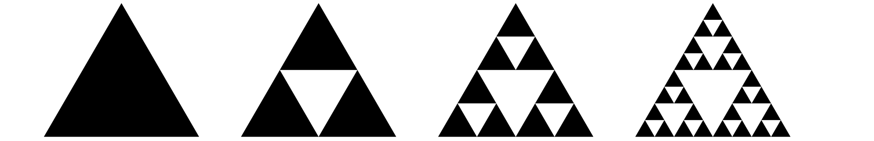
- Let $S$ be the number of black triangles in Step $n$. Define $S\left(n\right)$ recursively.
- Andre and Lin are asked to write an equation for $S$ that isn't recursive. Andre writes $S\left(n\right)=3^{n}$ for $n≥0$ while Lin writes $S\left(n\right)=3^{n−1}$ for $n≥1$. Whose equation do you think is correct? Explain or show your reasoning.
© CC BY 2019 by Illustrative Mathematics®

