Lesson 16 Practice Problems
- A scientist compares methane levels on Mars at several locations, in parts per billion, taken at 2 different times during the Martian day. The difference between the means of the methane levels for the two different times is -0.08 parts per billion. The scientist uses simulations to create a randomization distribution to try to determine the likelihood that the results happened by chance. The histogram represents the results of the 200 trials from the simulations.
- 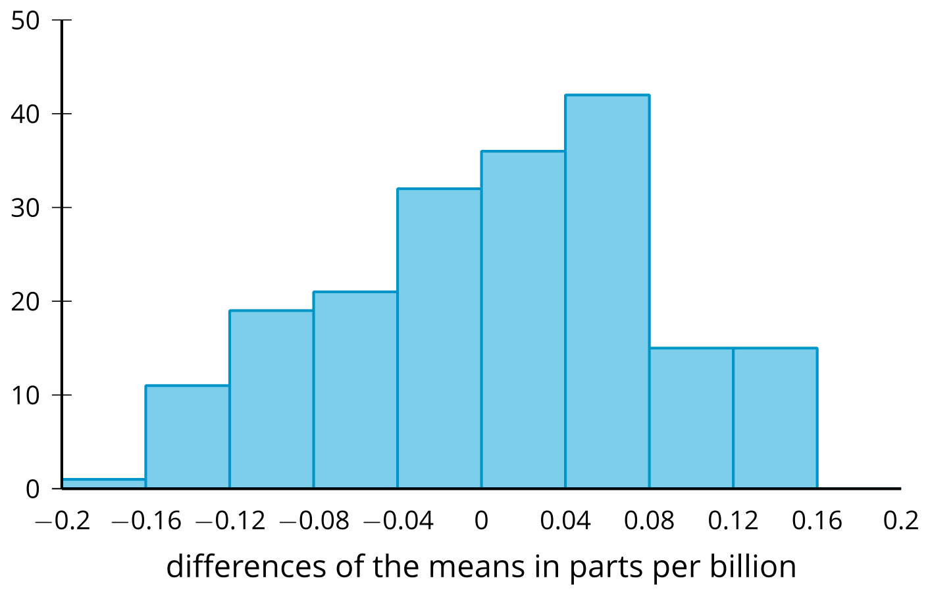
- According to the randomization distribution, is the difference in means due to chance or the time at which the measurements were made? Explain your reasoning.
- A biologist is studying the research question, “Do eggs from the common gull, a type of bird, take longer to hatch at 85 degrees Fahrenheit or at 87 degrees Fahrenheit?” They design an experiment in which they select 20 eggs and assign those eggs to 2 groups of 10 eggs each at random. The eggs in the first group are placed in an environment that is held at a constant temperature of 85 degrees Fahrenheit, and the eggs in the second group are placed in an environment that is held at a constant temperature of 87 degrees Fahrenheit. The hatching times, in days, for each group are displayed in the table.
- group 1 days to hatch | - group 2 days to hatch
- 25 | - 25
- 26 | - 24
- 25 | - 25
- 28 | - 26
- 26 | - 24
- 25 | - 25
- 27 | - 26
- 26 | - 25
- 25 | - 25
- 25 | - 27
- The mean hatching time for group 1 is 25.8 days and the mean hatching time for group 2 is 25.2 days.
  - How could the biologist get a randomization distribution to compare the two groups?
  - How would the biologist use the randomization distribution to determine whether the difference between the mean hatching time for group 1 and the mean hatching time for group 2 is due to chance?
- Technology required
- Diego rolls a standard number cube 10 times and adds the values to get a sum of 40. Is that unusually high? Priya simulates rolling the number cube 10 times on a computer and adds the values. She repeats that process 100 times and creates a histogram of the results.
- 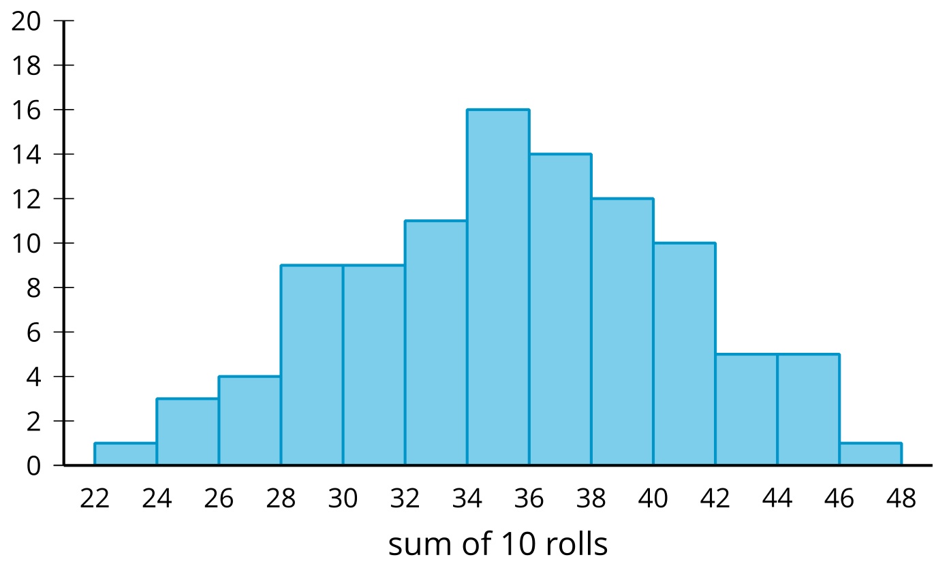
  - Based on the histogram, does 40 seem unusually high? Explain your reasoning.
  - The mean of Priya’s simulations is a sum of 35, and the standard deviation is 5.72. Using a normal distribution as an approximation of this distribution, what is the probability that a person would roll a sum greater than 40?
- Why do we use randomization distributions?
  - To randomly assign groups in an experiment
  - To determine how likely it is that you would arrive at a difference of means due to chance
  - To randomly select a sample for use in an experiment
  - To prove that the only way the difference could happen is due to the experimental treatment
- Which of these values would be most useful for determining whether the difference in means is likely due to the treatment? Explain your reasoning.
  - interquartile range
  - median
  - standard deviation
  - range
- (From Unit 7, Lesson 15.)
- A distribution is approximately normal with a mean of 70 and a standard deviation of 10. Match the interval with the approximate percentage of data that falls within that interval.
  - Between 70 and 80
  - Between 50 and 90
  - Between 60 and 80
  - Between 70 and 90
  - Between 40 and 100
  - 34%
  - 47.5%
  - 68%
  - 95%
  - 99.7%
- (From Unit 7, Lesson 7.)
© CC BY 2019 by Illustrative Mathematics®

