Lesson 7 Practice Problems
- The equation and the tables represent two different functions. Use the equation $b=4a−5$ and the table to answer the questions. This table represents $c$ as a function of $a$.
- $a$ | - -3 | - 0 | - 2 | - 5 | - 10 | - 12
- $c$ | - -20 | - 7 | - 3 | - 21 | - 19 | - 45
  - When $a$ is -3, is $b$ or $c$ greater?
  - When $c$ is 21, what is the value of $a$? What is the value of $b$ that goes with this value of $a$?
  - When $a$ is 6, is $b$ or $c$ greater?
  - For what values of $a$ do we know that $c$ is greater than $b$?
- Elena and Lin are training for a race. Elena runs her mile at a constant speed of 7.5 miles per hour.
- Lin’s total distances are recorded every minute:
- time (minutes) | - 1 | - 2 | - 3 | - 4 | - 5 | - 6 | - 7 | - 8 | - 9
- distance (miles) | - 0.11 | - 0.21 | - 0.32 | - 0.41 | - 0.53 | - 0.62 | - 0.73 | - 0.85 | - 1
  - Who finished their mile first?
  - This is a graph of Lin’s progress. Draw a graph to represent Elena’s mile on the same axes.
  - 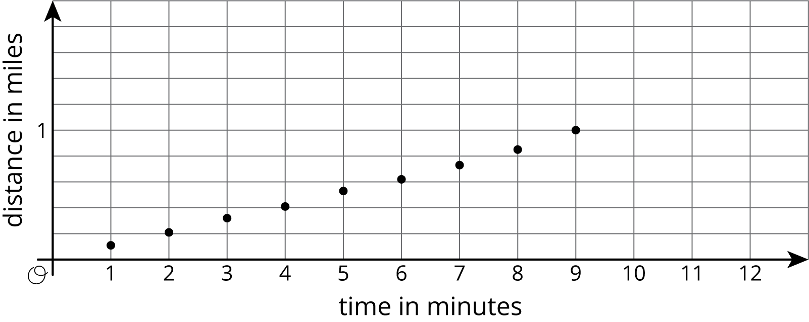
  - For these models, is distance a function of time? Is time a function of distance? Explain how you know.
- Match each function rule with the value that could not be a possible input for that function.
  - 3 divided by the input
  - Add 4 to the input, then divide this value into 3
  - Subtract 3 from the input, then divide this value into 1
  - 3
  - 4
  - -4
  - 0
  - 1
- (From Unit 6, Lesson 2.)
- Find a value of $x$ that makes the equation true. Explain your reasoning, and check that your answer is correct.
- $\text{-}\left(\text{-}2x+1\right)=9−14x$
- (From Unit 4, Lesson 13.)
© CC BY Open Up Resources. Adaptations CC BY IM.

