Lesson 3 Practice Problems
- Here are 3 polygons.
- 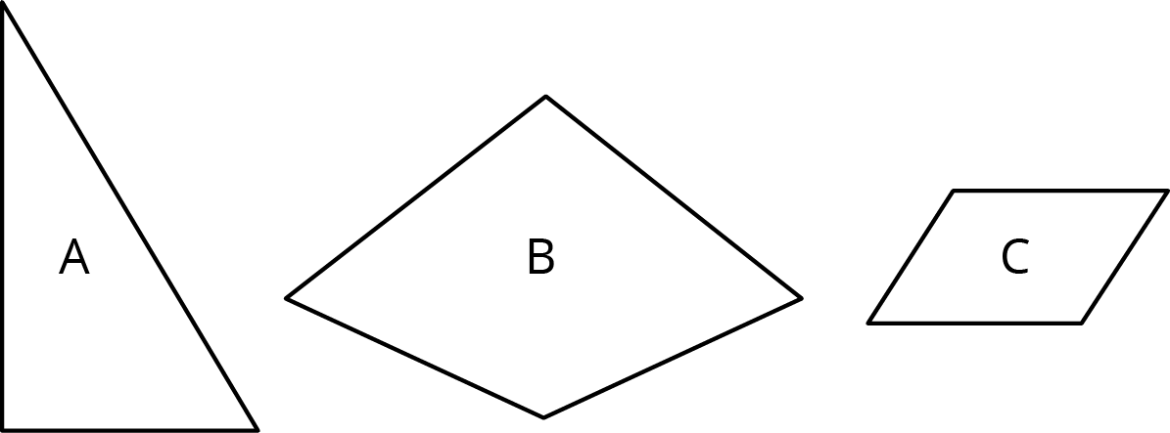
- Draw a scaled copy of Polygon A using a scale factor of 2.
- Draw a scaled copy of Polygon B using a scale factor of $\frac{1}{2}$.
- Draw a scaled copy of Polygon C using a scale factor of $\frac{3}{2}$.
- Quadrilateral A has side lengths 6, 9, 9, and 12. Quadrilateral B is a scaled copy of Quadrilateral A, with its shortest side of length 2. What is the perimeter of Quadrilateral B?
- Here is a polygon on a grid.
- Draw a scaled copy of this polygon that has a perimeter of 30 units. What is the scale factor? Explain how you know.
- Priya and Tyler are discussing the figures shown below. Priya thinks that B, C, and D are scaled copies of A. Tyler says B and D are scaled copies of A. Do you agree with Priya, or do you agree with Tyler? Explain your reasoning.
- 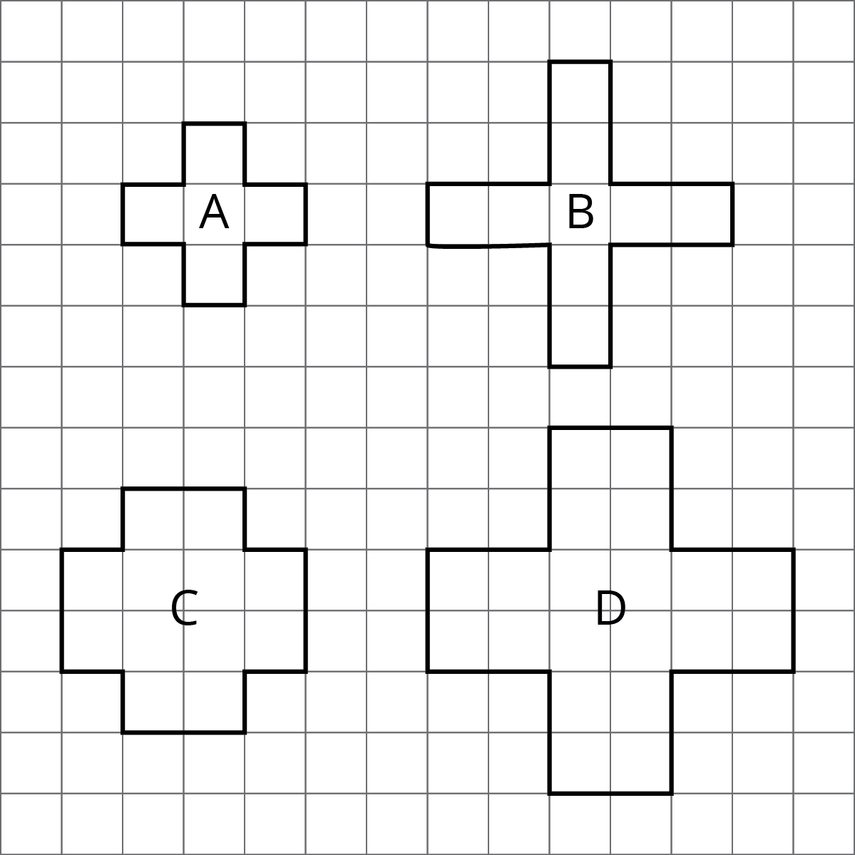
- (From Unit 1, Lesson 1.)
© CC BY Open Up Resources. Adaptations CC BY IM.

