Unit 1 Lesson 1: Tiling the Plane

1 Which One Doesn’t Belong: Tilings (Warm up)

Student Task Statement
Which pattern doesn’t belong?
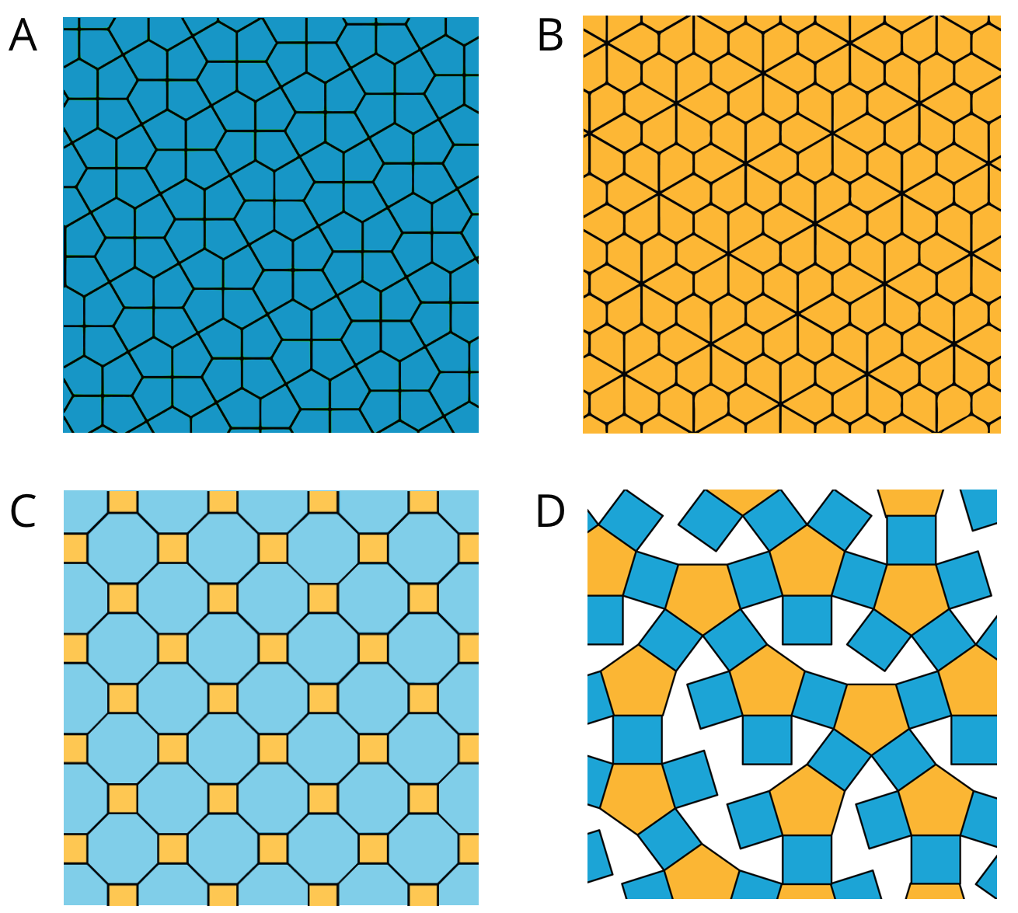

2 More Red, Green, or Blue?

Student Task Statement
Your teacher will assign you to look at Pattern A or Pattern B.
In your pattern, which shape covers more of the plane: blue rhombuses, red trapezoids, or green triangles? Explain how you know.

Pattern A
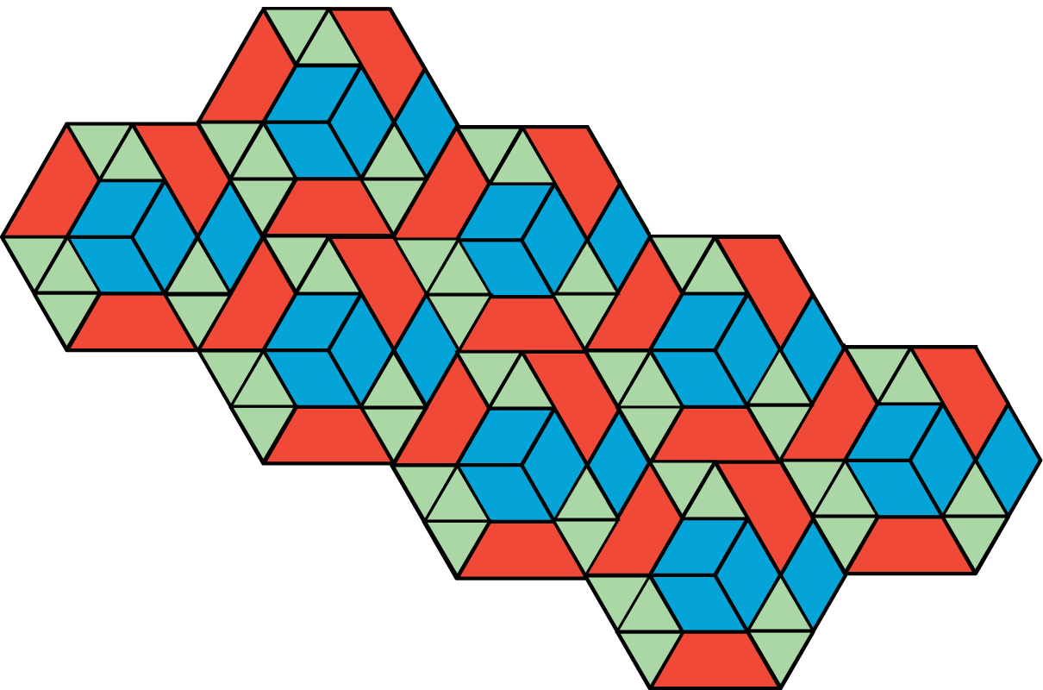

Pattern B
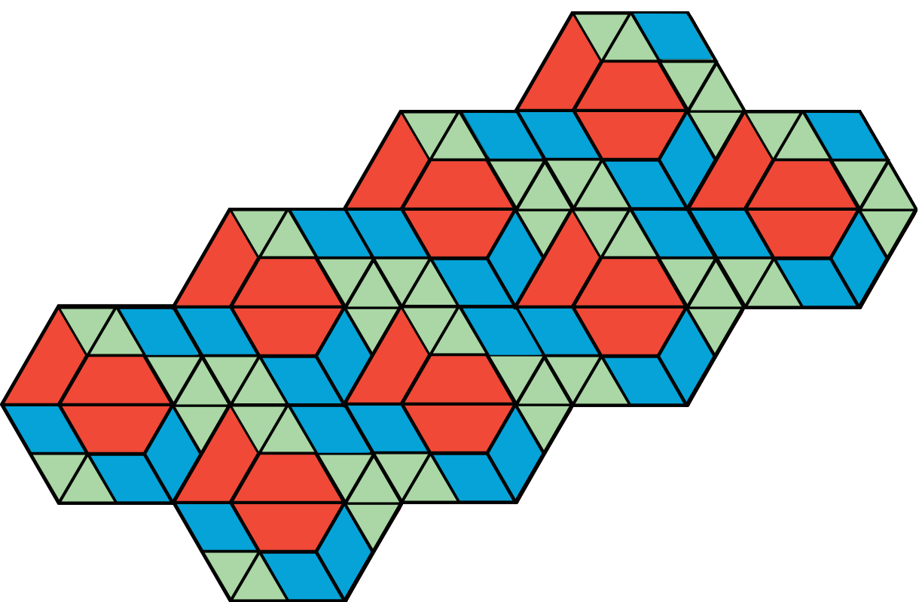

© CC BY Open Up Resources. Adaptations CC BY IM.

