Unit 2 Lesson 2: Congruent Parts, Part 2

1 Math Talk: Which Are Congruent? (Warm up)

Student Task Statement
Each pair of figures is congruent. Decide whether each congruence statement is true or false.

$△ABC≅△FED$
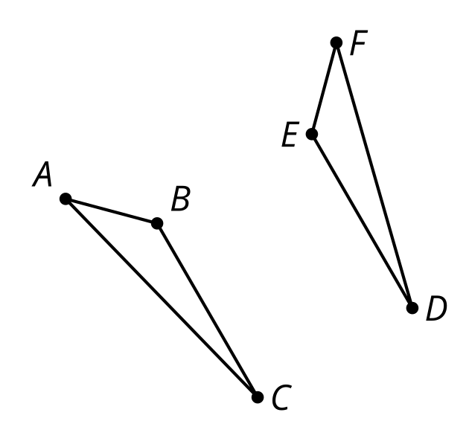

$PZJM≅LYXB$
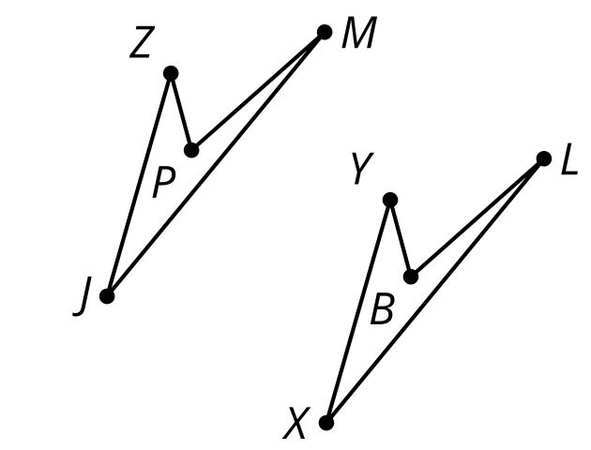
Triangle $ABC$ is congruent to triangle $FED$.
Quadrilateral $PZJM$ is congruent to quadrilateral $LYXB$.

$△JKL≅△QRS$
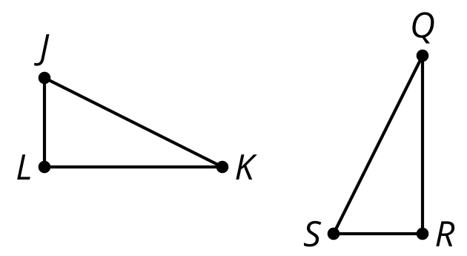

$ABCDE≅PQRST$
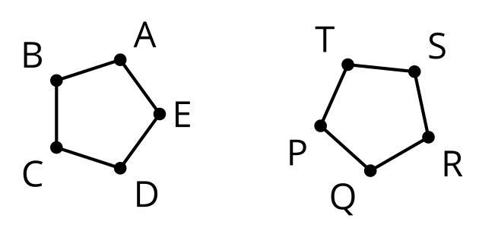
Triangle $JKL$ is congruent to triangle $QRS$.
Pentagon $ABCDE$ is congruent to pentagon $PQRST$.

2 Which Triangles Are Congruent?

Student Task Statement
Here are 3 triangles.
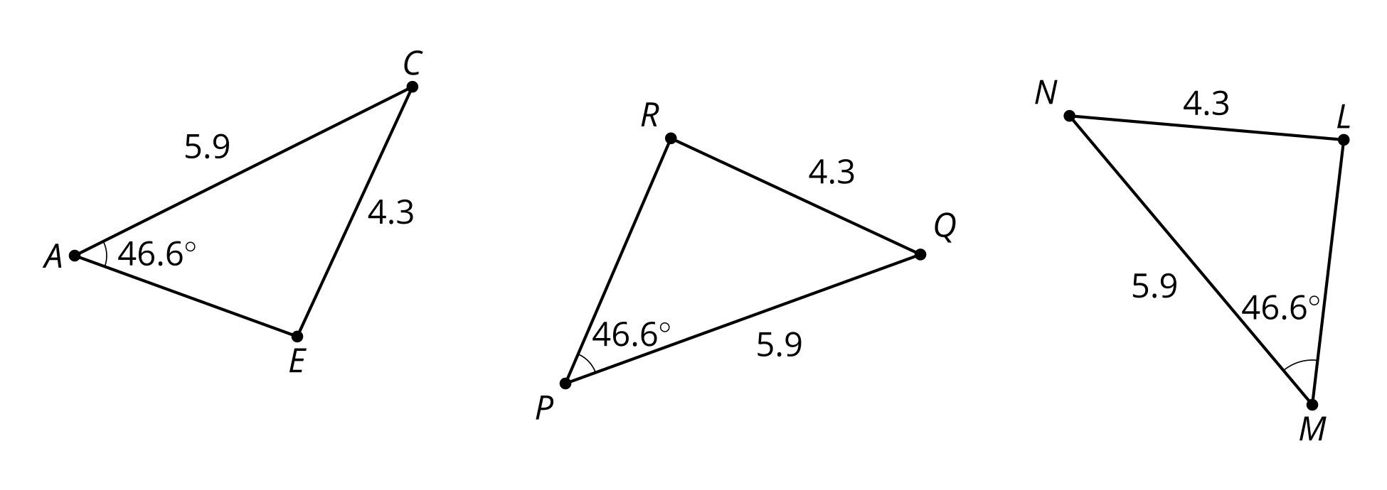
- Triangle $PQR$ is congruent to which triangle? Explain your reasoning.
- Show a sequence of rigid motions that takes triangle $PQR$ to that triangle. Draw each step of the transformation.
- Explain why there can’t be a rigid motion from triangle $PQR$ to the other triangle.

3 Are These Parts Congruent?

Student Task Statement
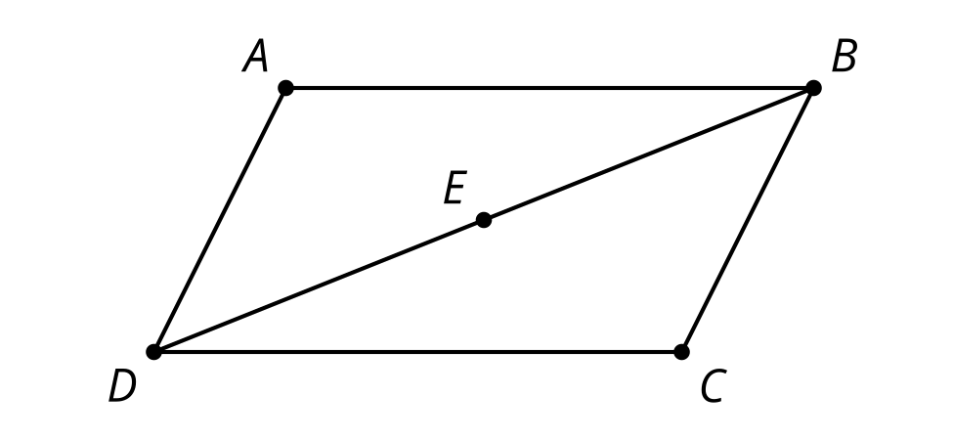
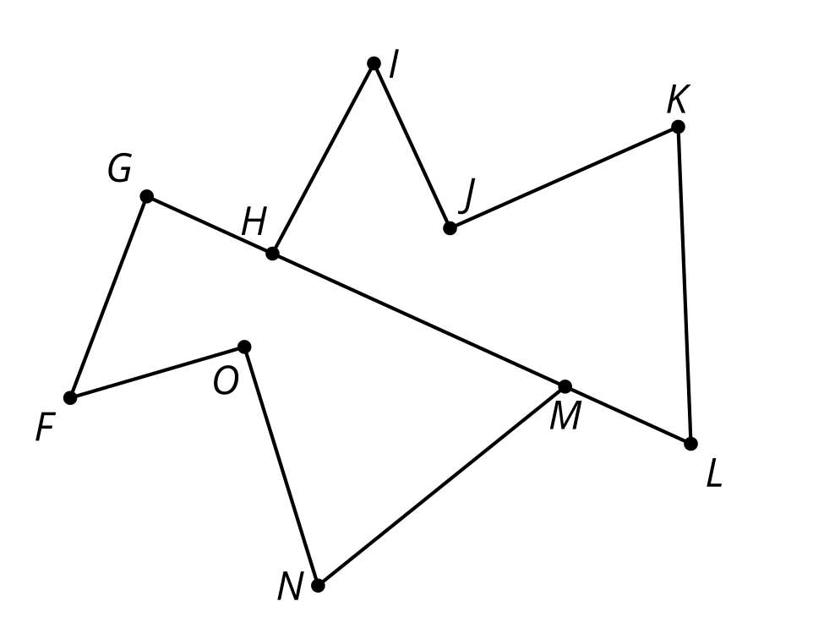
- Triangle $ABD$ is a rotation of triangle $CDB$ around point $E$ by ${180}^{∘}$. Is angle $ADB$ congruent to angle $CDB$? If so, explain your reasoning. If not, which angle is $ADB$ congruent to?
- Polygon $HIJKL$ is a reflection and translation of polygon $GFONM$. Is segment $KJ$ congruent to segment $NM$? If so, explain your reasoning. If not, which segment is $NM$ congruent to?
- Quadrilateral $PQRS$ is a rotation of polygon $VZYW$. Is angle $QRS$ congruent to angle $ZYW$? If so, explain your reasoning. If not, which angle is $QRS$ congruent to?

Images for Activity Synthesis
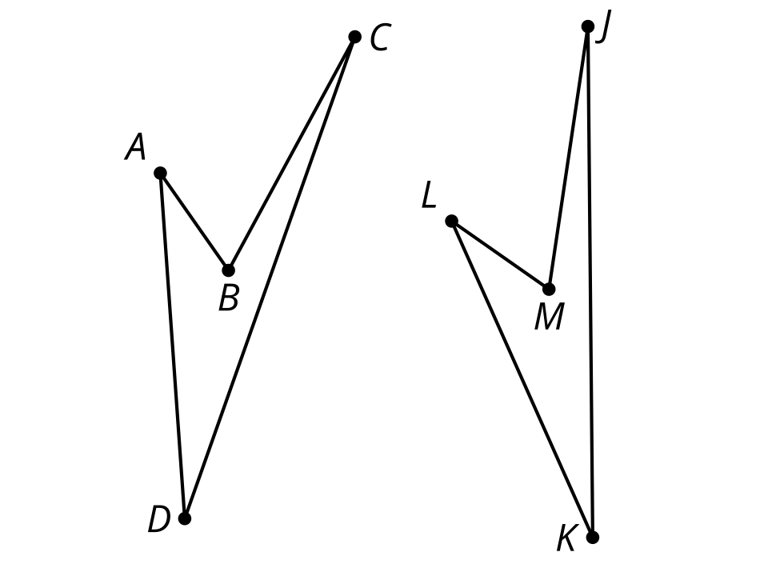
© CC BY 2019 by Illustrative Mathematics®

