Lesson 9 Practice Problems
- Write each quadratic expression in standard form. Draw a diagram if needed.
  - $\left(x+4\right)\left(x−1\right)$
  - $\left(2x−1\right)\left(3x−1\right)$
- Consider the expression $8−6x+x^{2}$.
  - Is the expression in standard form? Explain how you know.
  - Is the expression equivalent to $\left(x−4\right)\left(x−2\right)$? Explain how you know.
- Which quadratic expression is written in standard form?
  - $\left(x+3\right)x$
  - ${\left(x+4\right)}^{2}$
  - $\text{-}x^{2}−5x+7$
  - $x^{2}+2\left(x+3\right)$
- Explain why $3x^{2}$ can be said to be in both standard form and factored form.
- Jada dropped her sunglasses from a bridge over a river. Which equation could represent the distance $y$ fallen in feet as a function of time, $t$, in seconds?
  - $y=16t^{2}$
  - $y=48t$
  - $y=180−16t^{2}$
  - $y=180−48t$
- (From Unit 6, Lesson 5.)
- A football player throws a football. The function $h$ given by $h\left(t\right)=6+75t−16t^{2}$ describes the football’s height in feet $t$ seconds after it is thrown.
- Select all the statements that are true about this situation.
  - The football is thrown from ground level.
  - The football is thrown from 6 feet off the ground.
  - In the function, $\text{-}16t^{2}$ represents the effect of gravity.
  - The outputs of $h$ decrease then increase in value.
  - The function $h$ has 2 zeros that make sense in this situation.
  - The vertex of the graph of $h$ gives the maximum height of the football.
- (From Unit 6, Lesson 6.)
- Technology required. Two rocks are launched straight up in the air.
  - The height of Rock A is given by the function $f$, where $f\left(t\right)=4+30t−16t^{2}$.
  - The height of Rock B is given by function $g$, where $g\left(t\right)=5+20t−16t^{2}$.
- In both functions, $t$ is time measured in seconds and height is measured in feet. Use graphing technology to graph both equations.
  - What is the maximum height of each rock?
  - Which rock reaches its maximum height first? Explain how you know.
- (From Unit 6, Lesson 6.)
- The graph shows the number of grams of a radioactive substance in a sample at different times after the sample was first analyzed.
  - What is the average rate of change for the substance during the 10 year period?
  - Is the average rate of change a good measure for the change in the radioactive substance during these 10 years? Explain how you know.
- 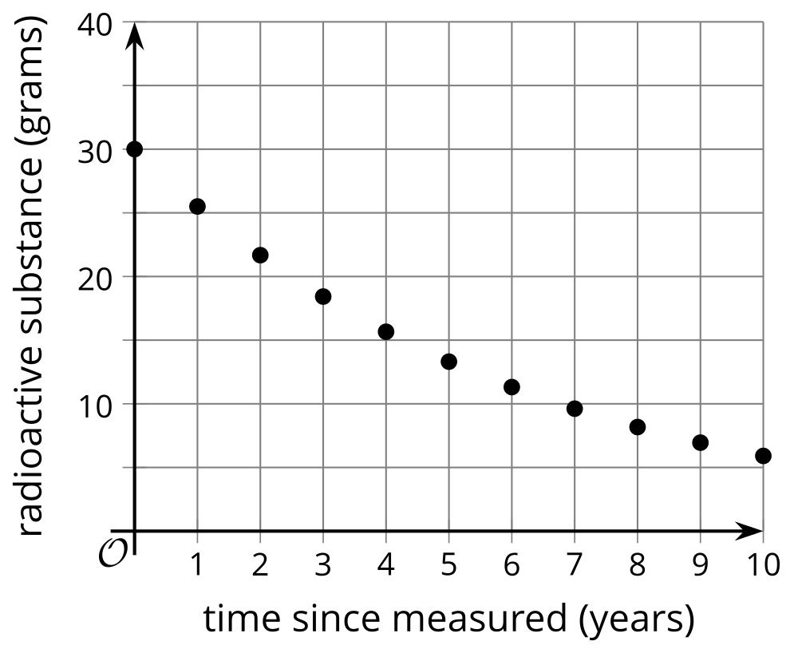
- (From Unit 5, Lesson 10.)
- Each day after an outbreak of a new strain of the flu virus, a public health scientist receives a report of the number of new cases of the flu reported by area hospitals.
- time since outbreak in days | - 2 | - 3 | - 4 | - 5 | - 6 | - 7
- number of new cases of the flu | - 20 | - 28 | - 38 | - 54 | - 75 | - 105
- Would a linear or exponential model be more appropriate for this data? Explain how you know.
- (From Unit 5, Lesson 11.)
- $A\left(t\right)$ is a model for the temperature in Aspen, Colorado, $t$ months after the start of the year. $M\left(t\right)$ is a model for the temperature in Minneapolis, Minnesota, $t$ months after the start of the year. Temperature is measured in degrees Fahrenheit.
- 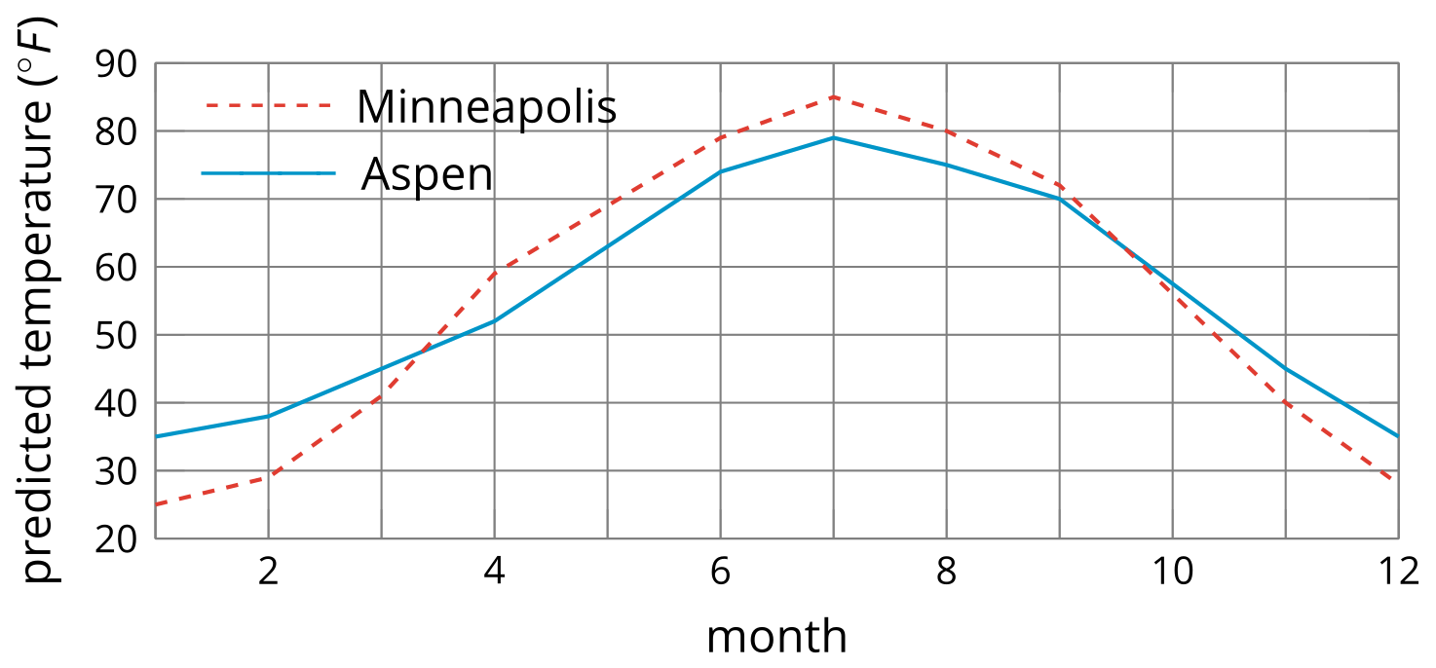
  - What does $A\left(8\right)$ mean in this situation? Estimate $A\left(8\right)$.
  - Which city has a higher predicted temperature in February?
  - Are the 2 cities’ predicted temperatures ever the same? If so, when?
- (From Unit 4, Lesson 9.)
© CC BY 2019 by Illustrative Mathematics®

