Lesson 6: Analyzing Graphs
Let's compare situations where quantities change exponentially.

6.1: Fractions and Decimals
fraction | $\frac{1}{2}$ | $\frac{1}{4}$ | $\frac{1}{8}$ | $\frac{1}{16}$ | $\frac{1}{32}$
decimal | 0.5 | 0.25 | 0.125
In the table, find as many patterns as you can. Use one or more patterns to help you complete the table. Be prepared to explain your reasoning.

6.2: Falling and Falling
The value of some cell phones changes exponentially after initial release. Here are graphs showing the depreciation of two phones 1, 2, and 3 years after they were released.
Phone A
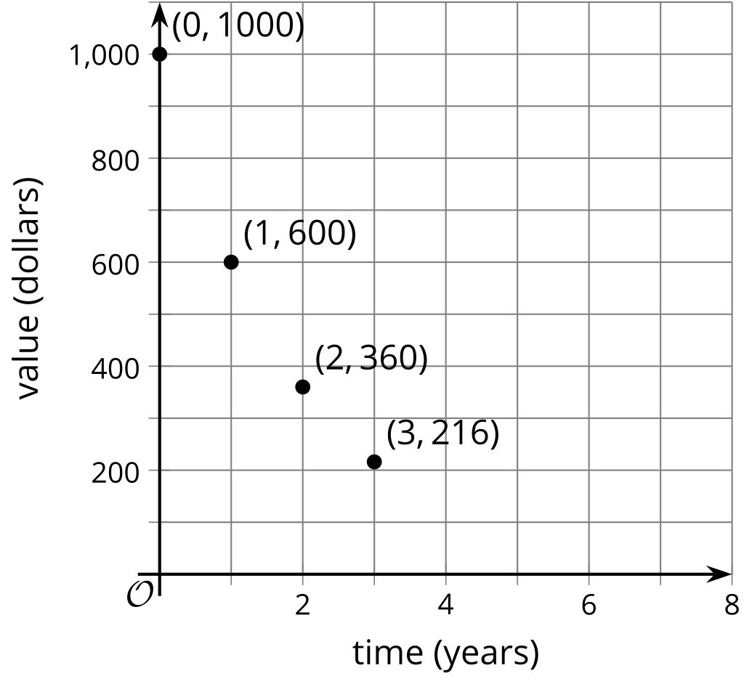
Phone B
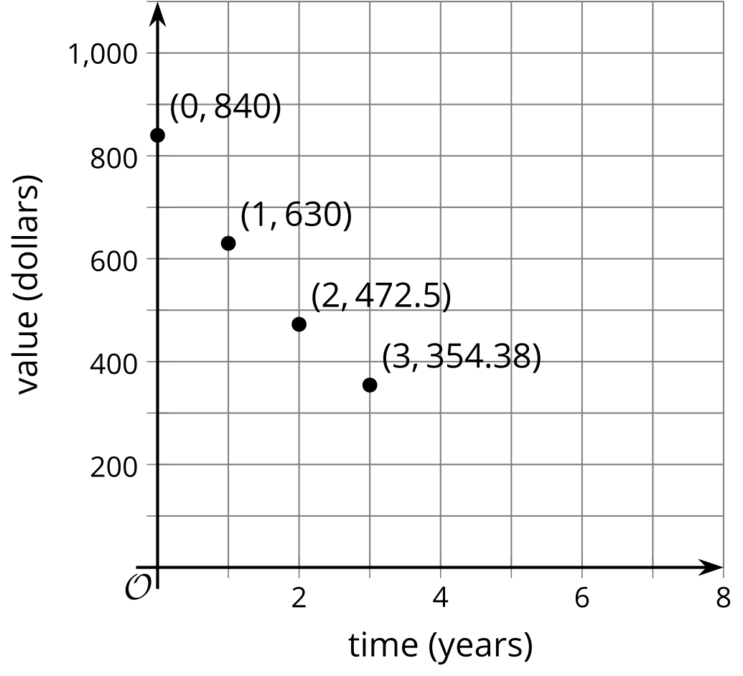
- Which phone is more expensive to buy when it is first released?
- How does the value of each phone change with every passing year?
- Which one is falling in value more quickly? Explain or show how you know.
- If the phones continue to depreciate by the same factor each year, what will the value of each phone be 4 years after its initial release?
- For each cell phone, write an equation that relates the value of the phone in dollars to the years since release, $t.$ Use $v$ for the value of Phone A and $w$ for the value of Phone B.

Are you ready for more?
When given data, it is not always clear how to best model it. In this case we were told the value of the cell phones was changing exponentially. Suppose, however, we were instead just given the initial values of the the cell phones when released and the values after each of the first three years.
- Use technology to compute the best fit line for each cell phone. Round any numbers to the nearest dollar.
- Explain why, in this situation, an exponential model might be more appropriate than the linear model you just created.

6.3: Card Sort: Matching Descriptions to Graphs
Your teacher will give you a set of cards containing descriptions of situations and graphs. Match each situation with a graph that represents it. Record your matches and be prepared to explain your reasoning.

Lesson 6 Summary
Graphs are useful for comparing relationships. Here are two graphs representing the amount of caffeine in Person A and Person B, in milligrams, at different times, measured hourly, after an initial measurement.

A
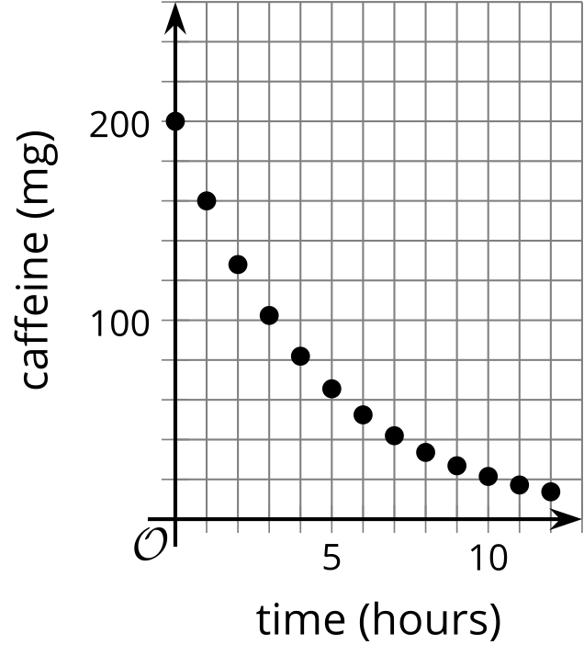

B
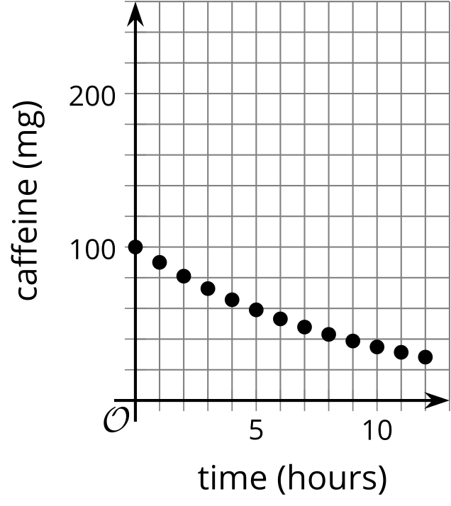
The graphs reveal interesting information about the caffeine in each person over time:
- At the initial measurement, Person A has more caffeine (200 milligrams) than Person B (100 milligrams).
- The caffeine in Person A's body decreases faster. It went from 200 to 160 milligrams in an hour. Because 160 is $\frac{8}{10}$ or $\frac{4}{5}$ of 200, the growth factor is $\frac{4}{5}$.
- The caffeine in Person B's body went from 100 to about 90 milligrams, so that growth factor is about $\frac{9}{10}$. This means that after each hour, a larger fraction of caffeine stays in Person B than in Person A.
- Even though Person A started out with twice as much caffeine, because of the growth factor, Person A had less caffeine than Person B after 6 hours.
© CC BY 2019 by Illustrative Mathematics®

