Unit 2 Lesson 1: Congruent Parts, Part 1

1 Notice and Wonder: Transformed Rectangles (Warm up)

Student Task Statement
What do you notice? What do you wonder?
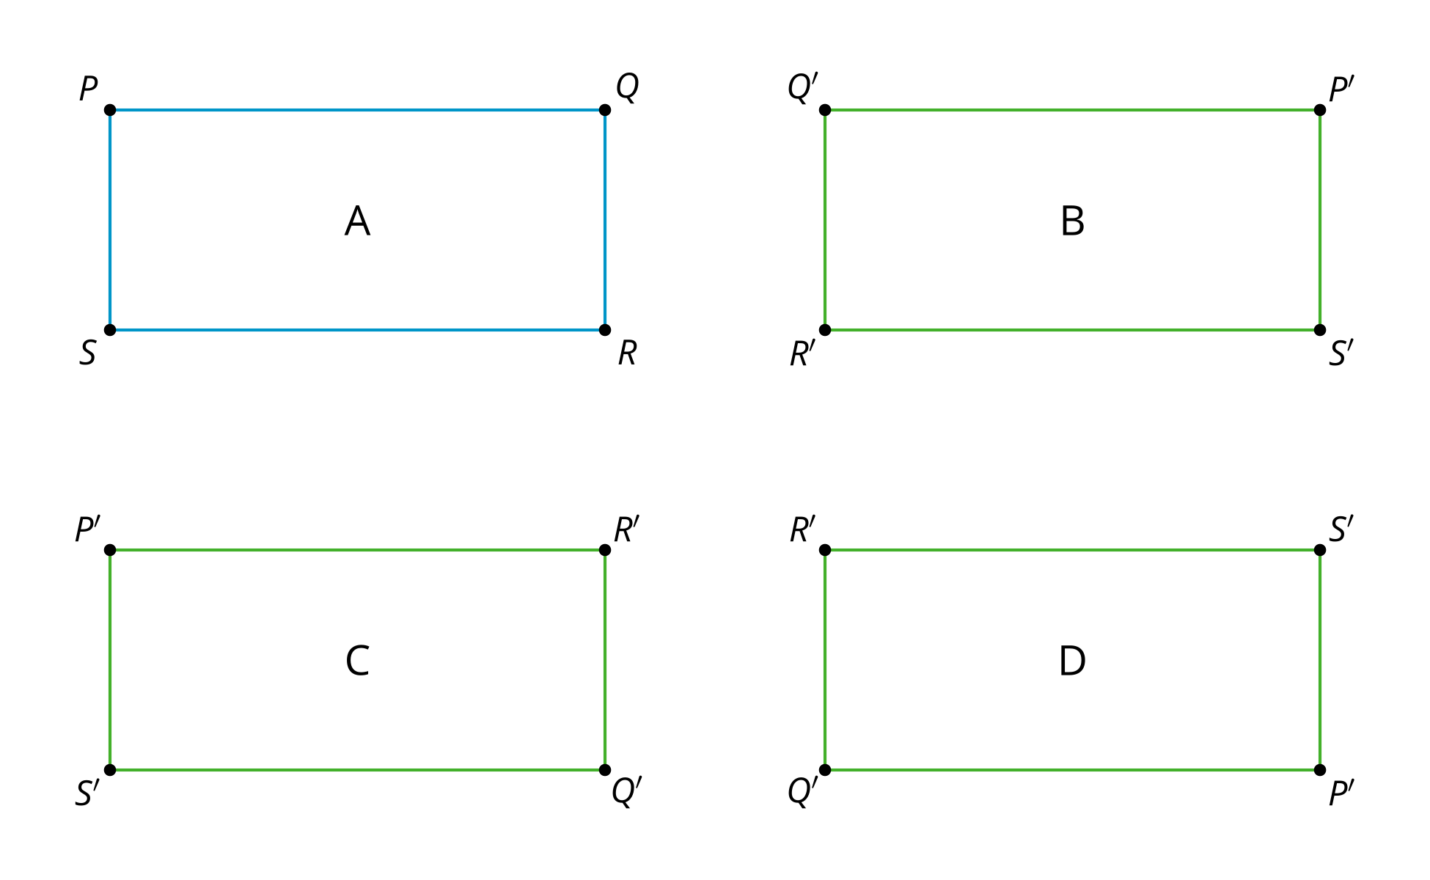

2 If We Know This, Then We Know That...

Student Task Statement
Triangle $ABC$ is congruent to triangle $DEF$.

$△ABC≅△DEF$
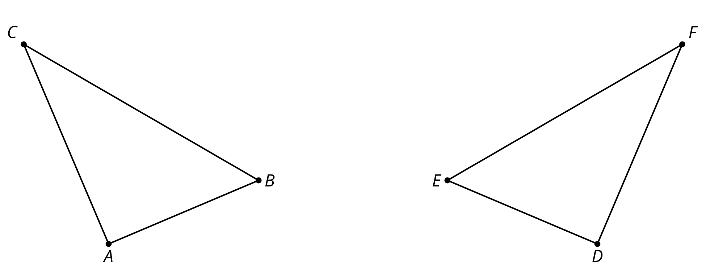
- Find a sequence of rigid motions that takes triangle $ABC$ to triangle $DEF$.
- What is the image of segment $BC$ after that transformation?
- Explain how you know those segments are congruent.
- Justify that angle $ABC$ is congruent to angle $DEF$.

Activity Synthesis

$△DEF≅△PQR$ so $\overset{¯}{PQ}≅\overset{¯}{DE},\overset{¯}{PR}≅\overset{¯}{DF},\overset{¯}{QR}≅\overset{¯}{EF},$ $∠P≅∠D,∠Q≅∠E,∠R≅∠F$
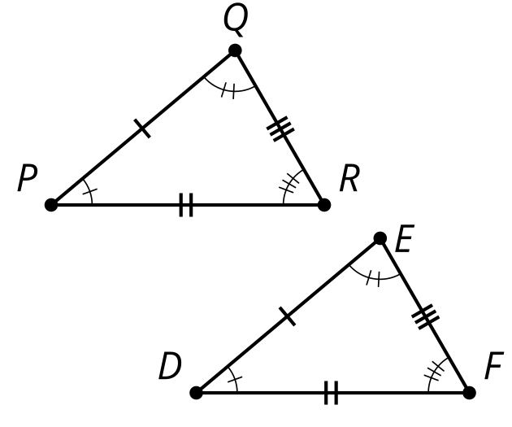

3 Making Quadrilaterals

Student Task Statement
- Draw a triangle.
- Find the midpoint of the longest side of your triangle.
- Rotate your triangle ${180}^{∘}$ using the midpoint of the longest side as the center of the rotation.
- Label the corresponding parts and mark what must be congruent.
- Make a conjecture and justify it.
  - What type of quadrilateral have you formed?
  - What is the definition of that quadrilateral type?
  - Why must the quadrilateral you have fit the definition?
© CC BY 2019 by Illustrative Mathematics®

